
The Society for Vascular Technology of Great Britain and Ireland (SVT)

The Accreditation Document

Attaining and Maintaining Registration as an Accredited Vascular Scientist (AVS)

Table of Contents

1. Introduction
2. Academic requirements
3. Training and support
4. Theory Exams
5. Practical Exam
6. CPD and maintaining AVS award

Appendices

Appendix 1 – The Core Modalities & Required Numbers
Appendix 2 – Calculating the number of years experience
Appendix 3 – The minimum scope of the scans
Appendix 4 – A bilateral carotid and vertebral duplex examination
Appendix 5 – A single full-leg arterial duplex
Appendix 6 – A single full-leg varicose vein and deep venous scan
1 – Introduction

The aim of the SVT Accreditation process is to ensure the achievement and maintenance of high standards of diagnostic vascular investigations for the benefit and safety of patients. Gaining accreditation as a Clinical Vascular Scientist is recommended for all individuals practicing vascular ultrasound in the UK or Ireland and is aimed at the ADVANCED SCIENTIST with a minimum of three years full-time postgraduate experience (or part-time equivalent) in a range of key diagnostic vascular investigations. The accreditation process can be summarised as follows:

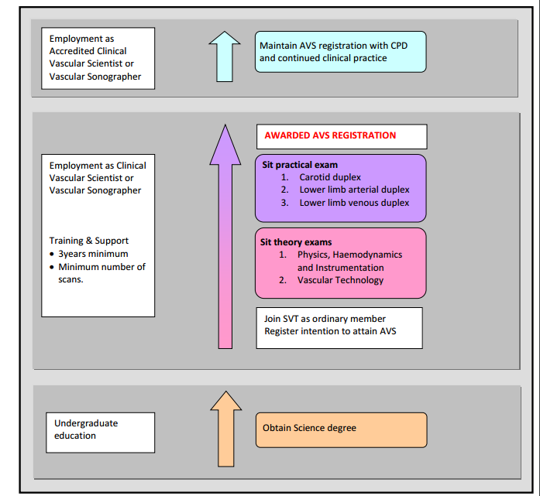

2 - Academic Requirements

- Applicants for AVS will be expected to hold a relevant science degree prior to accreditation training.
- The Society will consider equivalent professional qualifications or experience (e.g. radiography).
- Qualifications below degree level may be considered on individual merit in the case of those entering the vascular ultrasound profession before 2001.

How do I apply for ordinary membership of the SVT? The application form for new membership is available on the society website.

3 - Training and support

The SVT recognises that clinical vascular scientists work in a variety of clinical settings. They may be employed as lone practitioners, as part of a large team, in dedicated vascular studies units or in general radiology departments. They may be specifically employed as a supernumerary trainee with well-structured academic support and broad clinical training or they may be employed as a permanent member of staff expected to “learn on the job” with little educational support and unfocused clinical training.

It is the responsibility of the applicant to ensure that they have the appropriate support and guidance (preferably from an experienced AVS) and be able to gain sufficient clinical experience in all of the core modalities before embarking on the route to AVS. Supplementary academic support may be obtained from a higher education establishment (e.g. by studying for an MSc Medical Ultrasound, MSc Clinical Sciences: Vascular Science).

It is also the responsibility of the applicant to ensure there is a suitable record of each type of diagnostic vascular investigation carried out. This record may be part of PACS, a department database or an individual’s logbook but it must be in a format that contains enough information to breakdown the clinical activity into the compulsory and optional elements of the Core Modalities (the elements and numbers required are detailed in appendix 1).

4 - Theory Exams

​To become accredited through SVTGBI and earn the Accredited Vascular Scientist title, candidates must pass two theory examinations and a practical examination.

- Applicants for the theory exams must be a member (ordinary or associate) of the SVT.
- There are two theory exams
  - Vascular Physics, Haemodynamics and Instrumentation
  - Vascular Technology
- Candidates may choose to sit both exams in the same year or in different years.

The theory exams will be run electronically through a number of Pearson Vue test centres located around the UK:
London, Belfast, Crawley, Edinburgh, Glasgow, Reading, Salford (Manchester), Sutton Coldfield (Midlands), Watford and Dublin (New Horizons test centre).

Each theory exams lasts 2.5 hours and consists of 100 Multiple Choice Questions (MCQs). The primary test result will be a PASS or FAIL decision. However in addition, you will receive a scaled score, ranging from 300 to 700. A scaled score of 555 is required to pass both theory examinations. The scaled score is not a percentage of correct answers, nor is it built on a "curve" where a certain percentage of scores would pass and a certain percentage would fail.

The dates of the next applications, appointment booking window and exam dates and will be made available on the theory exam section of the website. Applications can be made through the SVT website education page where there will be a link to the SVT exam registration on the ARDMS website.

The cost is £100 for each exam. Candidates must be current members of the SVT.
Any candidates requiring extra time for a qualifying medical condition should contact the theory exams officer with evidence in advance of application through ARDMS.
There is no limit on the number of times a candidate may apply to re-sit a theory exam.

A successful pass in a theory exam is valid for 5 years (with respect to eligibility to sit practical exam). There is a detailed syllabus and reading list for each exam on the SVT website.

Who is eligible to take the theory exams?

The theory exams are aimed at individuals who have been practising diagnostic vascular investigations for 2 years however this length of experience is not mandatory. Candidates with well structured academic support may find they have confidence to sit the theory exams earlier. However remember the practical exam must be taken within 5 years of the passing the theory exams.

The theory exams are aimed at clinical vascular scientists aspiring for AVS. However they are open to any SVT member to sit at any time e.g. vascular researchers, nurses or surgeons wishing to test their theoretical knowledge.

The SVT runs a two day course in September/November for trainees covering both basic physics and technology theory and practical techniques. There is also an exam revision course each year in February/March held in London and is aimed at helping candidates in their final exam preparation.

5 - Practical Exam

Applicants for the practical exam
- Must be an ordinary member of the SVT (see website for details of membership types).
- Be currently employed in the UK or Ireland to perform vascular diagnostic investigations.
- Have been employed in the UK or Ireland to perform vascular diagnostic investigations for at least 6 months prior to applying to sit the practical exam.
- Meet the academic requirements specified in Section 2.
- Have passed both theory exams in the last 5 years.
- Have performed at least 600 scans in each of the 3 core duplex modalities (including a minimum number of compulsory elements) and 200 ABPIs. See appendix 1 of Accreditation for details of qualifying scans.
- Have at least 3 years full-time diagnostic vascular scanning experience (or part-time equivalent) in each core modality. See Appendix 2 of Accreditation Document for full details.
- Have carried out at least 25 scans from each of core modalities 1-3 in the preceding 3 months prior to applying to sit the practical exam.
- Must provide a reference from their current line manager, any previous line manager, internal examiner and a vascular surgeon.

How do I apply for the practical examination? The application form for the practical exam is available on the society website at all times of the year.

To apply for the practical examination all of the above criteria must be met. Included with your application you must have ready to upload the following documents:

- For each modality (1-3): a copy of your local protocols and 25 anonymised reports from the preceding 3 months. Please upload the documents as one zip file for each modality.
- References from your internal examiner, current line manager, any previous line manager (during your training) and a vascular consultant. Reference forms can be found on the SVT website.

The practical exam consists of 3 patient examinations and a viva voce
- A bilateral carotid and vertebral duplex examination (from Core Modality 1 – Carotid duplex)
- A single full-leg (aorta-ankle) arterial duplex (from Core Modality 2 – Peripheral arterial duplex)
- A single full-leg (groin-ankle) varicose vein and deep vein scan (from Core Modality 3 – Peripheral venous duplex)
- Viva Voce – covering clinical protocols, understanding of machine and service development.

For the purpose of a standardised accreditation process the minimum scope for each scan is defined by the SVT, irrespective of local protocols. Details of the minimum scope for each of the core modality scans can be found in appendices 3, 4, 5 & 6.

The practical exam may be taken at any time of the year, is taken in the candidate’s place of work and is expected to last 3-5 hours.

There will be two examiners (both current AVS)
- one internal examiner appointed by the candidate (>1 year post accreditation experience)
- one external examiner appointed by the SVT (>3 year post accreditation experience)

Two external AVS registered examiners may be appointed if there is not a suitably qualified or experienced internal examiner.

There is no limit on the number of times a candidate may apply to re-sit the practical exam however it must be taken within 5 years of passing both the theory exams and at least 6 months after a previously failed practical exam.

Successful completion of the practical exam entitles the candidate to be registered and use the term:

Accredited Vascular Scientist (AVS)

However AVS only remains valid with successful upkeep of CPD and clinical competency.

Lapsed AVS

For applicants who have lost their accreditation (longer than 5 years) you can still apply to be reaccredited, as of December 2014 it was agreed by the Education Committee that the following are requirements needed to apply.

Applicants for the practical exam if AVS has lapsed:
- Must be an ordinary member of the SVT (see website for details of membership types).
- Be currently employed in the UK or Ireland to perform vascular diagnostic investigations.
- Have been employed in the UK or Ireland to perform vascular diagnostic investigations for at least 6 months prior to applying to sit the practical exam.
- Meet the academic requirements set out in Section 2.
- Have passed both theory exams in the last 5 years.
- Have carried out at least 25 scans from each of core modalities 1-3 in the preceding 3 months prior to applying to sit the practical exam.
- Must provide a reference from their current line manager, any previous line manager, internal examiner and a vascular surgeon
- Must not have failed the practical exam in the last 6 months.

For details, advice or information on lapsed AVS/re-accreditation please refer to the CPD document available on the education page of the SVT website. Extensions for maternity/paternity leave may be granted for a maximum of 12 months. Extensions will be considered on a case by case basis.

6 - Continued Professional Development (CPD) and maintaining AVS status

For full information please see the CPD document available on the education page of the SVT website.

The AVS award only remains valid under specific conditions. The AVS must:
- Condition 1 - be a current paid-up Ordinary Member of the SVT. Fees are renewed annually on the anniversary of joining the society.
- Condition 2 - maintain clinical competency in each of the 3 core duplex modalities and keep appropriate records.
  - Core Modality 1 – Carotid duplex
  - Core Modality 2 – Peripheral arterial duplex
  - Core Modality 3 – Peripheral venous duplex
Clinical competency includes practical elements and individuals may maintain their skills by a combination of various activities, including regularly performing and/or supervising scans or carrying out alternative CPD activity.
- Condition 3 - Complete CPD activities and accrue a total of 30 SVT CPD points summed from the previous 3 membership years (i.e. average 10 points per year) and register points with the SVT before the end of August every year.

The CPD year runs from the 1st September to 31st August each year.

How do I register my CPD points?

Access to your personal CPD record is available on the SVT website for updating throughout the year. Data entry requires use of drop down menus with the relevant points for each activity given. The total year’s points should be entered before the end of August each year.
Any queries regarding qualifying activities should be addressed to the CPD co-ordinator (cpd.avs@svtgbi.org,uk)

Exceptions and exemptions in the form of allocated points may apply due to sabbaticals/ maternity/paternity leave / illness for up to 1 year. Applications will be considered on an individual basis. Other exemptions may be considered based on individual merit. Please contact the CPD coordinator for advice.

Newly registered AVS must start collecting CPD points immediately and submit data before the end of August following their practical exam.

Newly registered AVS will be awarded 10 points for each of the last 3 years, pro rata, to ensure their 3 year rolling average is not disadvantaged at the start. As of membership year 2017-2018 all CPD must be earnt post accreditation date.

CPD Audit

Each year the SVT Education Committee will randomly select 10% of AVS for a detailed inspection of CPD and clinical activity. It is the personal responsibility of each registered AVS to keep records of their CPD activity (e.g. certificates, programmes, course notes) and their clinical activity (e.g. using PACS, departmental database or personal logbook).

You will be required to produce copies of evidence for all CPD points claimed. Failure to do so will result in non-evidenced points being removed from your on-line CPD record.
You will also be required to submit copies of the relevant annual reflective CPD activity forms (See: The CPD document) to demonstrate how your CPD has benefited your personal development and service delivery.

Word document templates of the reflective practice form and clinical activity form are available to download from the SVT education page.

Failure to satisfy the 10% audit will result in lapse of AVS status. Reinstatement will be dependent on an individual remedial CPD programme which will be designed to ensure that conditions 1 to 3 have been satisfied. Payment of lapsed AVS fees will also apply.

Lapsed AVS

- If conditions 1 to 3 are not met before the 30th of September then AVS status will be changed to “lapsed”.
- If conditions 1 to 3 are then subsequently met between 1st of October and the 31st of December AVS status will be reinstated following payment of a £100 reinstatement fee which will be donated to The Circulation Foundation.
- If conditions 1 to 3 are still not by the 31st of December then AVS status will remain lapsed until Conditions 1 to 3 are met and an individually designed CPD remedial programme is successfully completed. This tailored programme will require evidence of professional development and clinical skills and will be at the discretion of the Education and Executive Committees. Reinstatement at this late stage will incur a fee of £250 which will be donated to the Circulation Foundation.

Lapse of AVS will result in removal from the publically available register of AVS. Reinstatement on the register will follow once the conditions for re-instatement are met.

If AVS status remains lapsed for 5 years or more, both the theory and practical exams will have to be retaken and all conditions met before AVS can be reinstated. Advice should be sought from the Education Committee.

For further details on CPD and re-instatement please read The CPD document, available on the website.

Appendix 1: The Core Modalities and Required Numbers

A minimum number of diagnostic vascular investigations is required and must be achieved by direct hands-on experience of appropriate patient referrals. At least 3 years full-time experience (or part-time equivalent) in each of the compulsory elements of the core modalities is required (even if the minimum number is reached sooner).

The Core Modalities required for eligibility for AVS registration are:
- Core Modality 1 – Carotid duplex MINIMUM 600
  - Compulsory element – Carotid/vertebral duplex MINIMUM 500
- Core Modality 2 - Peripheral arterial duplex MINMUM 600
  - Compulsory element – aorto/iliac/femoral/calf arterial duplex MINIMUM 300
- Core Modality 3 - Peripheral venous duplex MINIMUM 600
  - Compulsory element – lower limb varicose vein and deep venous duplex MINIMUM 400
- Core Modality 4 – ABPIs (including exercise testing) MINIMUM 200

The SVT strives to be as flexible and inclusive as possible and take into account the variety of clinical settings and changing workload of candidates aspiring to AVS. As such each Core Modality is split into compulsory and optional elements. The optional elements can be used to boost the numbers in each core modality up to the limits outlined in the table below. The general expectation would be for the number of scans to increase during the training period. For example: 100 scans in year 1, 200 in year 2 and 300 in year 3, in each modality. The majority of the scans must demonstrate pathology rather than be “normal”.

The 3 compulsory elements of Core Modalities 1, 2 & 3 will be assessed in the practical examination.

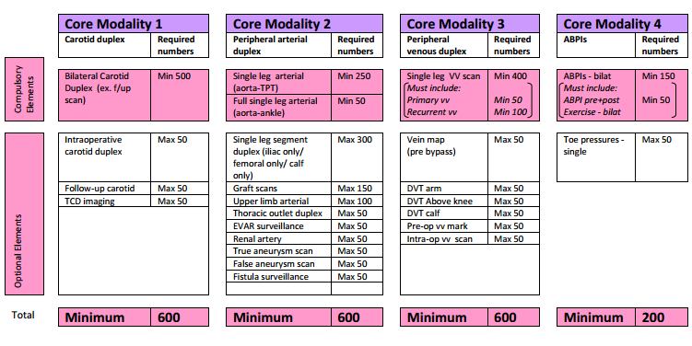

Appendix 2: Calculating the number of years experience

A minimum of 3 years clinical experience and responsibility in diagnostic vascular investigations is required before the practical examination can be taken.

The minimum of 3 years clinical experience is based on 37.5hrs per week employed as a clinical vascular scientist or vascular sonographer. Within these full-time hours there is the expectation that this will involve scanning patients on average 8 out of 10 sessions per week. It is expected that the reminder of the time will be spent doing structured reading, attending training courses, attending university etc.

Clinical vascular scientists or vascular sonographers working part-time must pro-rata their hours accordingly e.g. an individual working 22.5hrs per week in vascular ultrasound will take 5 years before eligible for the AVS practical examination even if they acquire the requisite number of scans in the core modalities sooner

37.5
Years = A x3 A=number of hours worked in diagnostic vascular ultrasound

The SVT recognises that some of the skills required for an AVS can be obtained by non-vascular ultrasound scanning. Skills such as ultrasound technology, use of the machine, scanning techniques, artefacts, image interpretation, hand-eye coordination, patient care and reporting. Sonographers working part-time in vascular ultrasound and part-time in another ultrasound specialty may have their non-vascular ultrasound experience credited towards their qualifying years at a value of 75% - providing they are fully responsible for reporting the scans. E.g. a sonographer who works 10 hours per week in general ultrasound can have this counted as 7.5hrs for the purpose of calculating qualifying years.

37.5
Years = A + 0.75B x3 B=number of hours worked in non- vascular diagnostic ultrasound

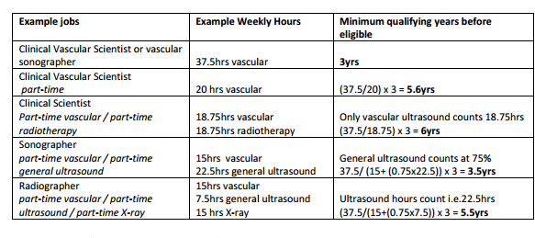

Other types of ultrasound, physics or physiological measurement work may be credited towards the qualifying years at the discretion of the education committee. If you are unsure how your experience or hours may count please contact the Chair of the Education Committee for clarification.
Appendix 3 – The minimum scope of the scans

With significant changes to scientific careers in the NHS it is important for the SVT to demonstrate that it has a robust and standard process of assessing the skills and clinical competencies of members. Candidates will no longer be able to choose what they are examined in.

The practical exam consists of 3 patient examinations and a viva voca
- A bilateral carotid and vertebral duplex examination (from Core Modality 1 – Carotid duplex)
- A single full-leg (aorta-ankle) arterial duplex (from Core Modality 2 – Peripheral arterial duplex)
- A single full-leg (groin-ankle) varicose vein and deep venous scan (from Core Modality 3 – peripheral venous duplex)
- Viva voca – covering clinical protocols, understanding of machine and service development

The minimum scope for each of the core modality scans is outlined in Appendices 4, 5 & 6 and sets out the basis upon which the candidate will be assessed. It is recognised that they may differ from the local protocols normally followed in any particular department. They are given in order to ensure that a uniform standard of assessment is performed for each candidate, no matter which department they are in, and are designed to include all the features of scan performance that a candidate achieving accreditation should be able to perform if required to do so.

Patient Selection
The 3 scans must be clinically appropriate referrals.
A patient’s consent to be part of the examination process must be acquired in advance.
During all scans it is important to remember the privacy and dignity of the patient particularly in light of the additional people present in the room.
The patients should be positioned appropriately for each scan being performed.

Equipment
A duplex ultrasound scanner with the appropriate range of probes for the examinations. Minimum requirements: Linear array 5-10MHz and Curvilinear array 2-5MHz

Image Recording
In order for the Assessors to be able to fully discuss the examination and report with the candidate after the patient has left the room, it is necessary to have images of the examination available. Therefore whilst it may not be the usual practice of a department to routinely record images and waveforms for the purposes of this exam a recording of the images and waveforms should be available for discussion with the final report. This may be in the form of hard copy or as a set of stored images available for viewing on the scanner. If you do not normally record images, you may find it helpful to practice doing so before the assessment takes place so you do not forget on the day.

Reporting
Using the in-house reporting system a full written report (with diagrammatic representation when used) will be expected.

Appendix 4 - A bilateral carotid and vertebral duplex examination

- The scan must be a diagnostic referral for a carotid duplex investigation.
- The patient must be >50yrs with appropriate carotid territory symptoms.
- The patient must be a new referral with no previous carotid duplex.

The examination should cover the arterial supply to the head from the common carotid artery (CCA) to the distal internal carotid artery (ICA) and include the proximal external carotid artery (ECA), vertebral artery, proximal subclavian artery and the brachiocephalic artery on the right.

- The CCA, bifurcation, ICA origin and ECA origin should be identified in B Mode using the transverse and longitudinal plane. The presence of any disease should be identified.
- Colour and spectral Doppler should be used appropriately to assess flow in the brachiocephalic, proximal subclavian, CCA, ICA, proximal ECA and vertebral.
- Identification and differentiation of the ECA and ICA should be clearly demonstrated with spectral Doppler.
- Peak systolic velocities and end diastolic velocities must be measured and documented in the distal CCA and proximal ICA and at any areas of flow disturbance.
- Direction of flow must be identified in the vertebral artery.
- The anatomical location of any haemodynamically significant lesion should be documented.
- Basic plaque characteristics and the length of any lesion should also be documented.
- The quality and patency of the ICA lumen distal to any disease should be documented.
- Any limitations of the scan must be documented.

Whilst stenoses may be graded and reported using local criteria, if this differs from the recommended criteria below you will be expected to justify your local protocol and understand and explain the implications of the differences.

Recommended carotid grading criteria

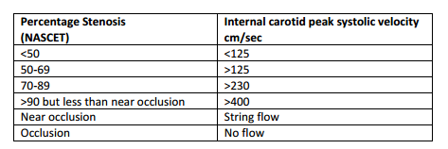
Appendix 5 - A single full-leg arterial duplex

- The scan must be a diagnostic referral for a full-leg lower limb arterial duplex. If the referral is just for a limited duplex (e.g. femoro-popliteal duplex) then the referrers and patient’s approval must be sought to extend examination to full leg for purposes of the exam.
- The patient must have suspected significant arterial disease. For the purposes of the examination this could include relevant symptoms with non-palpable pulses, monophasic signals on hand held Doppler, a resting ABPI ≤0.8 or a post-exercise ABPI of ≤0.6 which must be established prior to booking the patient for the exam.
- The patient must be a new duplex referral with no previous lower limb arterial duplex.

The examination should cover the arterial supply in the leg from the distal aorta to the ankle including the common iliac, external iliac, internal iliac origin, common femoral artery, profunda artery origin, superficial artery, popliteal artery, tibio-peroneal trunk, anterior tibial artery, posterior tibial artery and peroneal artery.

- The aorta should be identified in B Mode using the transverse and longitudinal plane. Anterior posterior diameter measurements should be taken. The presence of any disease should be identified.
- Colour and spectral Doppler should be used appropriately to assess flow in all of the lower limb arteries.
- Peak systolic velocities must be measured and documented at appropriate intervals particularly near a stenosis.
- The anatomical location of any haemodynamically significant lesion should be documented.
- The degree of narrowing and/or length of occlusion should be documented.
- Any limitations of the scan must be documented.
Appendix 6 - A single full-leg varicose vein and deep venous scan

- The scan must be a diagnostic referral for a varicose vein duplex.
- The patient must have significant visible varicosities.
- The patient must be a new duplex referral with no previous lower limb venous duplex.

The examination should cover the deep and superficial venous supply in the leg from the groin to the ankle including the common femoral vein, the profunda vein origin, superficial femoral vein, popliteal vein, tibio-peroneal trunk, anterior tibial veins, posterior tibial veins, peroneal veins, gastrocnemius veins, soleal veins, long saphenous vein, short saphenous vein, relevant perforators and branches.

- All the deep veins (including calf veins) should be assessed for deep venous thrombosis using transverse B Mode compression.
- The femoral and popliteal deep veins should be assessed for reflux using colour and spectral Doppler at appropriate intervals.
- The superficial veins should be assessed for superficial thrombophlebitis.
- The superficial veins and varicosities should be assessed for reflux with the source of reflux identified.
- Any limitations of the scan must be documented.

