

Dear All,

As part of the continued development of the SVT website the executive committee would like to include a searchable voluntary register for accredited vascular scientists on the site. This will enable anyone who visits the SVT website to type a name into a field and search to see if the individual entered is AVS registered with the SVT.


Upon searching if the individual is AVS registered the search only returns the information below:

If the individual searched for is not AVS registered the search returns the information below:
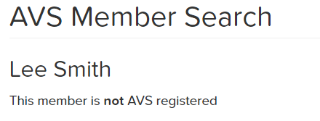

No other information will be available to search.

As this search facility is a voluntary register members are need to opt into the register for their information to be included in the search. If you wish to be included in this voluntary register you can opt in to the register from your locker on the SVT website.

Within your locker go to My Account and contact preferances, Update Details and then Click Opt in to AVS status search near the bottom of the page.
If you are not included on the register or the name entered is not on the database as a SVT member the search will simply return the following information below:
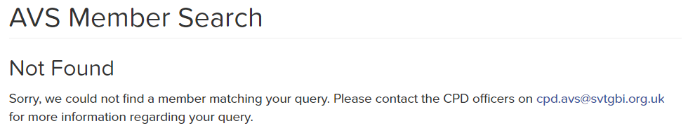

The AVS search will go live on the website Wednesday 1st November 2017.

If you have any questions regarding this please contact website@svtgbi.org.uk

Many Thanks

Lee Smith
SVT Website Secretary

