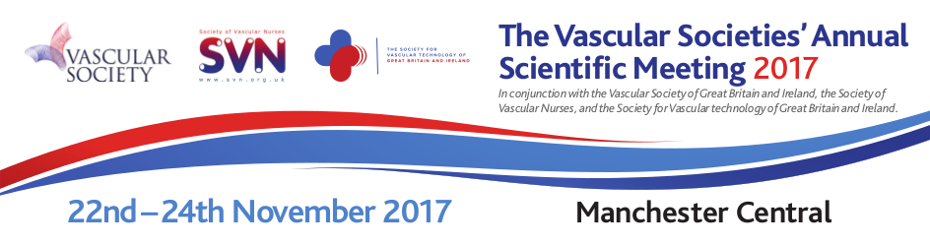

  www.vascularsociety.org.uk
  www.svn.org.uk
  www.svtgbi.org.uk
  Delegate registration is now open
  @VSGBI
  @vascularnurses
  @svtgbi

Delegate registration is now open for The Vascular Societies Annual Scientific Meeting 2017
Following the success of last year's meeting, we are pleased to announce for the third time the Vascular Society, Society of Vascular Nurses and the Society for Vascular Technology are working together to bring you one single integrated event – The Vascular Societies’ Annual Scientific Meeting.
This year's meeting is taking place from the 22nd – 24th November 2017, at Manchester Central, and features expert speakers who will deliver engaging sessions on the latest in vascular education and research.
The full programme is available online, via the link below.

To view the programme and book CLICK HERE

  The Programme
  With an exciting and comprehensive programme on offer, this year's conference features specialist sessions for Vascular Surgeons, Vascular Nurses and Vascular Scientists, and also includes debates, masterclasses, oral abstracts, company symposia, workshops and access to a large industry exhibition.
  In order to meet their individual educational requirements delegates can choose to attend any of the sessions in the programme. To view the full programme please click on the below link.
  To view the full programme CLICK HERE
  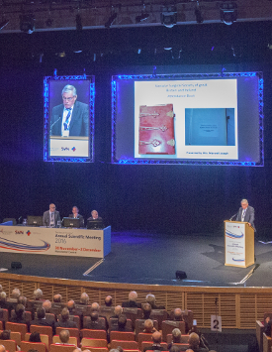

Vascular Surgeon session highlights include:
The main theme of these sessions is “Getting out and staying out of trouble”, which includes a range of topics from the management of ruptured and elective abdominal aortic aneurysms to the diabetic foot, vascular disease in childhood and the ‘doctor in trouble’. Thursday's highlights include the Sol-Cohen and BJS prize sessions, the return of the popular Dragons Den, a ‘What’s new in 2017’ session, and the day also has a series of debates. Friday’s highlight includes Professor Janet Powell giving the BJS lecture on ‘Tricks, trials and treats’, and Mr Paul Blair giving the Kinmonth lecture of the Modern Management of Vascular Trauma.
Vascular Nurse session highlights include:
The programme ranges from an overview of lower limb interventions and vascular pharmacology to discussing the burden of venous leg ulcers and presenting innovative wound management solutions. Delegates can participate in the lively debate of “whether claudicants should join the gym or meet the radiologist” and keep updated on the new horizons within vascular services.
Vascular Scientist session highlights include:
The programme starts with a study afternoon with expert speakers and demonstrators on duplex EVAR imaging and contrast. Following which there will be an SVT evening reception with drinks and canapes. Thursday is a full day with 10 trainee research proposals to consider, 9 scientific presentations, business meeting, trainee breakout session and talks from expert invited speakers. The day ends with prizes for the most promising trainee research proposal and the best scientific presentation.

  Manchester
  The conference will take place in the iconic Manchester Central.
  Manchester Central is located in the centre of the UK and benefits from an extensive multi-modal transport network. Manchester Airport is just nine miles from the city centre and serves more than 200 destinations worldwide. If you are travelling by train, Manchester Central is a 20 minute walk from Piccadilly Station or just five minutes by taxi.
  For full details, to include maps and parking information, please click on the below link.
  For more information please click here
  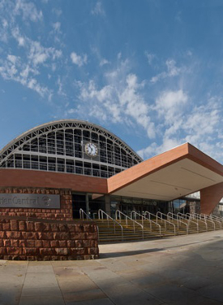

Fitwise Management (on behalf of The Vascular Societies’ Annual Scientific Meeting), Blackburn House, Redhouse Road, Seafield, Bathgate, West Lothian, EH47 7AQ.
Email: asm@vascularsociety.org.uk
Telephone: 01506 292034
Registered in Scotland. Company registration number: SC247380

