Duplex and 3D-tomographic ultrasound for veins, including varicose veins, planning arterial bypass and AV fistula for dialysis

Description:
Whether you are new to duplex or are in need of a refresher, this hands-on training will cover the skills needed for duplex imaging of arteries and veins including the novel 3D Tomographic Ultrasound (tUS) technology. The focus will be on preoperative imaging of varicose veins, long and short saphenous veins for autologous coronary and peripheral artery bypass and forearm arteries and veins in the planning of AV fistulas.
tUS provides a high definition 3D vessel map that can be easily and rapidly interpreted, shared and documented among clinicians.
This workshop is for vascular surgeons, varicose vein practitioners, vascular scientists, and nurses involved in planning varicose vein procedures, autologous coronary or peripheral artery bypass or arterio-venous fistula procedures whether open or endovascular.
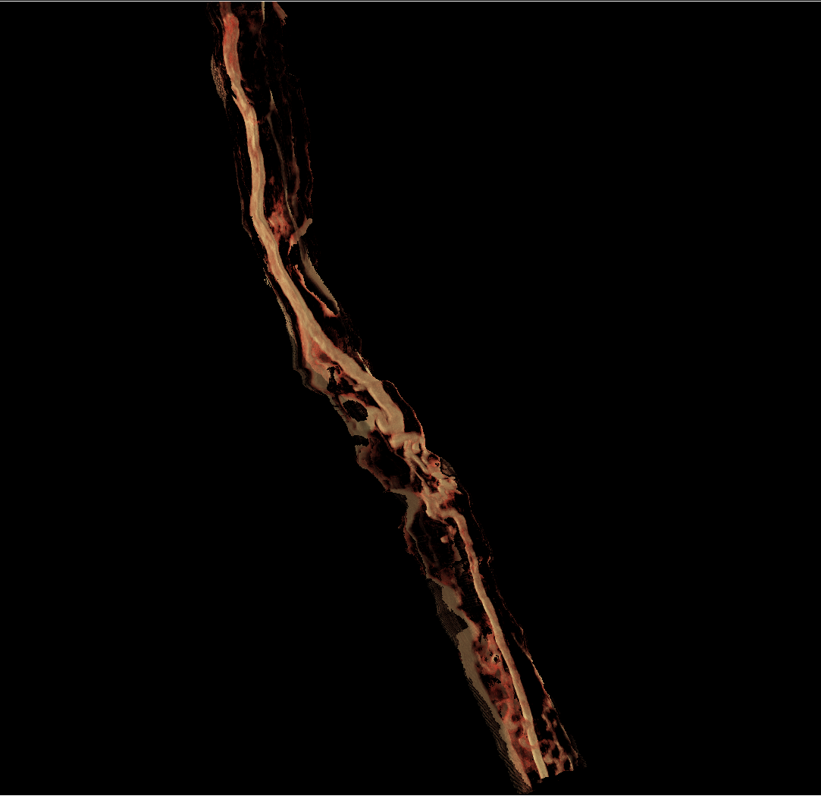
Figure 1: Tomographic ultrasound image of varicose below knee LSV

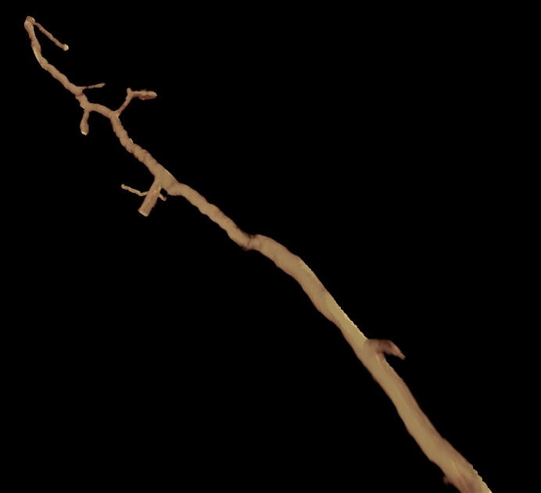
Figure 2: A right long saphenous vein which is adequate for bypass proximally (top right) but becomes small with multiple branches distally

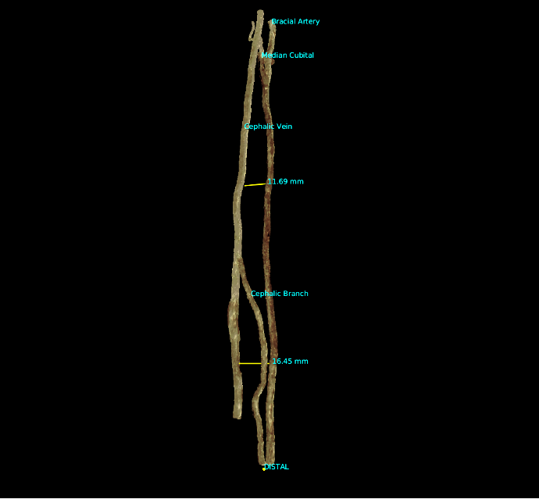
Figure 3: Radial Artery and Cephalic Vein which can be seen from any angle by rotating the image. There is an excellent venae comitantes adjacent to the radial artery and draining into a good cephalic vein, sufficient in diameter for an endovascular procedure. The open procedure can be planned wherever the cephalic vein and radial artery our closest.

