.

WANTED!
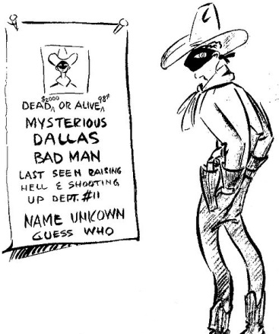
CASE Representative
CASE is the Consortium for the Accreditation of Sonographic Education. We need a new representative from SVT on CASE.
There should be three SVT representatives on CASE council, so that we can ensure there is always good SVT representation (two people preferred at each) at the three CASE council meetings held every year (usually two in London and one in York). This involves looking at courses, and changes to courses, for sonographic education around the country. The remit of CASE council continues to evolve with changing practice and education. The SVT representatives on CASE are also CASE accreditors which may involve travelling to educational sites for on-site visits with agreement.
For more information please contact Valda on valda.gazzard@nhs.net

