Local Lower Limb Artery Duplex Imaging Protocol:

LOWER LIMB ARTERIAL IMAGING

- SCOPE & OBJECTIVE

- Arterial duplex ultrasound examination to assess for stenotic, occlusive or aneurysmal arterial disease in the major arteries of the lower extremity and abdomen.
- To provide operators with general instructions on how to undertake the investigation.

- Responsibility
- The clinical scientist (or trainee clinical scientist) performing the scan is responsible for undertaking the procedure.
- The clinical scientist may alter procedure depending on individual patient and clinical information required.
- The chaperone/ clinical scientist (or trainee clinical scientist) is responsible for undertaking the patient identification.

- Imaging Procedure
- Confirm patient identifiers (Name, DOB and Address) and introduce themselves. Explain the scan procedure and obtain informed consent (trust consent policy). Obtain any relevant clinical history. Verify that the request correlates with patient’s clinical presentation.
- The protocol may be adjusted for a clinically focussed scan of a particular region, as per scan request.
- This is potentially an intimate procedure and if deemed so, then a chaperone can be present in the room at the time of the investigation. Ensure patient dignity is maintained throughout the examination.
- Ask the patient to lie on the bed supine for the abdominal and proximal leg investigation.
- Use sterile gel if required as per the sterile gel protocol.
- Select the correct patient on the ultrasound machine. Select the arterial pre-set and appropriate probe.
- The following techniques should be used to evaluate the lower arterial systems: B-mode should be used to assess for any aneurysmal dilatation and vessel contents e.g. atheroma, calcification, plaque or thrombus. Colour Doppler should be used to assess the presence or absence of flow and to detect stenoses. Spectral Doppler should be used to determine flow direction, to grade stenoses and to determine the arterial waveform (i.e. monophasic, biphasic, triphasic, hyperaemic – appendix 1) (1).
- Image common femoral artery (CFA) in longitudinal using B-mode, colour and spectral Doppler. Check patency of the artery and extent of any disease.
- Save an image of the CFA, including waveform and any other representative images, where possible.
- If the CFA waveform is triphasic continue to scan distally. If the CFA waveform is significantly modified or if aorto-iliac disease is suspected, then an aorto-iliac scan should be performed. This includes using colour and spectral Doppler to assess the aorta, common iliac artery (CIA), internal iliac artery (IIA) (where possible) and external iliac artery (EIA) for arterial disease.
- When scanned, and where possible, save a representative image of the aorta, CIA and EIA showing patency and waveform and any other representative images that may be appropriate. Make sure limitations are stated on the report if images aren’t saved.
- Image the profunda femoral artery (PFA) origin and check for patency and stenosis.
- Image the superficial femoral artery (SFA) in longitudinal (and transverse if necessary) using colour and spectral Doppler to determine patency and extent of disease.
- Examine the patency of the popliteal artery and the extent of disease using colour and spectral Doppler.
- A distal image of the SFA and popliteal artery showing patency and waveform should be saved as a minimum, where possible.
- Image the posterior tibial artery (PTA), anterior tibial artery (ATA) and peroneal artery (PER) in longitudinal and cross section if necessary, noting any disease present. The calf arteries can be challenging to view when calcified. Where possible, save a representative image of each tibial vessel showing patency and waveform as a minimum.
- If a stenosis is identified, then the following grading criteria should be used (table 1) (2):

PSV ratio | % Stenosis
<2 | Not haemodynamically significant
>2 | 50-75% (Moderate)
>4 | >75% (Severe)
No colour flow | Complete Occlusion

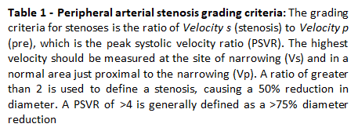

- Triphasic and biphasic waveforms represent normal flow patterns and monophasic waveforms represent presence of disease. Hyperaemic multiphasic (above baseline) can indicate enhanced blood flow due to distal vessel dilation from ulceration/infection or distal occlusion.
- If a complete occlusion is suspected check for trickle flow. Reduce the colour scale or use power Doppler and/or superb microvascular imaging and/or spectral Doppler to confirm occlusion. Note the presence of collateral vessels and level of reconstitution.
- If an acute event is suspected (acute arterial embolus or thrombus present with possible arterial distension). Determine extent of the obstruction.
- For aneurysmal disease, if requested (or suspected) measure vessel diameter in transverse/longitudinal section. Note presence of aneurysm/ sites of ectasia on the report.
- At the end of the scan provide the patient with tissue to wipe any excess gel. Inform the patients of the results and let them know the report will be available for the referring doctor to access.

- Images and Reporting
- End the exam on the machine to send images to PACS
- This is a dynamic scan and any images saved are not representative of the full scan performed. All images that are saved should be used to evidence diagnosis and aid reporting. The images alone should not be used to retrospectively diagnose
- For scans performed under ergonomically challenging conditions or with time constraints such as portable scans on the ward or within clinics a reduced set of images may be saved
- Record the name of any chaperone present in comments box on RADIS
- Complete the exam in RADIS
- Report the scan on the “CWM” patient reporting system.
- For any urgent findings; including acutely ischemic limb or newly diagnosed above surgical threshold aneurysm bleep the on-call vascular registrar (5214).

- References
- Interpretation of peripheral arterial and venous Doppler waveforms: A consensus statement from the Society for Vascular Medicine and Society for Vascular Ultrasound; Interpretation of peripheral arterial and venous Doppler waveforms: A consensus statement from the Society for Vascular Medicine and Society for Vascular Ultrasound - Esther SH Kim, Aditya M Sharma, Robert Scissons, David Dawson, Robert T Eberhardt, Marie Gerhard-Herman, Joseph P Hughes, Steve Knight, Ann Marie Kupinski, Guillaume Mahe, Marsha Neumyer, Patricia Poe, Rita Shugart, Paul Wennberg, David M Williams, R Eugene Zierler, 2020 (sagepub.com)
- SVT Professional Standards Committee April 2021. Arterial duplex ultrasound examination; Arterial_PPG_-_29.03.21.pdf (svtgbi.org.uk)

- Appendices
- Appendix 1 – Waveform Examples

TRIPHASIC:
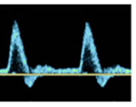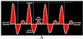

BIPHASIC:
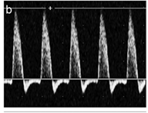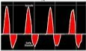

MONOPHASIC:
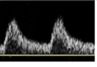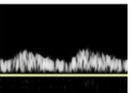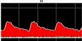

HYPERAEMIC:
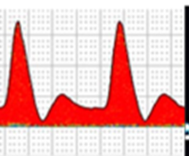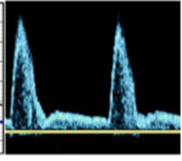

Peripheral Arterial Scan Numbers (June 2024 – July 2024)

