Reference Request to Vascular Consultant

Applicant’s name: _________________________________

The above named applicant has applied to sit the SVT practical examination. This is the final assessment on the route to becoming an Accredited Vascular Scientist. Applicants must fulfil certain eligibility criteria before they are entitled to sit the examination. The applicant has proposed that as their Vascular Consultant you can help confirm their eligibility. We would be grateful if you could fill in the details below.

Applicants current job title |  | Trainee Vascular Scientist
Applicants current Employer/Hospital |  | Royal Sussex County Hospital
Start date of applicants current job |  | March 2015
Applicants current weekly hours working in vascular ultrasound diagnostic scanning |  | 22.5
How long have you known the applicant? |  | Since March 2015

Where applicable please comment on your perception of the applicant’s proficiency in the following areas:

Duplex of carotid and vertebral arteries Poor Acceptable Good Excellent X
Duplex of lower limb arteries Poor Acceptable Good Excellent X Duplex of varicose veins Poor Acceptable Good Excellent X Ankle Brachial Pressure Indices Poor Acceptable Good Excellent X

Please comment on the applicant’s ability to write clear reports and relay urgent findings appropriately:

Ellie writes prompt, clear and concise reports. She will always refer urgent or unusual findings to the correct person in a timely manner. She has excellent communication skills.

Please include any other comments you may have (please continue on the reverse of the page if required).

Ellie is a very valuable member of the team. Her hard work and enthusiasm plus her delightful calm manner is much appreciated by staff , patients and their relatives.

Email Address.… michael.brooks3@nhs.net

Signed………………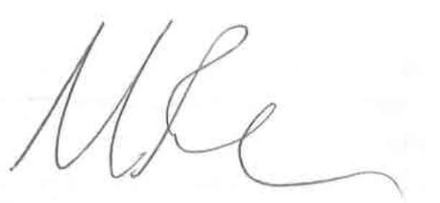……………………………… Print Name Mike Brooks

Designation…… Lead Consultant Surgeon, Sussex Vascular Network

Date 25/01/21

By signing this form you consent for your information to be uploaded to the SVTGBI website and for the SVTGBI to contact you in regards to this reference.

