Reference Request to Internal Assessor

Applicant’s name: _Reag Bermejo____________________________

The above named applicant has applied to sit the SVT practical examination. This is the final assessment on the route to becoming an Accredited Vascular Scientist. Applicants must fulfil certain eligibility criteria before they are entitled to sit the examination. The Education committee has agreed that the nominated internal should confirm the applicant’s eligibility.
We would be grateful if you could fill in the details below.

Applicants current job title |  | Clinical Vascular Scientist
Applicants current Employer/Hospital |  | Barts Health NHS Trust
Start date of applicants current job |  | 26/08/2020
Applicants current weekly hours working in vascular ultrasound diagnostic scanning |  | 37.5
How long have you known the applicant? |  | 9 months

Where applicable please comment on your perception of the applicant’s proficiency in the following areas:

Duplex of carotid and vertebral arteries Poor Acceptable Good Excellent ♦
Duplex of lower limb arteries Poor Acceptable Good Excellent ♦
Duplex of varicose veins Poor Acceptable Good Excellent ♦
Ankle Brachial Pressure Indices Poor Acceptable Good Excellent ♦

Please comment on the applicant’s ability to write clear reports and relay urgent findings appropriately:

Reag’s reports are clear and accurate and any urgent information gets passed on to the clinical team immediately.

Please include any other comments you may have (please continue on the reverse of the page if required).

Reag is ready to take his SVT practical exam, having gained a wide breadth of experience at 2 different NHS Trusts and gained enough scan numbers.

Email Address.…kate.crawford1@nhs.net…………………………………………………………………………………………………………………….
Signed……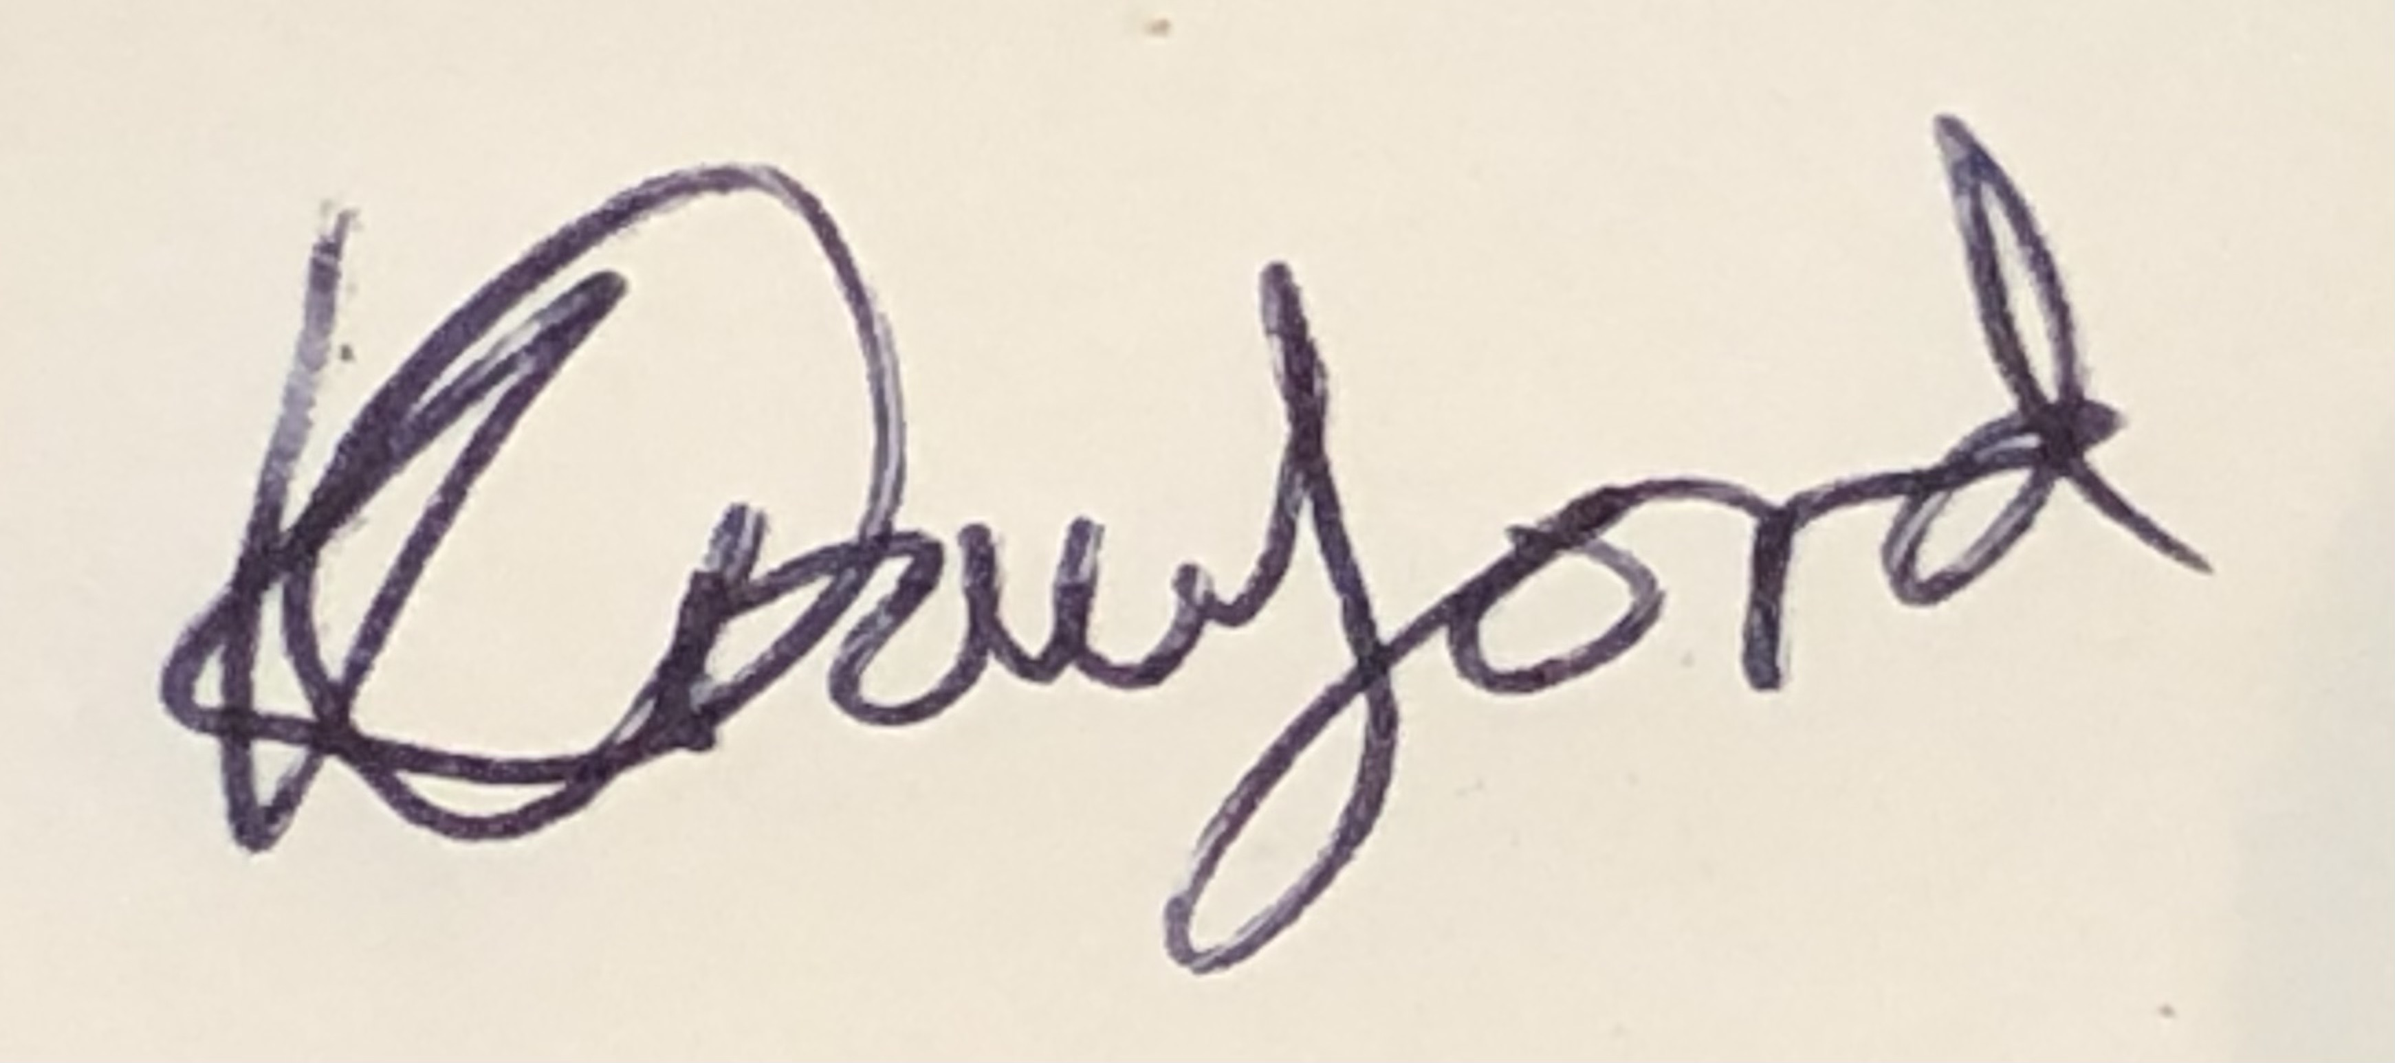………………………………………………..………………… Print Name……Kate Crawford………………………….
- AVS for at least 1 year
- Up to date CPD or clinical competency as required in the Accreditation Document

Designation……Lead Clinical Vascular Scientist……………………………………………………………………………………………………………..…….….

Date……19/05/2021…………………………………….……………..

By signing this form you consent for your information to be uploaded to the SVTGBI website and for the SVTGBI to contact you in regards to this reference.

Reference Request to Current Line manager

Applicant’s name: __Reag Bermejo_____________________________

The above named applicant has applied to sit the SVT practical examination. This is the final assessment on the route to becoming an Accredited Vascular Scientist. Applicants must fulfil certain eligibility criteria before they are entitled to sit the examination. The applicant has proposed that as their current line manager you can help confirm their eligibility. We would be grateful if you could fill in the details below.

Applicants must be currently employed in the UK or Ireland to perform vascular ultrasound diagnostic investigations

Applicants current job title |  | Clinical Vascular Scientist
Applicants current Employer/Hospital |  | Barts Health NHS Trust
Start date of applicants current job |  | 26/08/2020
Applicants current weekly hours working in vascular ultrasound diagnostic scanning |  | 37.5
How long have you known the applicant? |  | 9 months
Applicants start date of UK or Ireland employment |  | August 2009

Applicants must have performed a minimum number of scans and ABPIs. Approximately how many scans in each of the core modalities listed below has the applicant performed during their current employment?

Bilateral duplex of carotid and vertebral arteries 0 1 – 100 101-300 ♦ 301-600 >600
Single leg duplex of arteries (aorta-TPT, inc iliacs) 0 1 – 100 101-300 ♦ 301-600 >600
Single leg duplex of arteries (aorta-ankle) 0 1 – 100 101-300 ♦ 301-600 >600
Single leg graft duplex 0 1 – 100♦ 101-300 301-600 >600
Single leg duplex of primary varicose veins 0 1 – 100 101-300 ♦ 301-600 >600
Single leg duplex of recurrent varicose veins 0 1 – 100♦ 101-300 301-600 >600
Ankle Brachial Pressure Indices-bilat 0 1 – 100♦ 101-300 301-600 >600
ABPI pre+post exercise-bilat 0 1 – 100♦ 101-300 301-600 >600

Please include any other comments you may have (please continue on the reverse of the page if required).
Reag is ready to take his SVT practical exam, having gained a wide breadth of experience at 2 different NHS Trusts and gained enough scan numbers.

Email Address..……kate.crawford1@nhs.net………………………………………………………………………………………………………………………
Signed……..………………… Print Name……Kate Crawford………………………………………………………………………..

Designation………Lead Clinical Vascular Scientist…………………………………………………………………………………………..…….….

Date……19/05/2021……………………………………………………….……………..

By signing this form you consent for your information to be uploaded to the SVTGBI website and for the SVTGBI to contact you in regards to this reference.

Reference Request to Previous Line manager

Applicant’s name: __Reag Bermejo______________________________

The above named applicant has applied to sit the SVT practical examination. This is the final assessment on the route to becoming an Accredited Vascular Scientist. Applicants must fulfil certain eligibility criteria before they are entitled to sit the examination. The applicant has proposed that as their previous line manager you can help confirm their eligibility. We would be grateful if you could fill in the details below.

Applicants previous job title |  | Clinical vascular scientist
Applicants previous Employer/Hospital |  | Watford General Hospital
Start date of applicants previous job |  | 07/09/2016
End date of applicants previous job |  | 25/08/2020
Applicants previous weekly hours working in vascular ultrasound diagnostic scanning |  | 37.5
How long have you known the applicant? |  | 4 years

Applicants must have performed a minimum number of scans and ABPIs. Approximately how many scans in each of the core modalities listed below has the applicant performed during their previous employment?

Bilateral duplex of carotid and vertebral arteries 0 1 – 100 101-300 301-600 >600
Single leg duplex of arteries (aorta-TPT, inc iliacs) 0 1 – 100 101-300 301-600 >600
Single leg duplex of arteries (aorta-ankle) 0 1 – 100 101-300 301-600 >600
Single leg graft duplex 0 1 – 100 101-300 301-600 >600
Single leg duplex of primary varicose veins 0 1 – 100 101-300 301-600 >600
Single leg duplex of recurrent varicose veins 0 1 – 100 101-300 301-600 >600
Ankle Brachial Pressure Indices-bilat 0 1 – 100 101-300 301-600 >600
ABPI pre+post exercise-bilat 0 1 – 100 101-300 301-600 >600

Please include any other comments you may have (please continue on the reverse of the page if required).
Reag was a pleasant member of staff who worked well with all team members. He was enthusiastic, quick to learn and a competent clinical vascular scientist.

Email Address..………alison.elcott@nhs.net……………………………………………………………………………………………………………………………………………………………………
Signed………Alison Elcott………………………………………
Print Name………Alison Elcott…………………………………………………………………………………..

Designation……Lead Clinical Vascular Scientist…………………………………………………………………………………………………………………………………………………………………..…….….

Date……20/05/2021……………………………………………………….……………..

By signing this form you consent for your information to be uploaded to the SVTGBI website and for the SVTGBI to contact you in regards to this reference.

Reference Request to Vascular Consultant

Applicant’s name: Reag Bermejo

The above named applicant has applied to sit the SVT practical examination. This is the final assessment on the route to becoming an Accredited Vascular Scientist. Applicants must fulfil certain eligibility criteria before they are entitled to sit the examination. The applicant has proposed that as their Vascular Consultant you can help confirm their eligibility. We would be grateful if you could fill in the details below.

Applicants current job title |  | Clinical Vascular Scientist
Applicants current Employer/Hospital |  | Barts Health NHS Trust
Start date of applicants current job |  | 26/08/2020
Applicants current weekly hours working in vascular ultrasound diagnostic scanning |  | 37.5 hrs
How long have you known the applicant? |  | 9 months

Where applicable please comment on your perception of the applicant’s proficiency in the following areas:

Duplex of carotid and vertebral arteries Poor Acceptable Good Excellent √
Duplex of lower limb arteries Poor Acceptable Good Excellent √
Duplex of varicose veins Poor Acceptable Good Excellent √
Ankle Brachial Pressure Indices Poor Acceptable Good Excellent √

Please comment on the applicant’s ability to write clear reports and relay urgent findings appropriately:
Reag writes clear, concise, excellent reports which are informative to the decision making process in our Vascular patients. When there are urgent findings he is superb at both calling the oncall Registrar and emailing the relevant Consultant his findings. This is done without putting the pt at ill ease, which is hugely helpful in the clinical setting.

Please include any other comments you may have (please continue on the reverse of the page if required).
He is an excellent colleague who we like working with very much.

Email Address: pranav.somaiya@nhs.net

Signed: PRANAV SOMAIYA Print Name: Pranav Somaiya

Designation: consultant vascular Surgeon, Royal London Hospital, Barth Health Trust, London E1 1FR

Date: 26/05/2021

By signing this form you consent for your information to be uploaded to the SVTGBI website and for the SVTGBI to contact you in regards to this reference.

