CPD CERTIFICATE
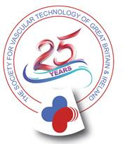
Veronica Sagayarajah

attended the SVT Study Afternoon on EVAR, FEVAR & Contrast imaging

on 22nd November 2017

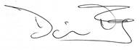Dominic Foy SVT Conference Secretary

