

Certificate of attendance
This is to certify that

Richard Harrison

Attended
The Mersey Vascular meeting
Held on 14th September 2023
at the
Liverpool Medical Institute (LMI)
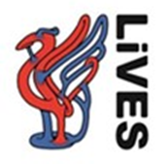

Course Organiser
Mr Simon Neequaye MSc BSc FRCS


Consultant Vascular Endovascular Surgeon

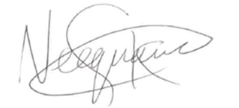
Liverpool University Hospital

