Dear Clare
Thank you for attending The Vascular Societies’ Annual Scientific Meeting 2016. We hope you enjoyed your time and found the conference both educational and enjoyable.
Please see below your certificate of attendance
If you require a certificate covering workshop attendance please do not hesitate to contact us.
Photographs taken during the event are now available to view at:
http://simonparvin.com/f942639714
Password: VS2016
Visitors will need to supply their name and email address.
Kind regards
The Vascular Societies’ Event Team
Fitwise Management Ltd
Tel: 01506 292042
Email: events@fitwise.co.uk

Certificate of Attendance
Certifies to all that
Clare Wakely
attended
The Vascular Societies' Annual Scientific Meeting
Wednesday 31 November - Friday 2 December 2016, Manchester Central
Registration Type
SVT Member - Full Conference
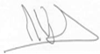 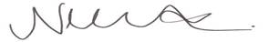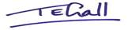
Mike Wyatt, President, The Vascular Society
Nikki Fenwick, President, Society for Vascular Nursing
Tracey Gall, President, Society for Vascular Technology

