A case study of Takayasu arteritis
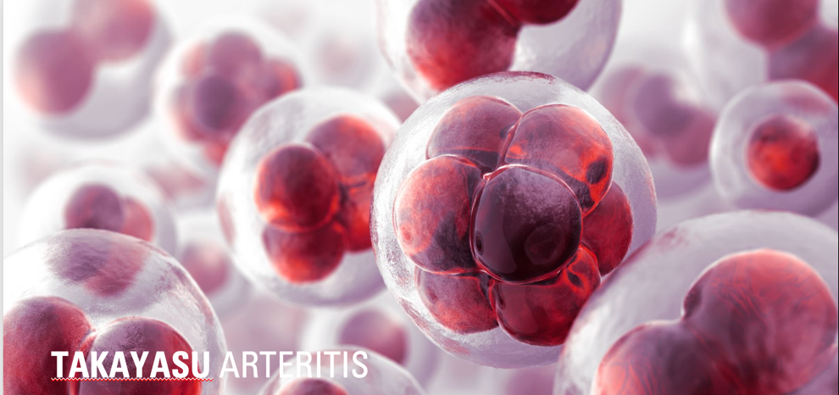

Presenting Symptoms
A 65yr old female, non-smoker, presented to her GP eight weeks post colonic resection for colon cancer, with a two-week history of intermittent left arm pain radiating from the shoulder to the fingertips worsening upon exercise e.g., carrying, lifting with left arm. The patient had no previous history of PAD.
The clinical examination demonstrated normal range of movement and faint Brachial and Radial pulses with a cold left hand.
The patient’s recent blood work showed raised inflammatory markers:
- CRP 77 (Normal range <10mg/L) and ESR 97 mm/hr. (normal range women 0-29 mm/hr.).
The GP referred the patient to the Vascular triage clinic at the John Radcliffe hospital where the patient was assessed by the Specialist Vascular Registrar who in turn referred the patient to the Vascular Studies unit for arterial duplex scan.

Fig 1. Left Axillary artery showed diffuse circumferential lightly echogenic disease causing a severe string like stenosis >90% stenosis (PSVR >6) PSV/EDV = 445/169cm/sec. Stenosis length was approx. 5cm long.
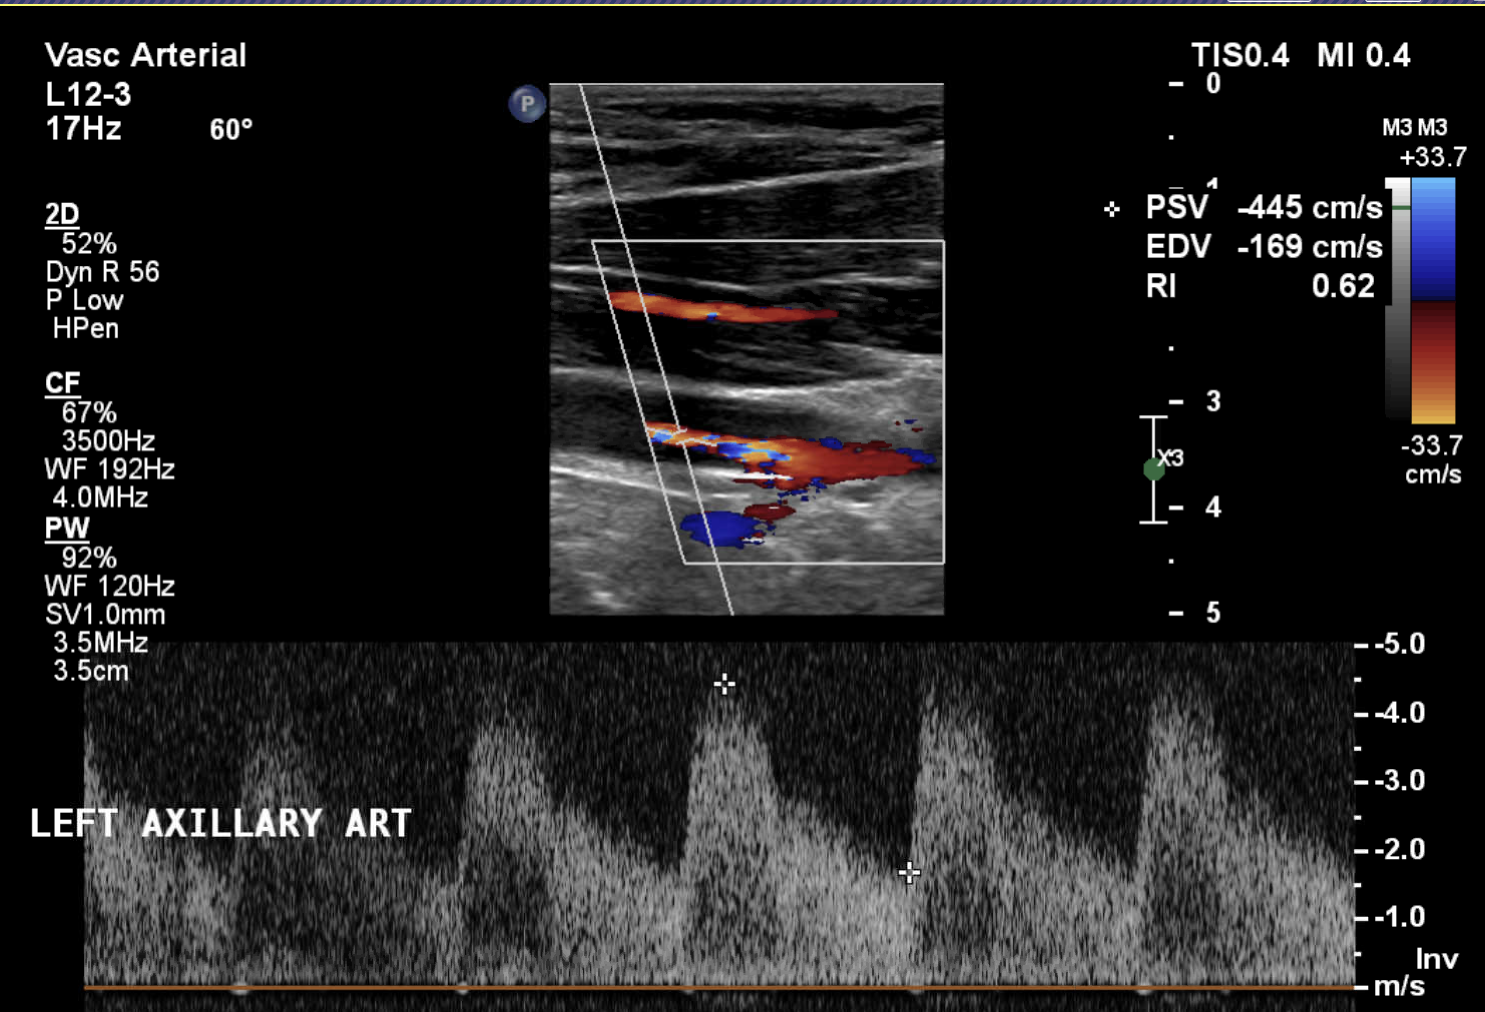
Fig 2. Left Brachial Artery is patent with damped monophasic tardus-parvus waveform – PSV 25cm/sec.
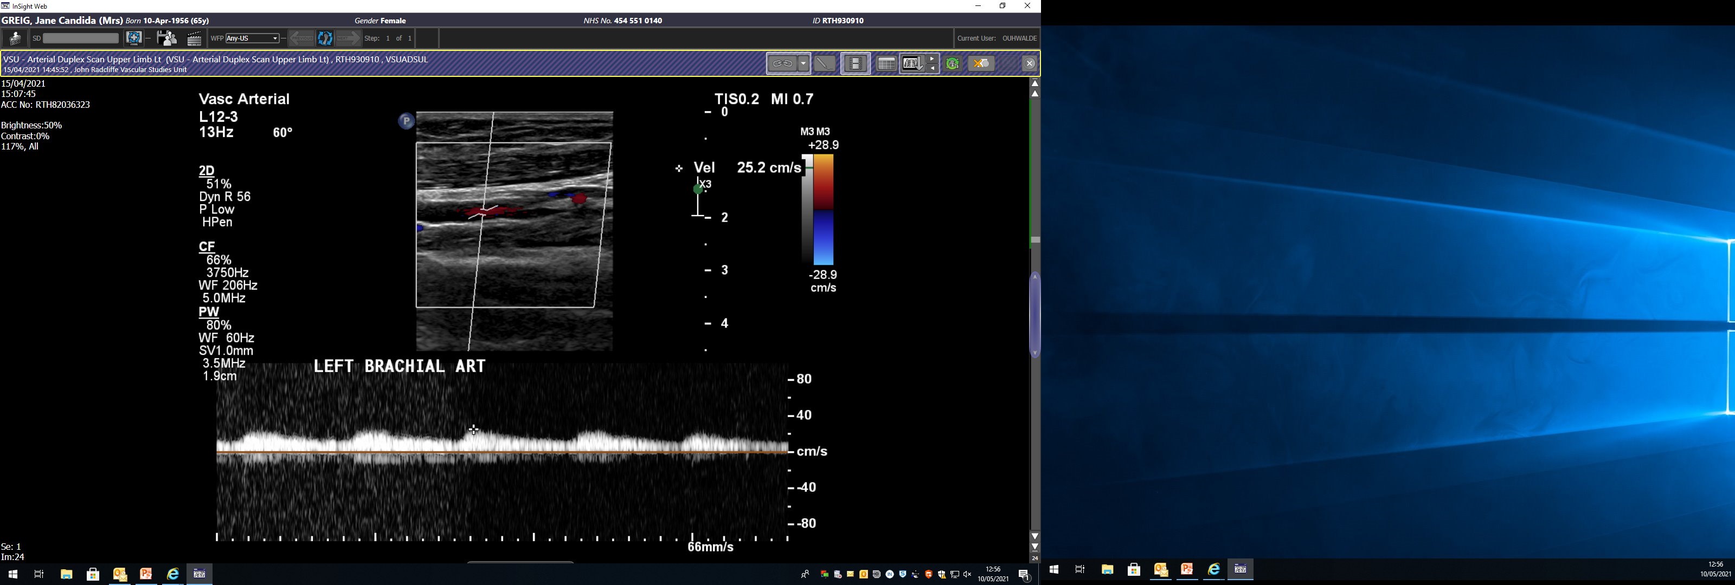

Fig 3. Right Axillary artery shows diffuse light echogenic disease circumferentially narrowing the lumen of the vessel causing a >75% stenosis.
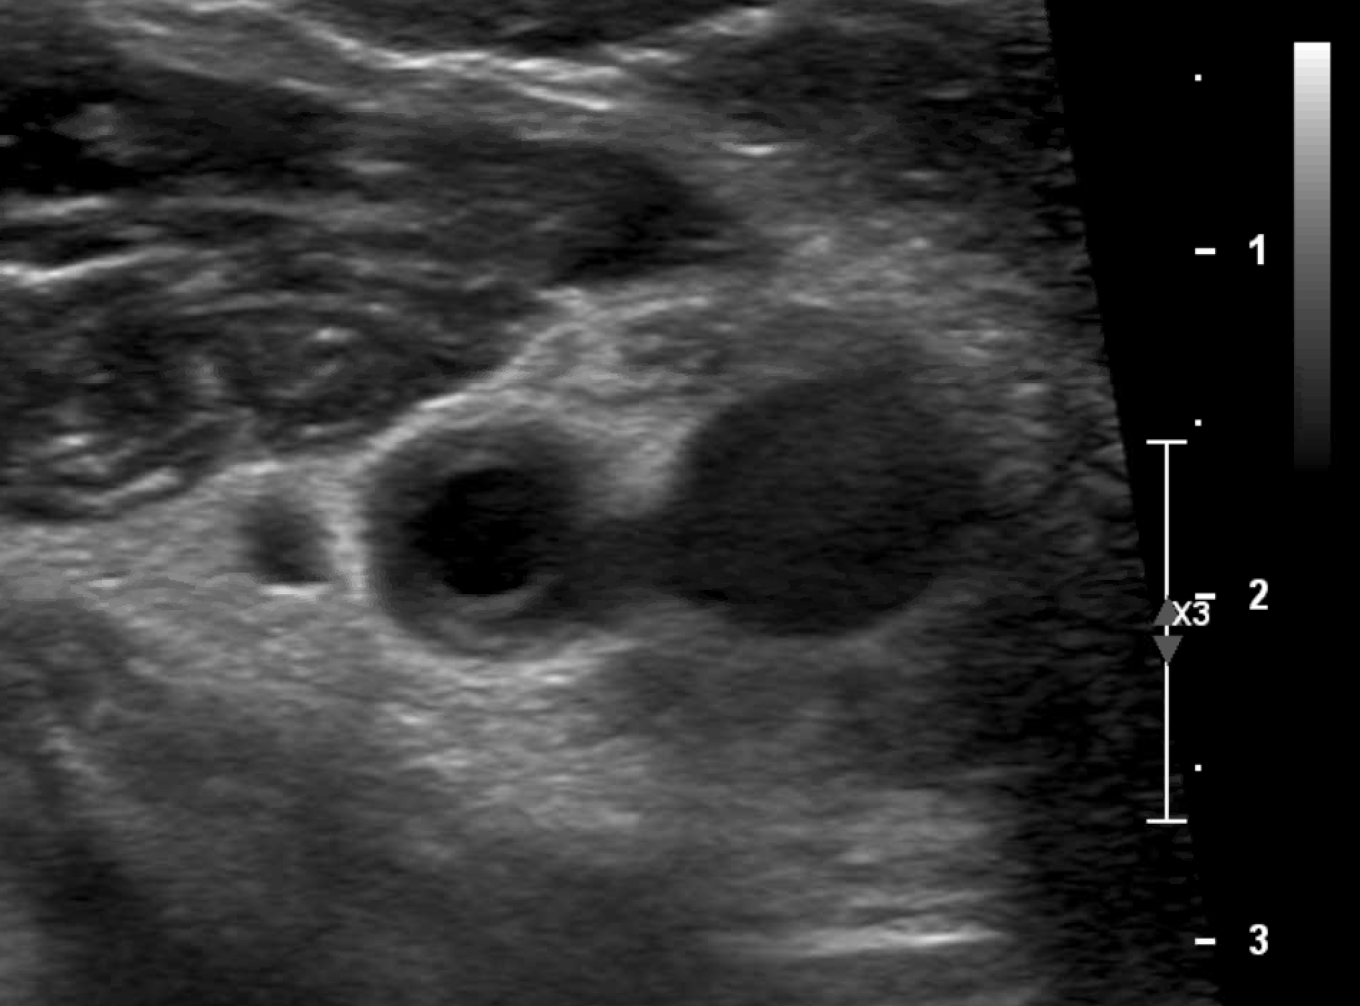
Fig 4. Right Axillary artery shows diffuse light echogenic disease circumferentially narrowing the lumen of the vessel causing a >75% stenosis PSV 3.97m/sec PSVR 5
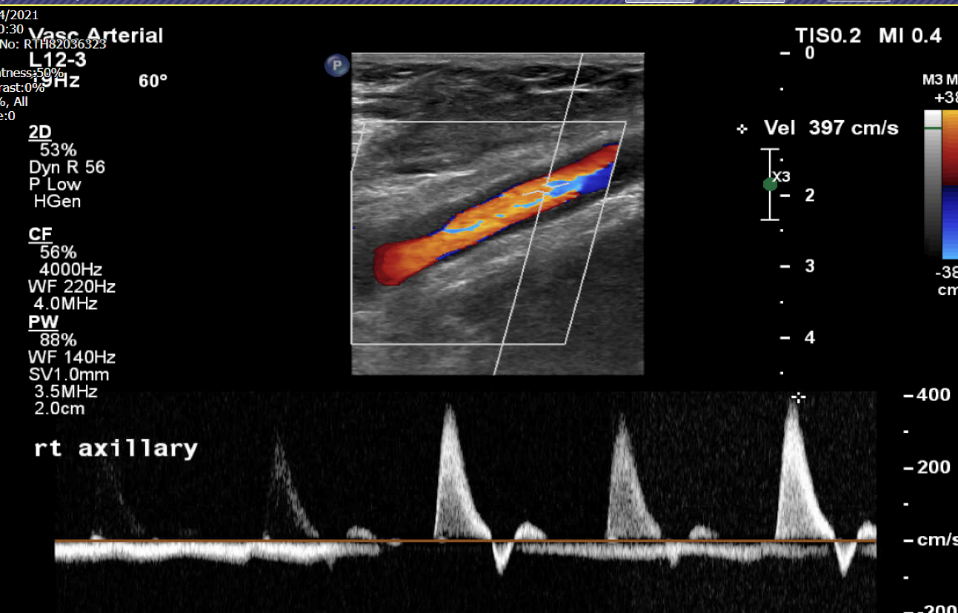
Fig 5. Right Brachial artery flow normalises to triphasic with a good PSV of 126cm/sec. is PSV 3.97m/sec PSVR
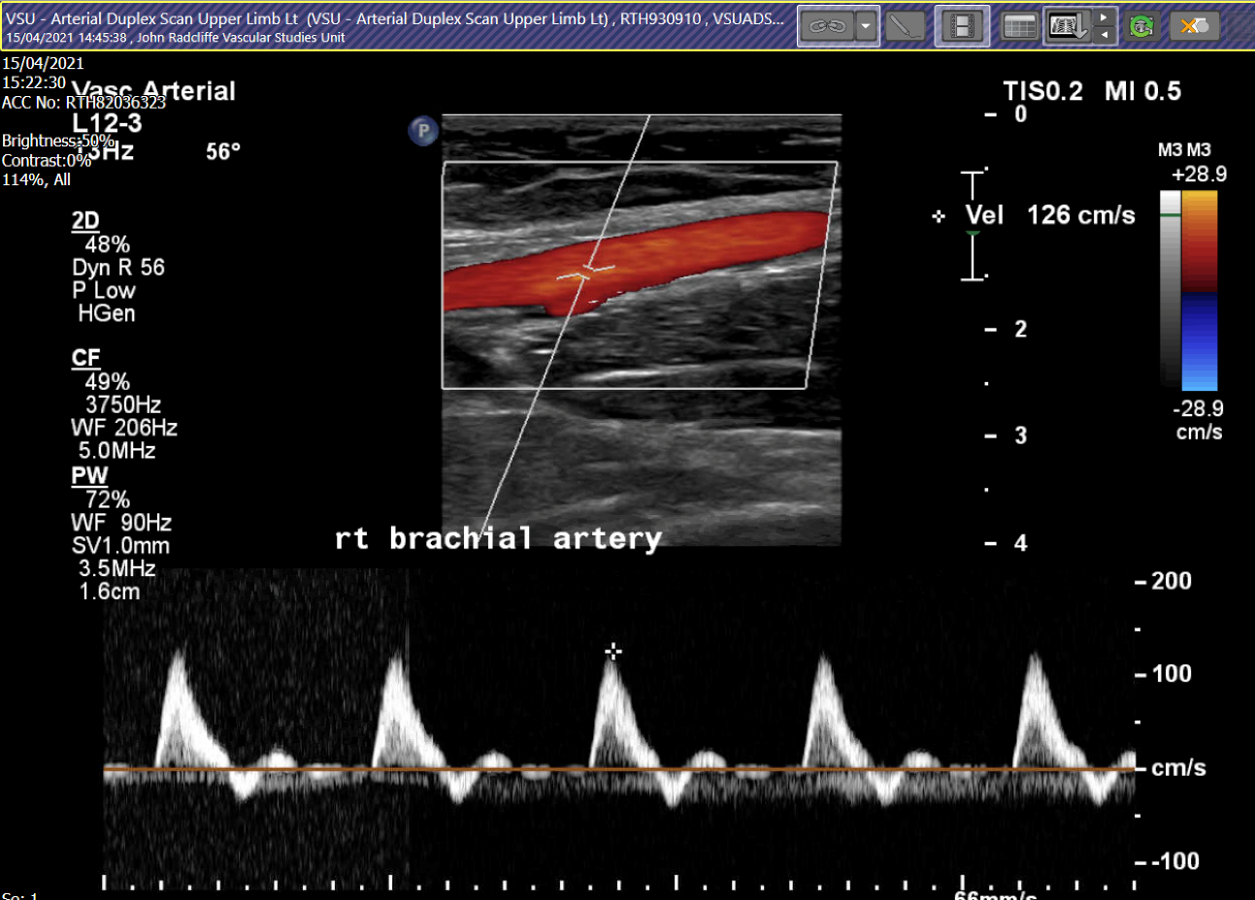
Right Brachial artery Pressure = 146mmHg
Left Brachial artery pressure = 106mmHg
- Brachial pressures deficit between right and left arms = 40mmHg

Giant Cell Arteritis or Takayasu Arteritis:
The American college of Rheumatology (ACR) 1990 classification criteria for vasculitis are used to distinguish between GCA and TAK but recent studies believe these two vasculitides are very similar and could coexist on the same disease spectrum.
Both Takayasu and GCA affect large arteries by the process of granulomatous inflammation. However, the typical initial manifestations of the two diseases are usually different. Patients with GCA present with headaches in the temple region, jaw pain and fatigue with stiffness and pain over the shoulders and can have sudden changes in vision. Patients with GCA are usually older >50 years of age.
Patient with Takayasu arteritis are usually <40years of age and present with arm or leg claudication or chest pain. On clinical examination can be found to have no pulses in the leg or arm. Takayasu arteries more often causes long stenotic lesions resulting in local ischaemia.
The 6 criteria for TAK focuses on large vessel disease of the Aorta and its primary branches and is defined as ‘granulomatous inflammation of aorta and major branches affecting women of childbearing age’.
American college of Rheumatology (ACR) 1990 classification criteria for Takayasu Arteritis:
3 of the 6 criteria need to be present for diagnosis
1. Age at onset of disease – of 40 years or younger
2. Claudication of the extremities
3. Decreased pulsation of one or both Brachial arteries
4. Difference of at least 10mmHg in systolic blood pressure between arms
5. Bruit over one or both Subclavian arteries or Abdominal Aorta
6. Arteriographic narrowing or occlusion of the entire Aorta, its primary branches or large arteries in the upper or lower extremities that is not due to atherosclerosis fibromuscular dysplasia or other causes.
Patients with TAK generally have symmetrical presentation in paired arteries (right and left carotid arteries, right and left Axillary) and contiguous in the Aorta (sharing common border with the aorta)
The patient had CT imaging which demonstrated inflammation of the Abdominal Aorta and iliac arteries as well as the Axillary Arteries. A PET scan was also requested and results showed update of

