
11th August 2023

Witness Statement on behalf of the SHU Clinical Tutor’s Team to confirm:
That Nicola Sutcliffe has undertaken the role of Cardiovascular Clinical Tutor and Associate Lecturer, for the academic year of 2022/2023, at Sheffield Hallam University.
I can confirm that Nicola has taken an active part in the above role on the Healthcare Science, Cardiovascular, Respiratory and Sleep, Level 6 Degree apprenticeship course.
Nicola has provided several teaching sessions at the University campus including an hour-long presentation on vascular disease and Vascular Ultrasound on 22/03/2023.
Nicola has also been a Clinical Tutor, providing verbal support, advice and feedback to students and work-based supervisors, throughout the year.
This role has also included writing and marking student assignments and marking and providing written feedback in students’ Cardiovascular clinical portfolios.

Yours sincerely,
(On behalf of the SHU CVRS Clinical Tutors Team),

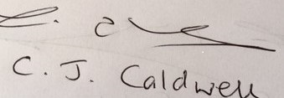

(Carole) Jane Caldwell

Part time Associate Lecturer/
Clinical Tutor for Respiratory & Sleep
Department of Biomedical Sciences & Pharmacology
Sheffield Hallam University

Ex NHS Clinical Service Manager
ARTP Lifetime Achievement Award 2011
Chief Scientific Officer’s Lifetime Achievement Award winner 2021

