Pathway of Vascular U/S referrals

- IP that are suspected ischemic and urgent are to be seen by vascular team first to be determined if vascular U/S needs to be done ASAP.

- IP that are non-urgent and non-ischemic with leg swelling,? Palpation of foot pulses
To Perform ABPI or to exclude asymptomatic vascular disease and need U/S scan are to be referred to Radiology for scan at earliest convenience do not need vascular review.

- Non urgent IP/OP clinical vascular referrals are seen by vascular consultants in clinic and/or on wards will come to us as OP referral and appointments given.

- If demand is too high against capacity then Radiologists will support the Vascular sonographers in prioritising workload.

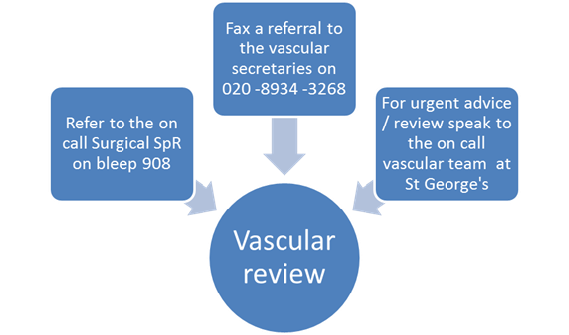

Golnaz Morshedian Lead Vascular Sonographer
Dawn Warrington Clinical Lead Sonographer
Jim Weir Radiology Manager
Vin Majuran Clinical Director Radiology
Sudip Ray Consultant Vascular Surgeon
December 2016

