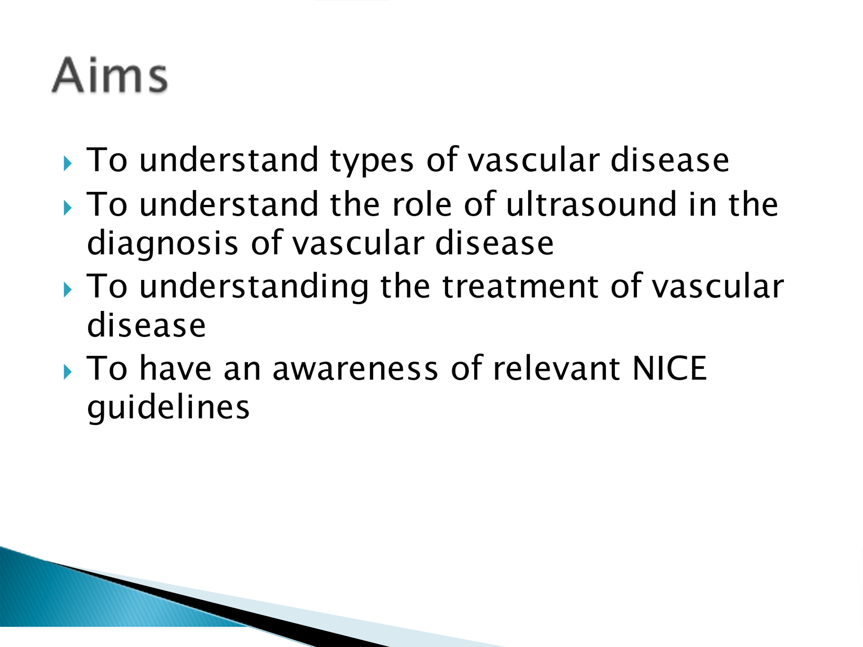

LO 3 indicative content includes:

- Diseases of the vascular system
- Ultrasound and physiological measurement systems in evaluation of vascular disease
- Investigations and procedures carried out in the investigation of vascular disease

Evidence of lecture provided to level 4 BSc Cardiovascular, Respiratory and Sleep students at Sheffield Hallam University 23/03/2022.

Aims slide and learning outcome indicative content.

