Vascular Science STP Clinical Scientist Training
Meeting – 6th March 11-15 - 1215
Dumfries and Galloway Vascular Science Department
(Richard’s office, Radiology – Admin Block)
Richard Cannon D&G richardcannon@nhs.net
Joseph Sanianathan D&G josephsathianathan@nhs.net
Claire Tarbert GGC ctarbert@nhs.net
Sarah Jane Carmichael Lothian sarahjane.carmichael@nhslothian.scot.nhs.uk By TEL CON

Caroline Fattah D&G trainee STP 1 caroline.fattah@nhs.net
Lisa Robertson Lothian trainee STP 2 Lisa.Robertson@nhslothian.scot.nhs.uk
Emma Keegan GGC trainee STP 1 emz.keegan@sky.com

Rob Farley NES Healthcare Science Programme Director Robert.farley@nes.scot.nhs.uk
Duncan Macfarlane NES Specialty Lead, Clinical Physiology Duncan.macfarlane@nes.scot.nhs.uk

- Introductions
- Update on postgraduate quality monitoring role by NES Healthcare Science
- UK review of STP training in Scotland and indicative outcome of recent review (1-3-17).
- Training plans
- OLAT consistency
- Study time (spot check)
- Research project… readiness
- Training needs proportional to service provision
- Training supervisor contact with HEI; link between workplace and academic development
- AOB

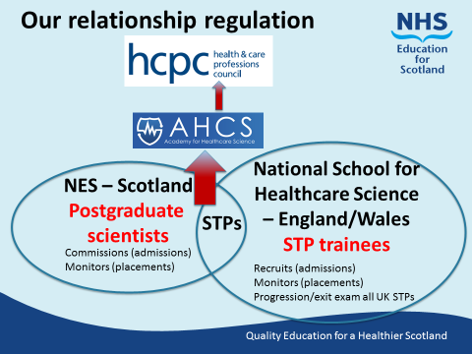

12-30: Scottish Government Healthcare Science engagement with D & G staff. Commences with lunch at 1230 and 1300 Lecture theatre presentations. Colleagues welcome.

