VASCULAR SOCIETYS’ ANNUAL SCIENTIFIC MEETING – DUBLIN 2023

Advanced skills workshop

EVAR endoleak imaging (Prof. Ciaran McDonnell, Mater Misericordiae University Hospital Dublin)

Proposed that all questions needing to be addressed as par of EVAR surveillance can be answered using duplex rather than CT: normal sac? Is flow successfully excluded from the aneurysm sac? Is distal flow ok? Any stent kinking/stenosis?

At his centre, duplex is used as a first line surveillance tool over CT. More type II endoleaks were picked up on duplex.

EVAR endoleak imaging using 2D duplex and 2D CEUS (Louis Bowen, IVS)

Indication for CEUS (IVS, Manchester):
- >5mm increase in a 6 month period with or without endoleak
- New endoleak not previous seen on duplex or CT (of any type)
- Unsuitable for CT due to poor renal function
- CT unable to classify endoleak type
- Stent migration or kinking seen on AXR
Measurements taken and information reported:
- Neck size (LS)
- Sac diameter (both inner and outer wall measurements)
- Waveforms in limbs
- EIA flow
- Assess for endoleak
Waveform analysis of endoleak flow can indicate whether there is an entry and exit point (unidirectional flow) or flow going in and out of the sac at the same point (bidirectional flow).
*Should we assess whether a CEUS service is something the vascular consultants would like us to implement at Derriford within the VAU?

Pedal vessel imaging (Ben Freedman)
Use of a hockey stick prob can aid assessment of pedal vessels both due to its shape and frequency. This has helped identify sites for distal bypass graft landing, in centres where pedal bypasses are performed. Distal angioplasty is also increasingly being performed, and duplex pedal vessel assessment can identify target lesions.
*Should we discuss with the vascular consultants whether more detailed pedal vessel assessments would be of use to them?

Diagrams from: Sommerset J, Teso D, Karmy-Jones R, Vea Y, Feliciano B. Pedal Flow Hemodynamics in Patients With Chronic Limb-Threatening Ischemia. Journal for Vascular Ultrasound. 2020;44(1):14-20. doi:10.1177/1544316719894412

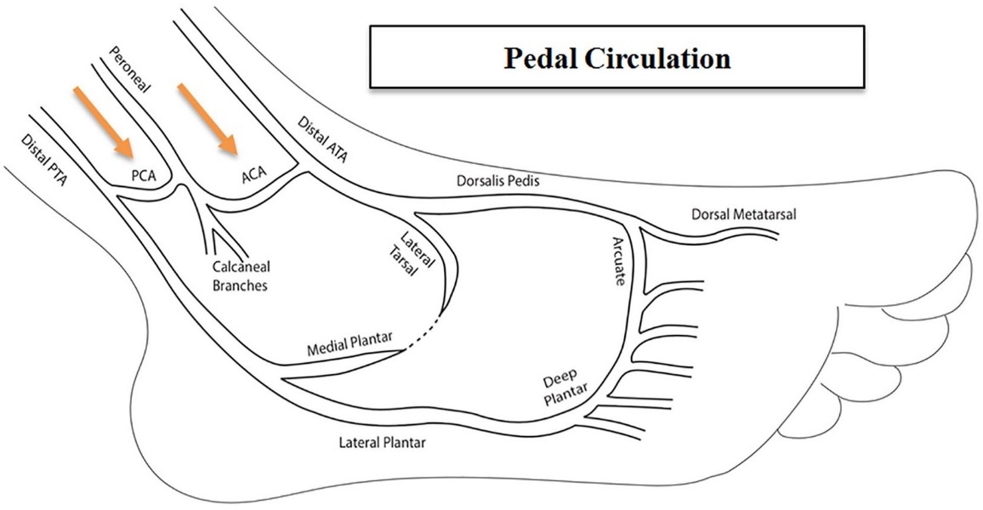

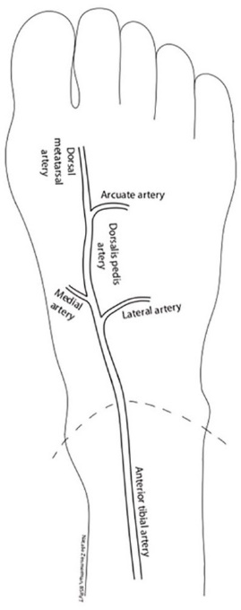
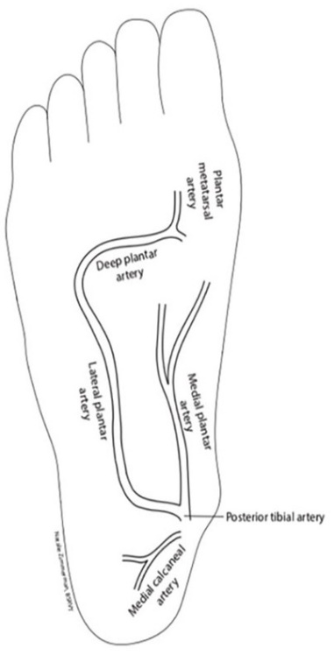

Carotid Imaging
UK and Ireland Stenosis Grading Audit
An audit aimed at summarising current UK and Ireland practices in grading carotid artery stenoses. 72 UK trusts and 8 in Ireland were invited to complete an online questionnaire based on their carotid grading criteria and practices – 58% of centres completed the survey.
Found that 70% follow the UK guidelines published in 2009, 22% follow some of the guidance.
No consensus on what criteria should be prioritised for grading.
For PSV and PSV ratios:
- <50% stenosis: 81%use <125cm/s, 74% use <2
- >50% stenosis: 81% use >125cm/s, 71% use >2-4
- >70% stenosis: 90% use >230cm/s, 86% use >4
- >90% stenosis: 76% use >400cm/s, 67% use >5
The greatest number of different velocity threshold was for grading >80% stenosis (13 separate thresholds were reported)
EDV is also used additionally to grade stenoses in some centres.
78% use St Marys ratio to grade in deciles
ECST as a reference standard is not commonly used – ECST calliper measurements are used by some centres to grade plaque within large carotid bulbs.

Advances in AI to assess carotid disease (Mr Dominic Howard, Oxford University Hospitals)
A pilot study using ultrasound and AI to assess plaque composition to identify whether it is vulnerable or stable. Images of carotid plaque were sent to an AI company allowing the AI to be trained, followed by cross validation producing test data (to assess AI accuracy).
AI was found to be accurate in identifying symptomatic plaque, but not for asymptomatic plaque. With further development, this could be used as part of a stroke risk assessment and inform clinical decision making.
Issues with AI:
- It doesn’t have the same abstract understanding of the world that the human mind has.
- We don’t understand how AI has come up with its answers.

Advances in 3D-ultrasound artificial intelligence to assess carotid disease (Steven Rogers, MAVRIC)
Patients with symptoms associated with carotid disease (CAD) and PAD have the same high risk of major adverse cardiovascular events (MACE) as with ischaemic heart disease. All MACE are known to be associated with CAD.
Proposed that early detection by screening could reduce the frequency and cost of MACE, as the long-term effects of atherosclerosis are largely preventable. Screening with 2D ultrasound is unlikely to be cost effective at population level due to the requirement for skilled staff. However, the use of AI alongside tomographic 3D ultrasound can quickly detect asymptomatic CAD in a cheaper, more effective way.
AI can automatically measure the carotid disease in terms of its volume, morphology and fluid-tissue interaction to identify which people are at high-risk of MACE, so physicians can put in place early interventions. The goal is for prediction and prevention.

Identification of the ‘at risk’ carotid plaque (Prof. Ciaran McDonnell, Mater Misericordiae University Hospital Dublin)
PET CT and MRI can show metabolically active plaque which associated with increased stroke risk. However, these modalities are time-consuming, expensive, involve radiation exposure (CT) and have contraindications (MRI). CEUS can instead be used to assess plaque; this can demonstrate neovascularisation within the plaque which is associated with embolic events.

Joint Symposium – The Ideal Amputation/Amputee
Gained perspectives from different healthcare professionals and a representative from an amputee charity into their role in supporting individuals pre and post amputation. Hearing about the Steel Bones charity was particularly interesting; they provide support to amputees and their families.

Scientific & Case Study Abstract Presentations
Case Study: acquired arterio-venous fistula following deep vein thrombosis (Rahul Rai, Portsmouth University Hospital)
A 78 male presented with left leg swelling and a previous history of left ileo-femoral DVT 12 months prior. Duplex demonstrated chronic occlusive thrombus in the popliteal and distal SFV, and partial thrombus extending from the proximal SFV into the EIV. The waveform within the patent channel showed pulsatile arterialised flow, consistent with an AV fistula. A connection between the proximal CFV and SFJ was demonstrated, however, there was no history of vascular access via the groin. This could be treated be venous stenting, although conservative management was chosen in this case.
A literature review revealed three documented cases of acquired AVF following DVT with similar presentations. The pathogenesis remains unclear, however, factors such as venous hypertension, hypoxia, shear stress, inflammation, angiogenesis and neovascularisation are thought to contribute to acquired AVF formation. These factors could occur as a result of increased expression of VEGF (vascular endothelial growth factor) in patients with DVT, which is upregulated in patients with DVT (occurs in hypoxic conditions). VEGF promotes angiogenesis and upregulates tissue factor (stimulates the coagulation cascade)

Crural-to-crural/pedal bypasses: a reasonable alternative in challenging cases and times (Yasmeen Gouda, Kings College Hospital)
An assessment of outcomes of using crural vessels as inflow for crural and pedal bypasses. A retrospective analysis of all patients who underwent crural-crural/pedal bypasses between 2015-2022, assessing 30-day mortality, limb salvage and graft patency rates as primary end points.
41 cases presented with critical limb ischaemia, with a mean age of 66 (range 40-87). The incidence of diabetes was 90%, CKD 39% and IHD 50%. Immediately following bypass, 2 needed angioplasty to the plantar arch resulting in ruptured anastomosis, and 1 had a failed bypass attempt due to occluded run-off; all of these were excluded. 12 cases were performed under local anaesthetic (high risk for GA).
The 30 day mortality was 0% and limb salvage was 100%. Primary and secondary patency rates at 1 year were 57% and 83%.
This study shows that crural-crural/pedal bypass is a feasible and reliable option in selected patients. Medium term results showed a good outcome with good patency and high limb salvage rates.

Creating and delivering a scientist and nurse-led supervised exercise programme at St George’s hospital (Rhodri Furlong, St Georges)
Presented the planning, considerations, and experiences of delivering a supervised exercise programme (SEP) for claudicants.
New pilot service within the trust with only one group of 10 patient completed the programme so far, but early data suggests that it has been beneficial for patients.
Proposed that a national framework/toolkit for creating and delivering a SEP would be beneficial.

An unusual case of ultrasound-proven occipital GCA: disproving the misnomer of temporal arteritis (Angie White, Royal Berkshire Hospital)
Case study of a patient who presented with occipital pain and ‘lumpiness’ in this region, with corresponding ultrasound showing a halo of the occipital arteries as well as the temporal arteries and their branches (but more significant in the occipital arteries).
Proposed that the occipital arteries should be included in the imaging for all patients presenting with occipital pain. Also proposed that that GCA is a more appropriate term than TA, as other vessels can be involved – not just the temporal arteries.

A local evaluation of the fistula intervention timeline (Jeny Anton, Kings)
A local service evaluation to establish waiting times between identifying significant stenosis or thrombus on duplex scan to intervention. This was a retrospective analysis of all patients with a red-coded duplex report in 2022.
293 red-coded reports identified:
- 69% of which received an intervention with the average waiting time being 27.7 days.
- 3% received an intervention on the same day as the red-coded report.
- 31% didn’t receive any intervention for various reason (unsuitability for any intervention, still had reasonable volume flow, or fistula occluded before elective surgery
- 16% of patients with no intervention progressed to a thrombosed fistula
Reducing the time between identification of stenosis and treatment might reduce the number of thrombosed fistulas.
Reports are colour coded:
- Green – no problem
- Amber – moderate stenosis but flow remains good
- Red – urgent finding (eg. poor flow below 600ml/min, occlusion, significant stenosis)
*Would a similar system be beneficial at Derriford?
Service evaluation of an ultrasound service for renal artery stenosis (Alexandra Croucher, Kings)
There is an anecdotal low positive finding rate for renal artery stenosis (RAS) and an even lower intervention rate (medical management over intervention in the majority of patients is supported by randomised control trials STAR, ASTRAL and CORAL: ). A service evaluation was therefore performed with the aim of improving referral criteria for renal artery (RA) duplex scans.
All RA duplex scans performed in 2022 were retrospectively reviewed and analysed by outcome and referrer speciality. Positive findings were defined by a maximum PSV of >180cm/s and/or damped intrarenal waveforms.
Out of 930 scans, 651 were negative for RAS, 45 could not assess for RAS due to poor views, 190 found no severe stenosis but could not excluded moderate stenosis, and 42 were positive – of these, only 2 had angioplasty (0.2% of total scanned).
Referral criteria developed in collaboration with renal medicine to achieve more efficient use of time and resources.
- Severe resistant hypertension with clinical suspicion of FMD (female to male ratio of FMD is 9:1)
- Flash pulmonary oedema with clinical suspicion of RAS
- Clinical suspicion of RAS in a single kidney with progressive CKD/refractory hypertension
- Clinical suspicion of renal vein thrombosis
- Suspicion of high grade RAS in leading AKI to progressive CKD (normally would be suggested by supportive evidence eg. asymmetric or single kidney or extensive vascular disease)
Not suitable indications for referral:
- Chronic kidney disease
- Acute kidney injury
- Nephrotic syndrome
- New onset or essential/primary hypertension

Is BlueDop an accurate screening tool for determining the presence of peripheral arterial disease? (Jake Lantry & Prof. Mary-Paula Colgan, St James’s Hospital Dublin)
The aim of the study was to compare ABPI measurement using BlueDop and Falcon-Pro (automated vascular diagnostic system).
142 patients were studied. Calcified vessels were excluded from analysis, leaving 225 limbs for comparison. The higher of the two measurements was compared for each leg and defined as either normal or abnormal.
The study found a sensitivity of 89% and a specificity of 72% for BlueDop with a positive predictive value of 63% and a negative predictive value of 93%. Overall accuracy was 78%. They proposed that this supports the role of BlueDop as a screening tool.
Limitations of BlueDop:
- Oedema
- Calcification
- Movement
- Bulky probe
- Poor classification of mild disease
The study didn’t compare BlueDop with conventional ABPI, just an automated system.
One of the benefits of BlueDop is the cuffless system, particularly when assessing patients with leg ulcers. However NICE guidelines state https://www.nice.org.uk/guidance/dg52 :
‘There is not enough evidence to recommend routine adoption of automated ankle brachial pressure index (ABPI) measurement devices to detect peripheral arterial disease in people with leg ulcers. They should only be used in the context of research for these people’

The Great Debate – should vascular scientists adopt advanced/extended practice?
For: Prof Torella and Steve Wallace – Liverpool University Hospitals
- Create opportunities for your profession.
- Diversifies the workforce and keeps professional brains alive.
- Gives rise to non-clinical activities, thereby reducing RKI risk and clinical burnout risk.
- Can choose direction, research vs advanced clinical practice.
- Helps shape the future of vascular surgical care.
Against: Mr Juszczak and Katy Bloom – University Hospitals Birmingham
- What direction and why?
- Your gain at someone else’s loss. Who takes on the things you must drop in order to develop extended practice?
- Accountability. Become liable.
- Expect higher pay? From what budget?

SVT AGM
- Kamran Modaresi takes over the role of president from Emma Waldegrave, with Steve Rogers becoming the vice president.
- The name of the society is changing to the Society and College of Vascular Science
- The research committee is developing a research module which has been mapped for equivalence to the STP syllabus. This will become compulsory for new AVS trainees planning to do their practical after 30th November 2024.
- SVT are engaged in a ‘recognition of prior learning’ application with the AHCS for the AVS certificate. This should streamline the equivalence process.

