Understanding Multigenerational Teams: How to be Flexible and Thrive
Steve Butler, “The Age Diversity Challenge”
- Example of Joanna and John. Controversial worker versus conventional.
- Need to actively manage teams and deeply understand their emotions. Change in management style compared to previously where it was “do as I say”.
- Analogue generation versus digital generation – Single biggest impact on a workforce (generation that grew up with the internet versus those that didn’t).
- Flexible working is the only way to reduce age and gender gaps.
- Flexible working should be “reason neutral” – Should work for the team as a whole but shouldn’t have to come with a reason for it. Do not shoehorn existing job into a different structure e.g. working a full time job in three days – not possible.

Different generations that now have to work together:
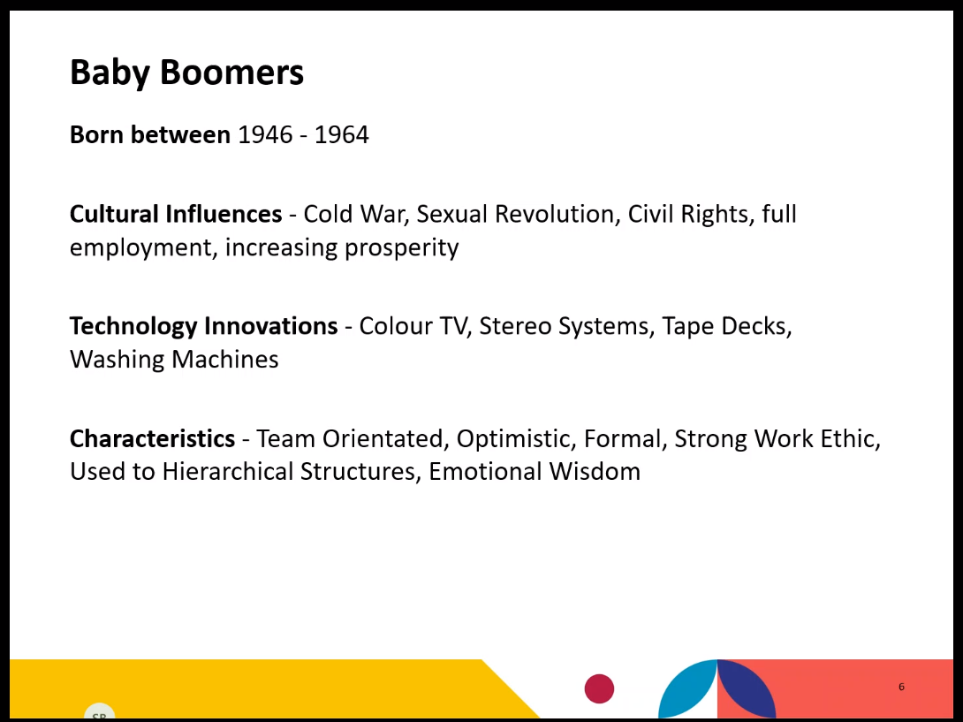

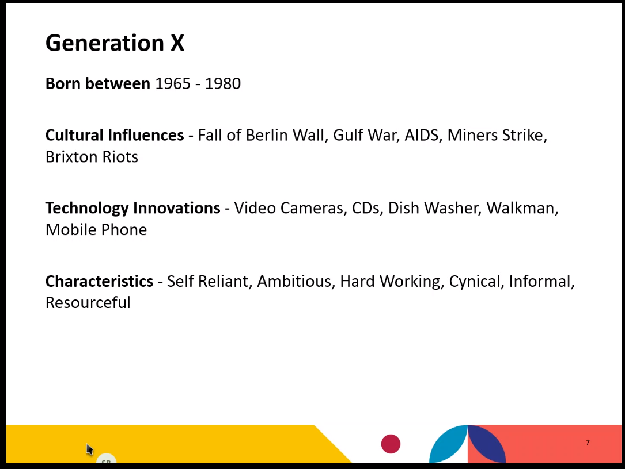
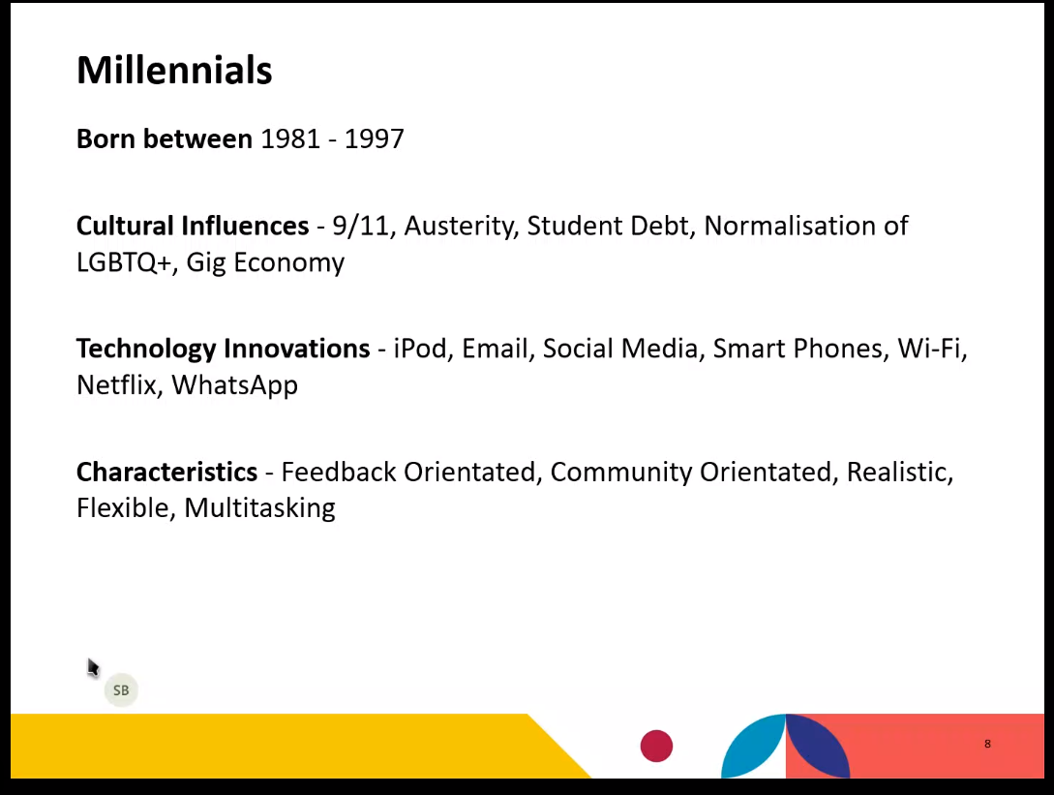

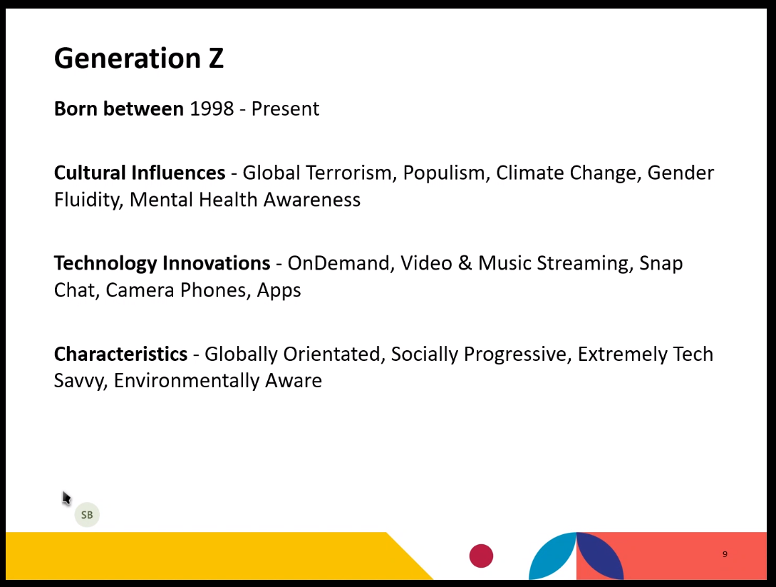

Emily Andrews, Centre for Ageing Better
- 1 in 3 workers aged 50+. 1 in 4 workers surveyed believed they wouldn’t be able to do their job when they are 60.
- Job ads that are age friendly for older people encourage older people to apply for jobs but do not put off younger people from applying. Not true the other way round.
- Five things needed for age friendly working:–
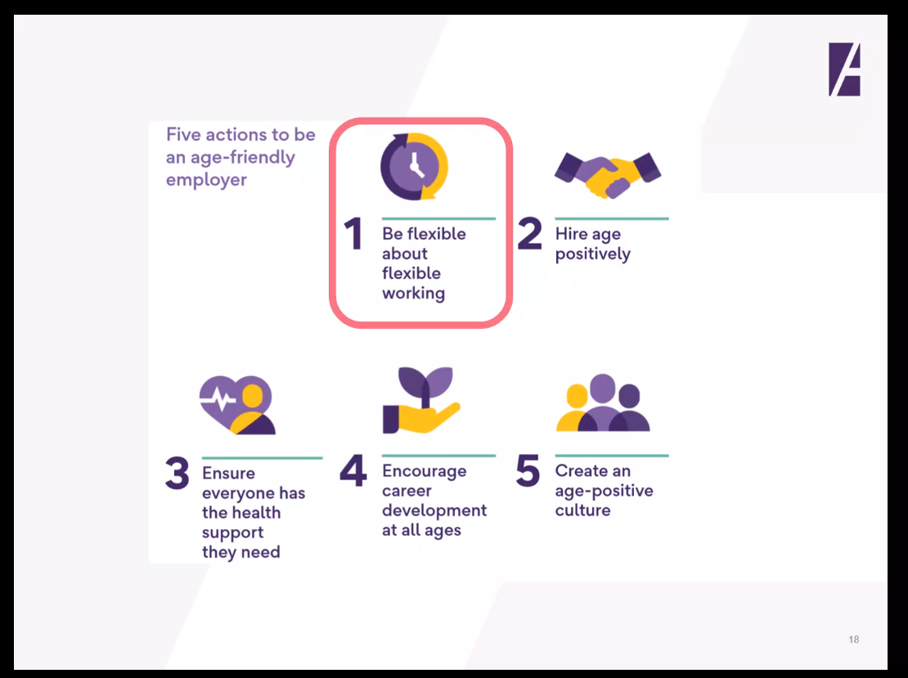

Becci Newton, “Employing the multigenerational workforce”
- Need for action across recruitment and retention.
- Professional development approaches needed to enhance communication across generations.
- Mobilising, maximizing, maintaining – Supporting changes to workers e.g. changes to health.
- The terms for different generations should be used with caution as can come with some negative connotations e.g. millennials and gen z known as the snowflake generation.

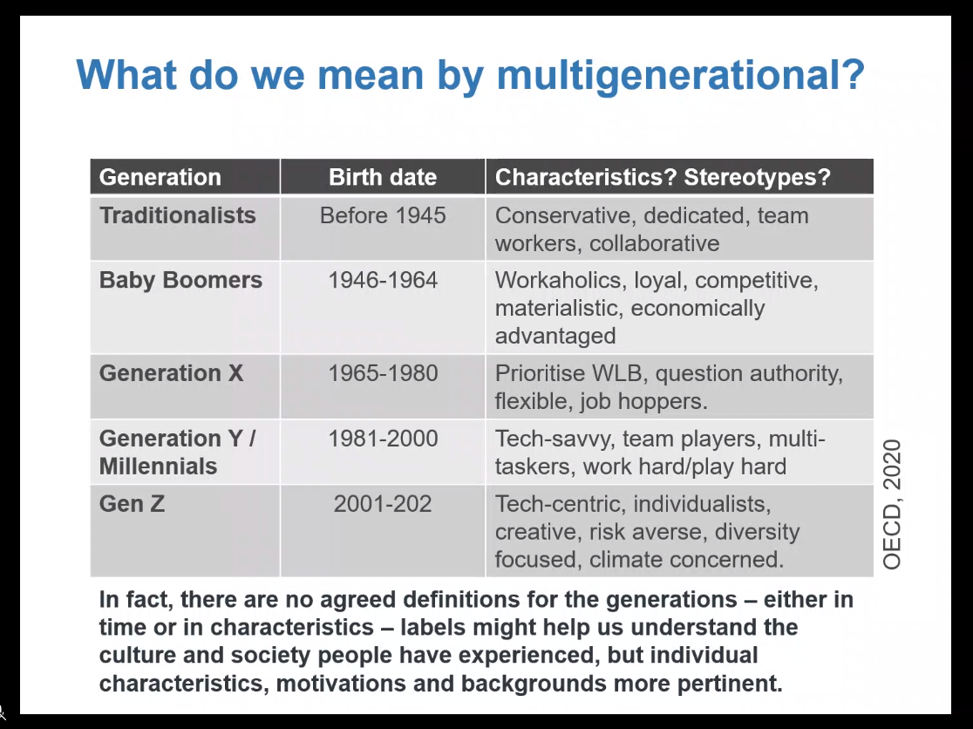

Laura Hipple, “View from the Frontline, a clinicians perspective”
- Job does become harder as you get older, problems compounded due to being female and having family.
- Previously working 120 hour weeks, and asked in interviews how you would cope if you got married and had children.
- Now an SAS doctor, more flexible and adaptable for her needs.

Charlene Presseley, “Early Career Registered Nurses”
- Taking knowledge of how different generations behave differently to retain registered nurses.
- Different career needs, motivations and challenges – Need to meet all of these for all workers.
- Younger nurses make a decision to move and when they do, they move very quickly. Need to be ready for this.
- Mentorship and coaching – Found that immediately identifying and meeting new nurse’s needs, they will stay. Mentoring opens these conversations.
- Simple and easy – Asking someone what they want. Applies to all generations.
- What jelly baby are you? Starts a career conversation and shows how much support someone needs:
