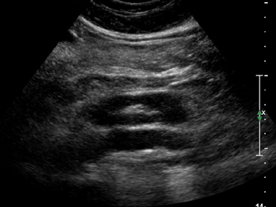

Ultrasound Image of a Horseshoe kidney in longitudinal plane

