UPPER LIMB STUDY DAY JUNE ‘23
1. ULTRASOUND ASSESSMENT OF ARTERIAL THORACIC OUTLET SYNDROME – Dr Matt Bartlett
Anatomy Notes
High origin of radial artery c. 9.2%
Conventionally, ulnar artery is continuation of brachial artery with the radial artery as a branch vessel.
Cervical rib in <1% of population.
Prevalence
8% symptomatic TOS.
>90% neurogenic (typically very rapid onset with typical neurogenic symptoms, numbness of ulnar distribution of hand).
Arterial TOS <1%.
Testing and Imaging
The speaker appears not to routinely image the vessels during manoeuvres, relying on use of distal CW (brachial, radial) during provocation testing. Reasons given: difficulty of maintaining position, lack of reference sites for velocity ratios, not required as test is only is/isn’t significant arterial compression occurring.
Costoclavicular/Roo’s Test:
- Produces symptoms in normal individuals due to unnatural positioning.
- Therefore, high false positive.
- Purpose – to stretch anterior and middle scalene muscles.
Adson’s:
- High false +ve rate.
- Assessing for anterior scalene compression.
The speaker’s procedure is test what the patient indicates causes the symptoms, only then proceeding on to the standard manoeuvres. Repeat with contralateral arm if there is compression, particularly if the contralateral arm is asymptomatic. By implication, if compression demonstrated in both, but only one symptomatic, is arterial compression the cause of the symptoms?
Report symptoms and what brought on the symptoms, significant evidence of arterial TOS if demonstrated.
Reflection
Frankly bonkers not to image the site of compression. Yes, the peak narrowing might be hidden by the clavicle, but stenotic jetting/high velocities achievable, and on occasion the site of compression is not at subclavian level but at proximal-to-mid axillary artery, giving the surgeon more hints as to the likely cause.
Reference velocities are easily achievable at the site of compression when the vessel is not under compression (with the proviso that hyperaemia sets in after limb loading, so be quick with measurements). Also, provided no major branches come off/supply in before the steady state distal velocity is achieved a distal velocity will give a ball-park PSVR.
Otherwise, sensible advice re. the conventional manoeuvres and the necessity to take a good history and find out what provokes symptoms.
2. THORACIC OUTLET SYNDROME – Mr Arun Pherwani
Talk from surgical perspective including a detailed physical assessment. The surgeon does not work in a centre with a dedicated vascular studies unit with Vascular Scientists and therefore his practice is heavily reliant on conventional radiology assessment.
In order of TOS prevalence:
- Compression of brachial plexus
- Compression of ulnar nerve
- Venous TOS
- Arterial TOS
In Mr Pherwani’s practice, equal prevalence of venous and arterial TOS, but the majority are neurological.
Awareness that compression can result from the tip of coracoid process and pectoralis minor muscle rather than classic TOS picture.
Generally poor data sets due to rarity of condition.
Anatomy
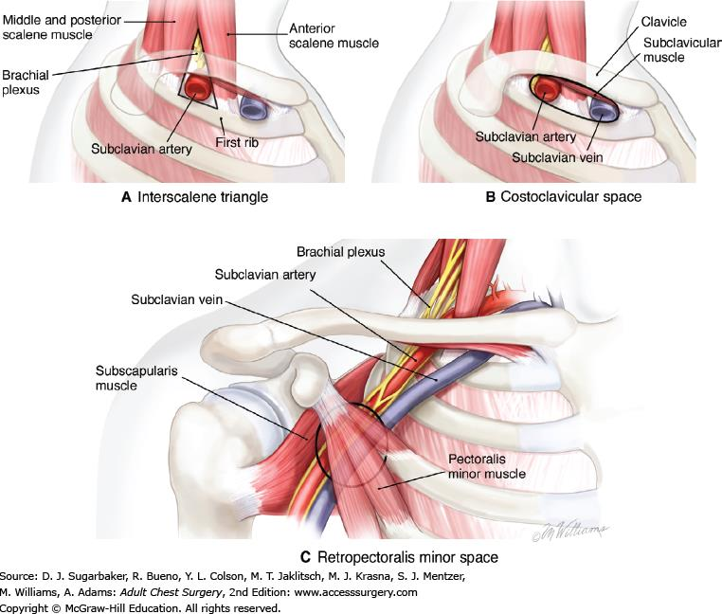

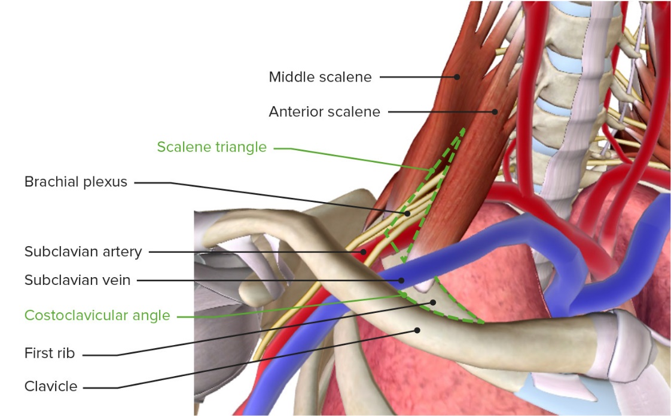

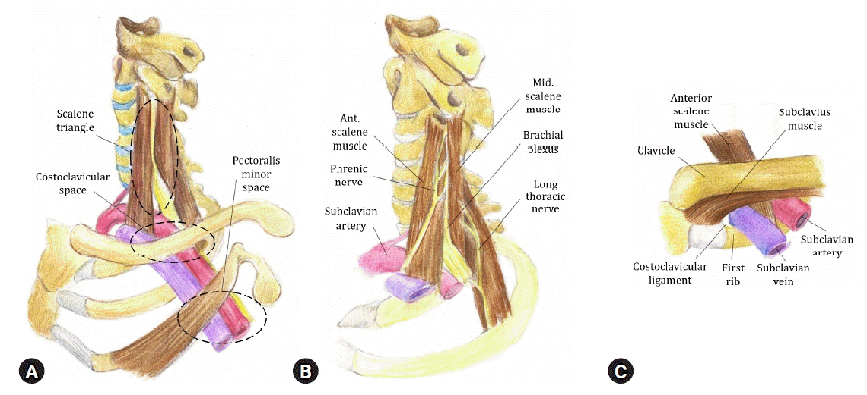
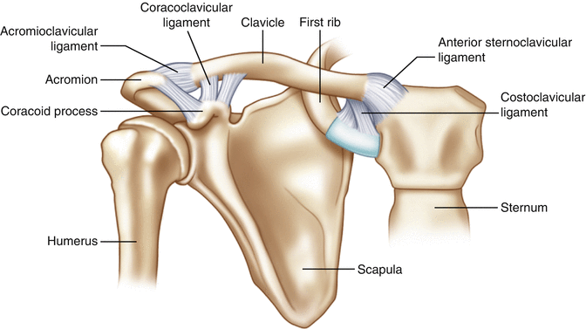
Roo’s Test
Arms in ‘surrender’ position with 3 minutes of hand clenches.
Adson’s Test
Purpose: to tension the scalene muscles and provide an opposing compression surface via the inflated lung.
Imaging
Plain film X-ray of the thoracic outlet.
MRI in neutral and hyper-abducted positions.
Clinical History and Examination
Features to assess:
- Subclavian fullness.
- Neck mobility.
- Muscle wasting of shoulder and trapezius.
- Shoulder power and grip strength.
- Shoulder masses.
- Pulses, bruits, differential brachial pressures.
- Roo’s and Adson’s tests.
- Bilateral examination.
Treatment
Surgical treatment: removal of first rib, resection of scalene muscles. Endovascular interventions with stents (either artery or vein) to be avoided due to mobility of region of interest – stent crushing occurs.
Complications
13% recurrence at 5 years.
10% post-surgical complication rate.
Complications included:
- Damage to long thoracic nerve (producing dropped pectoral muscles, winging scapula).
- Damage to brachial plexus.
- Damage to sympathetic chain (Horner’s syndrome; drooping eyelid, constricted pupil and reduced facial sweating on the ipsilateral side).
- Haemothorax (into pleural space).
- Pneumothorax.
- Phrenic nerve injury (potential paralysis of the diaphragm).
- Pleural effusion (fluid build up between the layers of the pleura).
- Lymphatic leakage into the surgical space.
- Re-occlusion of the vein.
Reflection
Greatly increased my knowledge of the anatomy of the thoracic outlet. Focus on standardised provocation manoeuvres to differentiate between triggering mechanisms. Unfortunate lack of confidence/experience with ultrasound testing of the thoracic outlet, but understandable given professed lack of suitably trained/experienced sonographers in area of practice.
The coracoid process/pectoralis minor compression touched on explained my occasional findings of compression of the proximal-mid axillary artery – see reflection for Talk 1.
3. VENOUS THORACIC OUTLET: ULTRASOUND APPROACH – Daniel Rimmer
Prevalence:
- Neurological TOS 85-90%
- Venous TOS 10-15%
- Arterial TOS 2-5%
Venous TOS:
- Generally 20-50 years old.
- 70% female (70% having cervical ribs in females).
- 1/100,000
Otherwise in (non-venous) TOS, 2:1 M:F split, with most likely candidate being a male in their 30’s.
Imaging
- Image subclavian vein at rest, looking for evidence of occlusion, scarring, etc.
- Raise arm from 90 degrees to 180 degrees:
- Vein will dilate, absence of colour filling, reversed by dropping arm below 30 degrees elevation, indicating venous TOS.
The other conventionally recommended manoeuvre (hand on back of head, turning head away from body and externally rotating the elbow), the presenter does not recommend as it does not replicate a real world position any patient is likely to adopt.
Remember you are likely to be imaging distal to the site of peak compression due to acoustic shadowing from clavicle. Remember that compression can result from pectoralis minor as per Talk 2 (and Reflections).

McCleery Syndrome
Intermittent compression of the subclavian vein between the clavicle and 1st rib without thrombus formation with consequent swelling and discolouration.
Results from repeated elevation of the arm (overhead extension typically).
Causes cycle of injury and inflammation, eventually leading to thrombosis (Paget-Schroetter syndrome).
Venous TOS Criteria
- History of arm swelling, often with discolouration and often with arm elevation.
- Objective findings on examination: arm swelling, dilated superficial veins, discolouration on elevation or at rest.
- Imaging: venography (the gold standard), duplex (according to the presenter, a recent study* indicated a 21% false negative rate for upper limb DVT for ultrasound), X-ray foe cervical rib.
99% visible shoulder collaterals.
96% arm swelling.
94% bluish discolouration.
33% aching pain on exercise.
10% have cervical ribs.
Reflection
In his opening remarks, Daniel queried the 1st presenter’s not directly imaging the vessels across the shoulder, making the same point re. using the vessel at rest as a reference velocity.
I have subsequently read the * study and the robust exchange of letters following publication, and the findings appear suspect on many counts, not least the prolonged period between ultrasound imaging and ‘gold standard’ imaging, the lack of details on the imaging protocol followed, or the experience/training of the staff involved.
Otherwise, a very informative presentation.
*False-negative upper extremity ultrasound in the initial evaluation of patients with suspected subclavian vein thrombosis due to thoracic outlet syndrome (Paget-Schroetter syndrome), Brownie ER et al, J Vasc Surg Lymph Disorders

4. UPPER LIMB DVT – Emma Waldegrave
10% upper limb DVT.
Increasing frequency due to central venous catheters.
Prevalence: 14-18% of those with CVC, 23% post pace-maker insertion.
Aetiology
Primary: Idiopathic Paget-Schroetter syndrome.
Secondary: Indwelling lines, cancer, thrombophilia, auto-immune disorders, Crohn’s, oral contraception, CKD, CHD.
Presentation
- Unilateral pain and swelling.
- Arm fatigue/aching.
- Collaterals across the shoulder/chest wall.
- Chest wall oedema.
- Facial plethora (if BCV, SVC involvement).
- PICC/CVC not working.
- Can be asymptomatic.
Imaging
Everything, deep and superficial, from internal jugular to wrist.
Normally pulsatile flow closer to central veins (due to proximity to heart).
Treatment
Aspiration, venoplasty, anticoagulation.
Reflection
Informative and to the point. The question has to be what is the evidence for scanning everything? What is the probability of a isolated wrist level superficial thrombophlebitis (due to, for instance, blood test access needling) causing a pulmonary embolism?

