Train the Trainer Webinar 1

Introduction to STP

Sally Clee Education Training Manager sally.clee@hee.nhs.uk
Jane Lynch STP Training Program Director jane.lynch@hee.nhs.uk
Namir Al Hasso STP Training Program Director namir.alhasso@hee.nhs.uk

Overview of STP
- Fulltime 3 yr program integrating work-based learning w/parttime MSC in clinical science
- Same annual leave – contract of employment
- Different university blocks depending on university and specialty
- Part of Health Education England – soon to merge w/NHS England – funding for university through them
- Aim of programme:
  - Candidate eligible for statutory registration upon completion of training

How to complete programme:
- Complete MSc
- Complete e-portfolio of work-based assessments (my part)
- Pass final assessment (set by the school) – currently nonstandardised d/t COVID, however new curriculum should standardise

1st year:
- Workplace
  - Work based induction
  - Work based mandatory training
  - Core modules
  - 4 rotational modules – to experience the most closely linked specialties to chosen one and to potentially meet other STP trainees
- University
  - University modules (e-portfolio)
  - Exams May/June

2nd year:
- Workplace
  - Specialty modules/research project
- NSHCS
  - Complete mid-term review of progression (MRP) to help determine if extra support needed (usually @ 14 month point in training)
- University
  - Complete MSc Exams

3rd year:
- Workplace
  - Finish
Once completed, trainee can apply to HCPC (regulatory body) to become registered clinical scientist

Trainees hopefully by 1st Sept – set by the trust
University term dates published on website – published by Uni first – contact education lead @ university to see if dates are set yet.

Trainees get funding support £2000/yr for all trainees in all regions – contribution to travel/accommodation for university learning. Not for flights abroad. Needs to be a part of trust operating policy – living / hotel / travel expenses for training / university.

Training Responsibilities:

- Follow national guidelines re: Covid
- Register on school website to get monthly memos
- Training Officer responsible for looking after trainee
  - Introduce them to everyone on the team to help understand department dynamics – clinical and nonclinical
- Training roles / responsibilities – oversight of everything trainee is doing, including liaising w/supervisors in other modules. Colleague assessors – others in the department who help complete clinical assessments
- Your role
  - Education supervision
  - Mentoring and support – either directly or by allocating a mentor
  - Facilitate additional training in other departments or regions to help meet competencies
  - Assessment / Feedback – case based or supervisional – can be delegated to others – Feedback should come from Training officer – adjust training plan accordingly. BE AWARE OF ALL FEEDBACK GIVE TO THE TRAINEE!!! Look at trainees progression during regular meetings. Minute the meetings to have records to work from. Get trainee to do the minutes. Actions to complete.
- Ensure the induction is arranged – Trust, departmental – arrange the rotational training – arrange / facilitate Independent Professional Development, i.e. what needs to be completed or improved, introduce idea of CPD – Specialist modules very large part of training programme
- Equality diversity inclusion
  - Be aware of the impact of culture, equality and diversity on practice
  - Be able to practise in a non-discriminatory manner
- Trainees are supernumerary – only there to train, not to fulfil service provisions

What is expected of Trainee?
- Responsible for training and learning – find out what is expected of them / familiarise themselves with the programme
- Responsible for professional behaviour – “Good Scientific Practice” and standards and behaviours

Quiz results:
- Training plan created planned by both training officer and trainee
- 1st point of contact if trainee needs support with training – TRAINING OFFICER as 1st point of contact
- Both trainee and trainer responsible for training and learning!
- Trainee responsible for keeping National School up to date with trainee contact details
- Trainee responsible for providing National School with Training Officer details – they need to provide permission for TO to access student portfolio
- Both responsible for keeping up to date with trainee’s progress

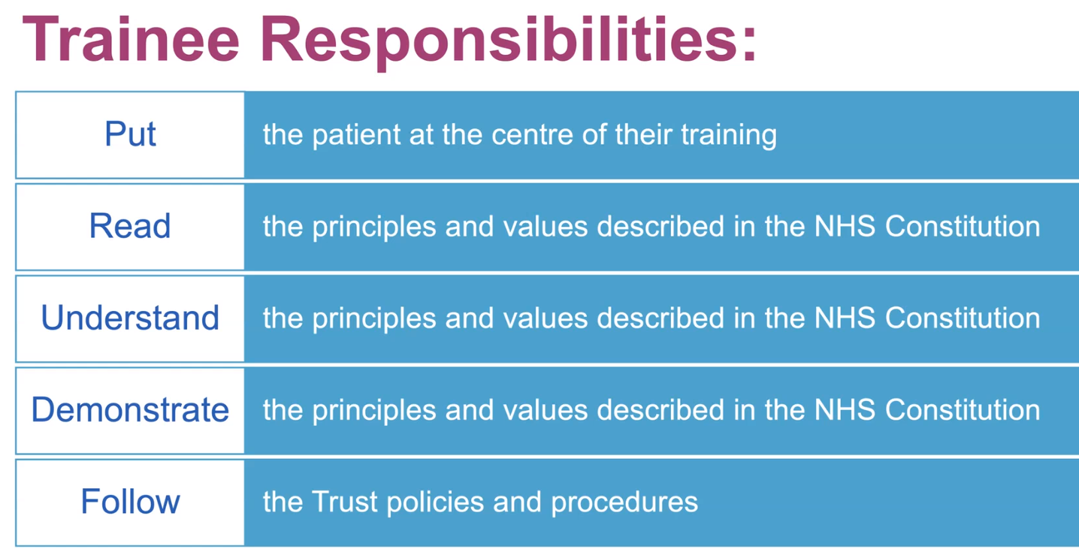

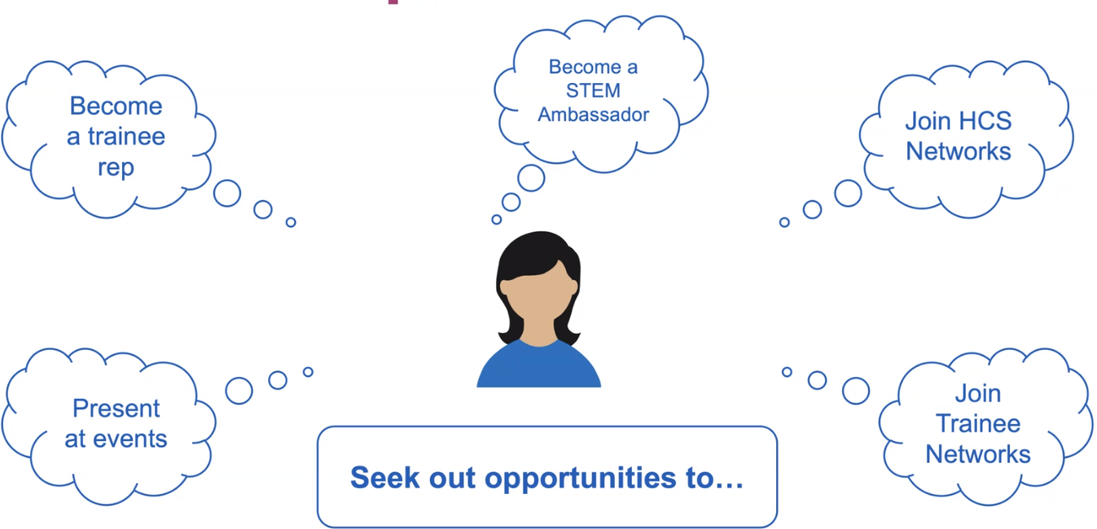

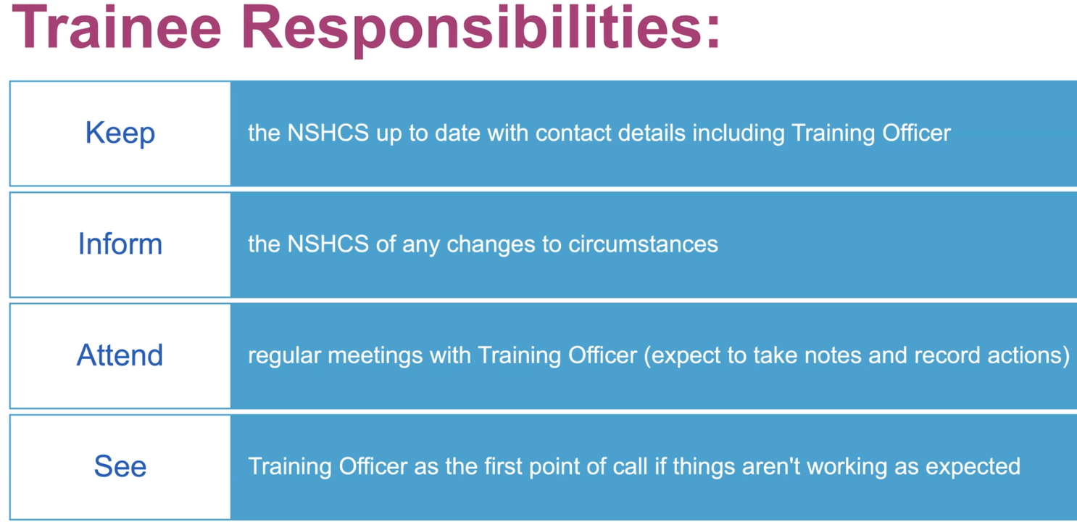

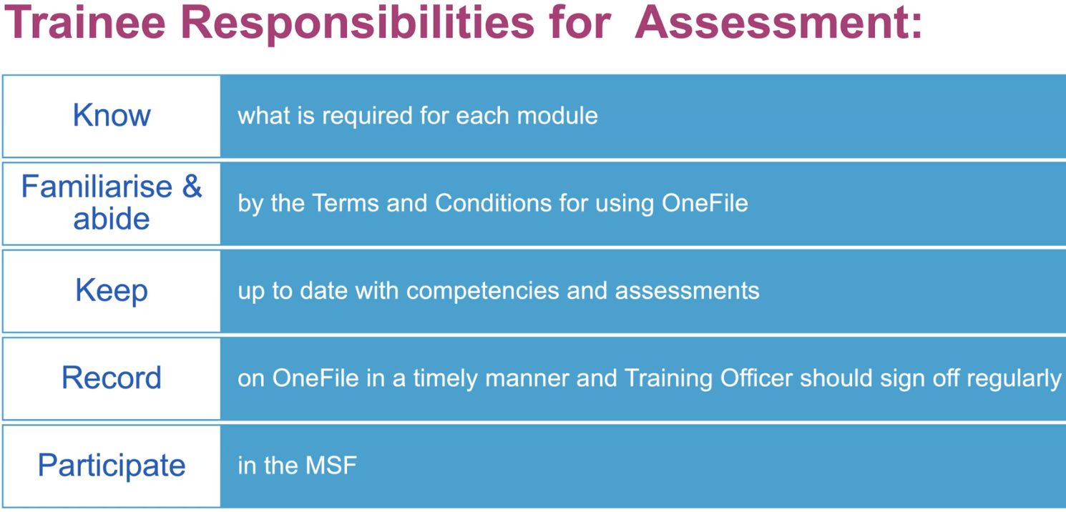
- May need to do background reading b4 each module
- TO needs to remind/give a push regarding signing off competencies / assessments
- Participate in multisource feedback – 2x in programme – 18 months and at end
- Mid term Review of progression to be done after MSF in mid term

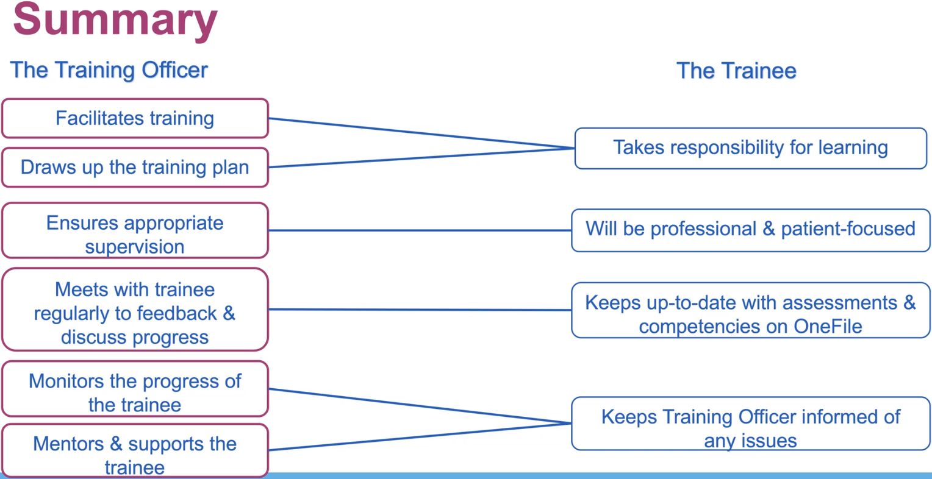

Regular meetings – weekly to start, perhaps, then progress to fortnightly – MINIMUM 1/month

TRAINING PLANNING:

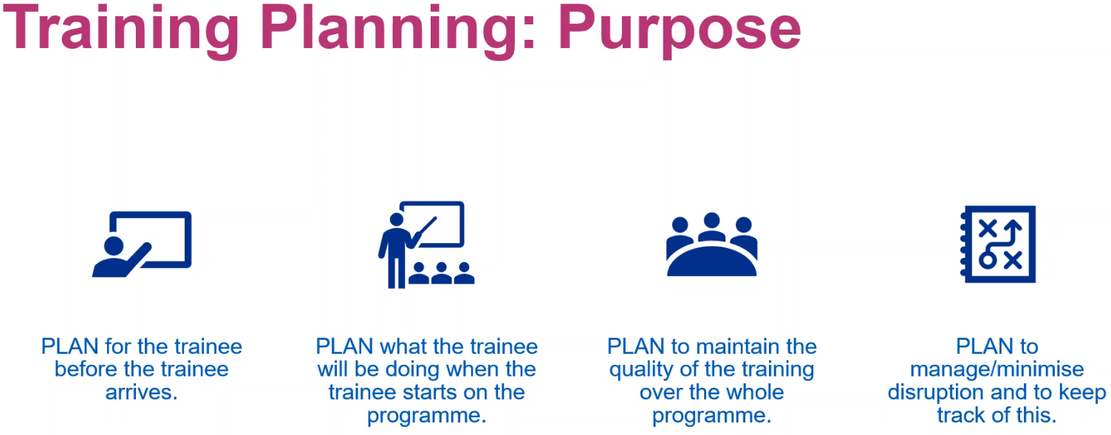
- Make sure trainee feels welcome, and that others understand why the trainee is there
- Induction, what some of the trainee’s first tasks are – Day 1, having tasks to do to be kept busy and feeling like a part of the team
- WORKING DOCUMENT – flexible, reconfigure to achieve all goals

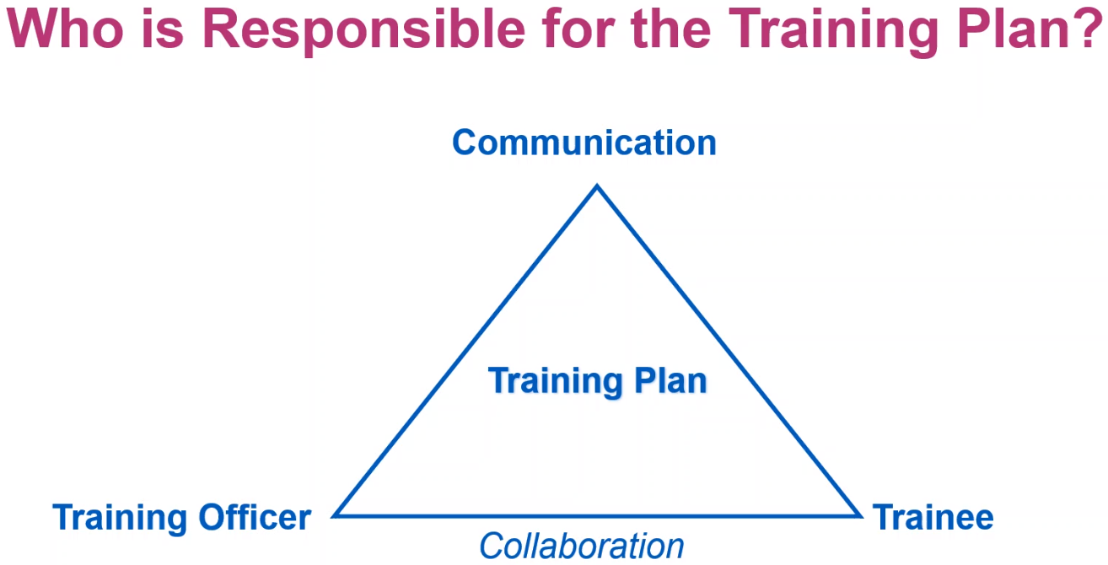
- EVERYONE involved in the training responsible for training plan – trainees responsible to ensure that their training is on track – linked to the specialty competencies
- Needs to be collaborative, adaptable, and flexible
- Timely reviews of document
- Include a Gaps analysis – What’s been achieved?

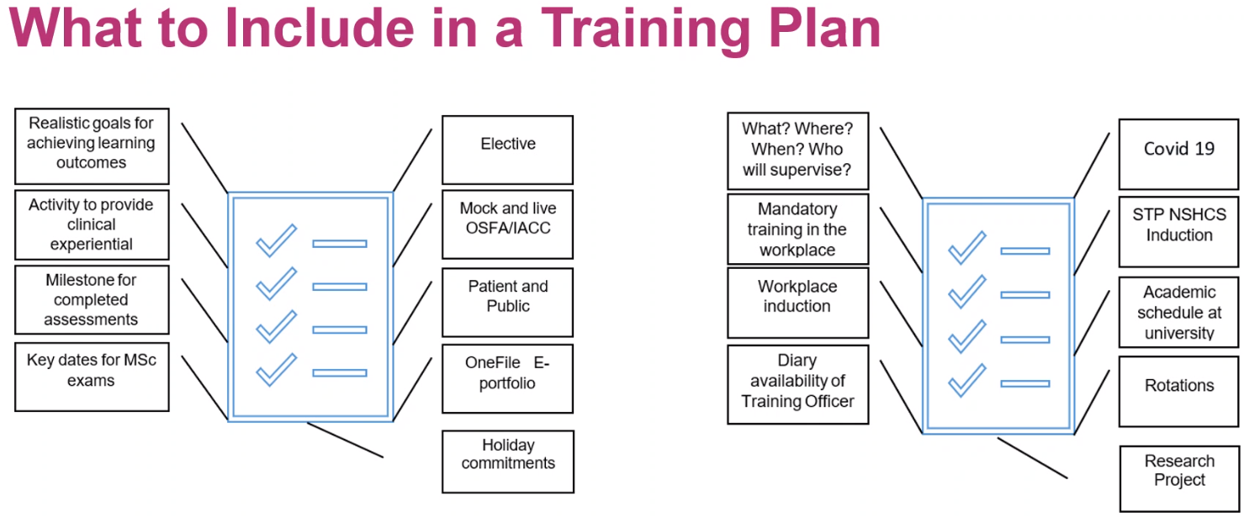
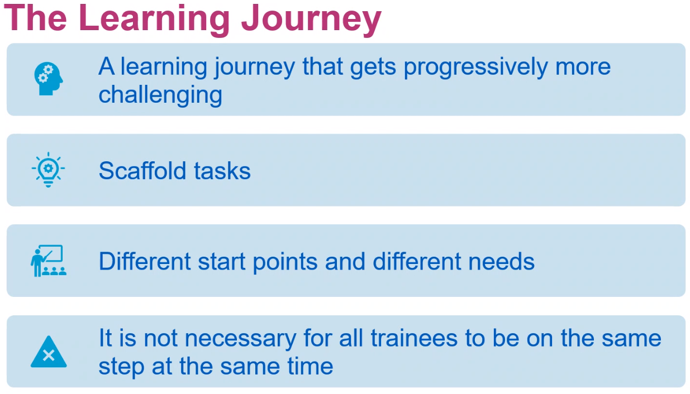
- Must achieve certain goals b4 moving on to another
- Scaffold task – observe a task, write up the task, then perform the task
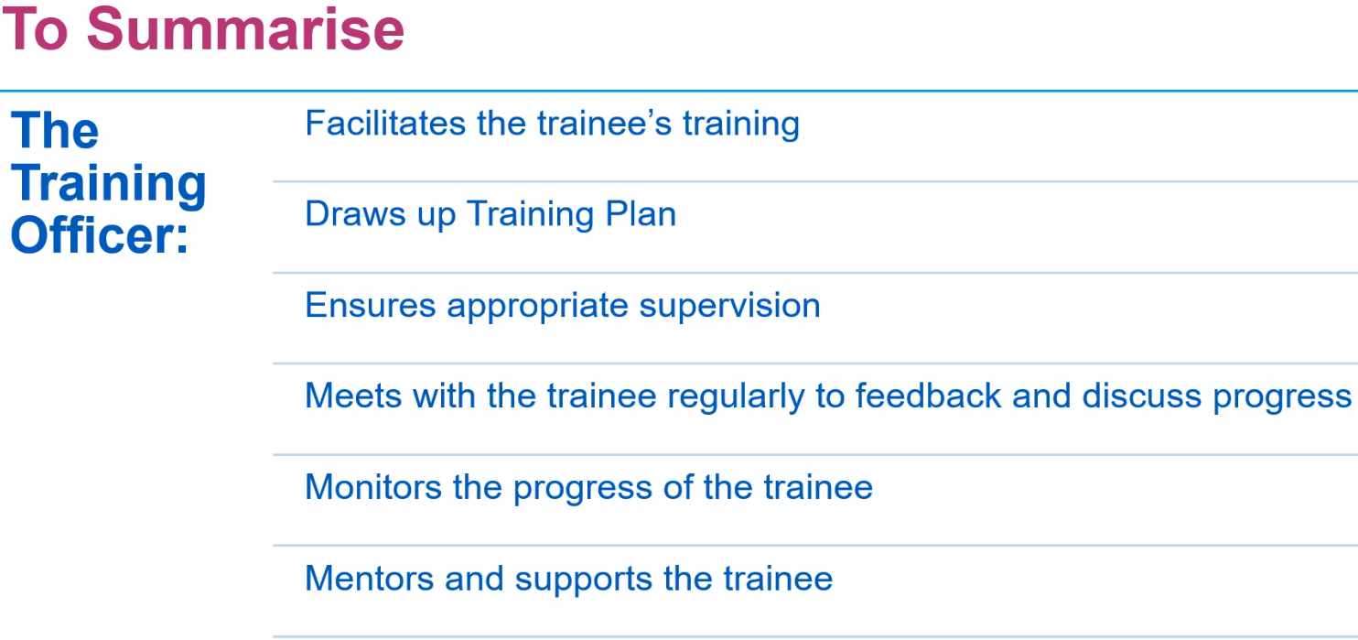
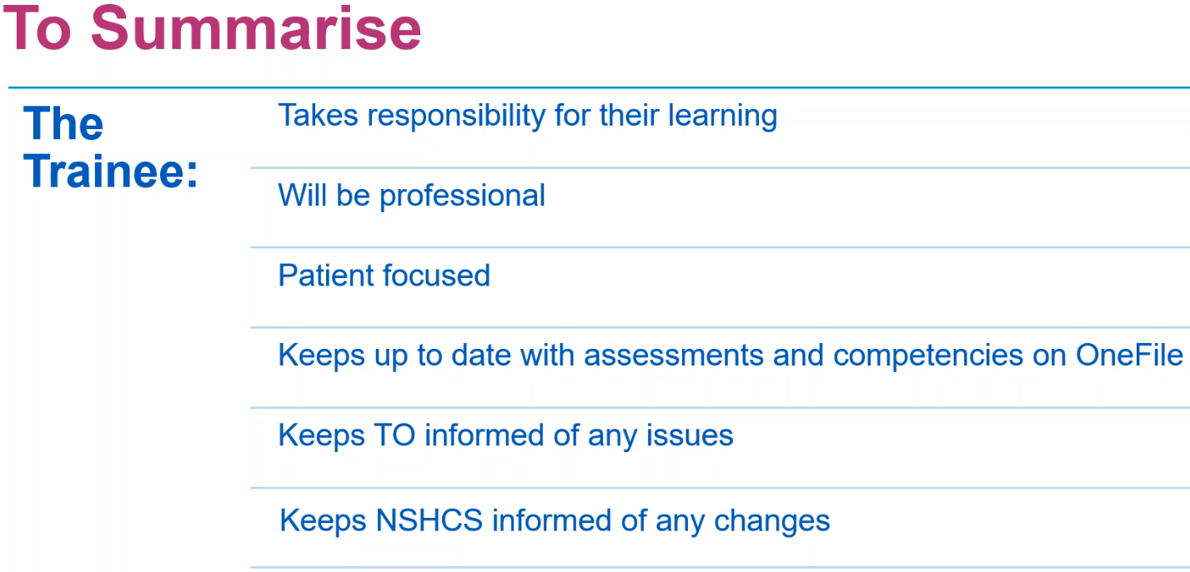
- Able to self-identify which tasks are yet to be completed

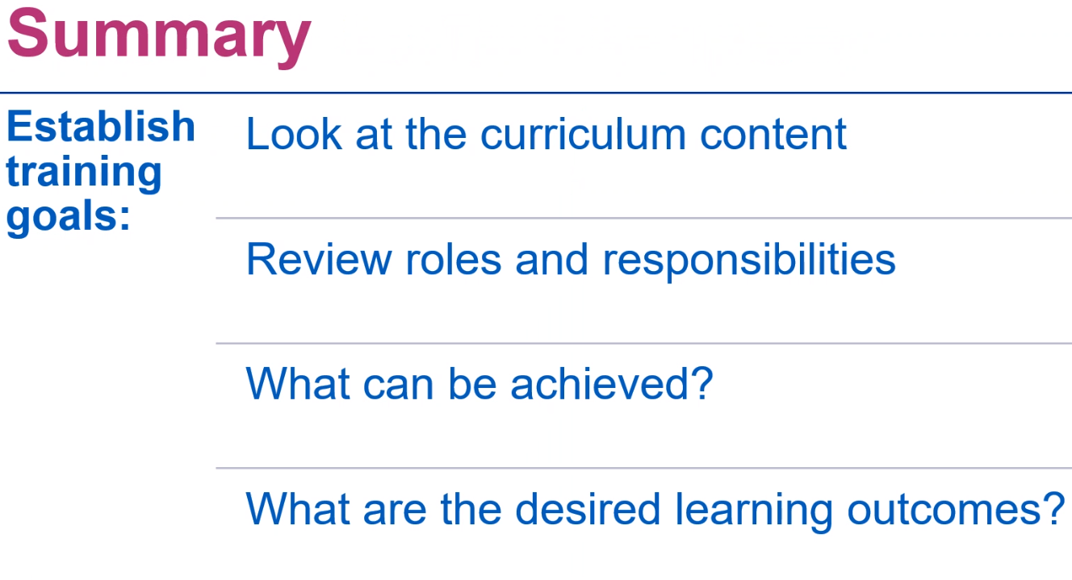
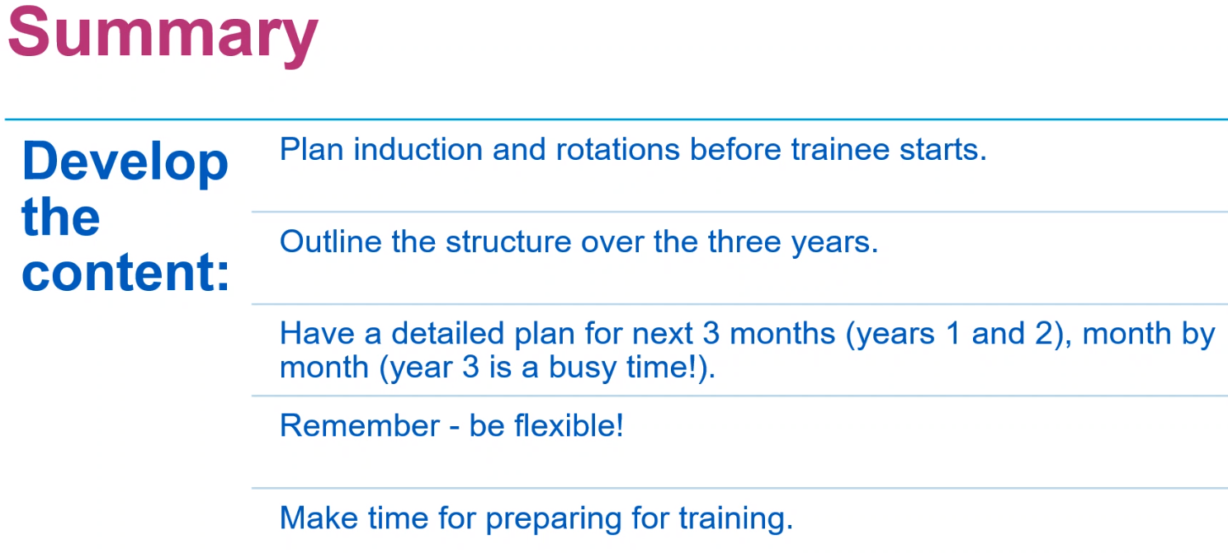
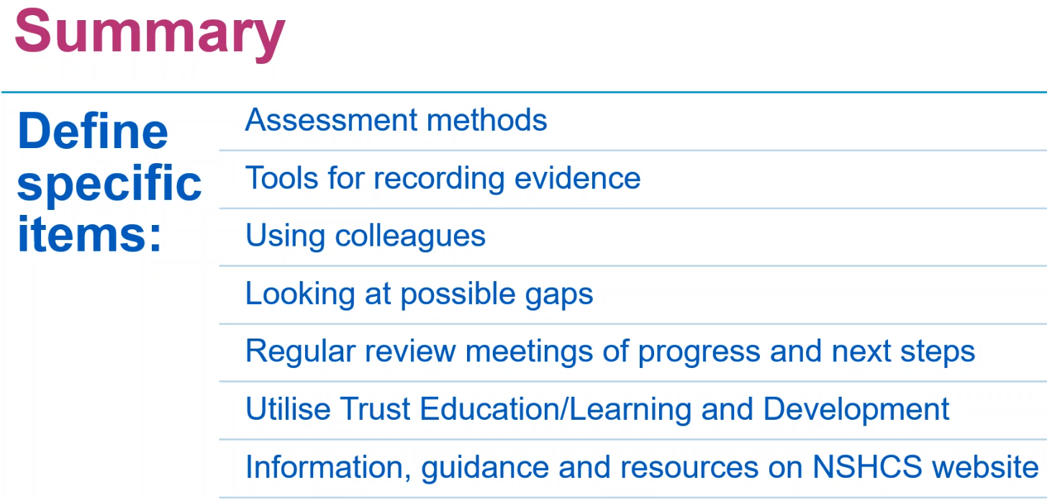
- Assessment methods on website

