The Abdominal Aorta

Screening - offered to men in the year they turn 65
Is not currently offered to women (or men under 65 years)

Background –
AAA often has few or no obvious symptoms
About 8 in every 10 people who have a ruptured AAA die before they can get to a hospital or do not survive the emergency surgery to repair it.
The aim of screening is to pick up AAA before it ruptures. Once found regular scans to monitor or plan surgery.
Research shows that screening for AAA can halve the risk of dying from AAA.

Scan results –
NHS website says
- you will be told the result at the end of your scan
- less than 3cm is normal
- small AAA is 3 - 4.4cm and will be followed up with an annual surveillance scan
- medium AAA is 4.5 – 5.4cm and will be followed up with a scan every 3 months
- large AAA is 5.5cm or larger and will be followed by a specialist appointment within 2 weeks. Most require intervention / surgery

Our protocols (September 2015) says
- examine the aorta from diaphragm to bifurcation and into the iliac arteries, in both LS and TS
- document AP diameters of the aorta (but doesn’t specify in LS or TS)
- worryingly our protocol says assess size of internal iliac arteries which I assume should be CIAs
- method:
measure outer to outer
comment of location (infra/juxta/supra renal), involvement of the renal arteries
measure the true or false aneurysm, documenting the presence of thrombus (i.e. anterior, lateral etc)
A quick reminder…
True aneurysm – weakness of the blood vessel wall results in bulging (has all three layers of arterial wall)
False aneurysm / pseudoaneurysm - occurs when a blood vessel wall is injured and leaking blood collects in the surrounding tissue

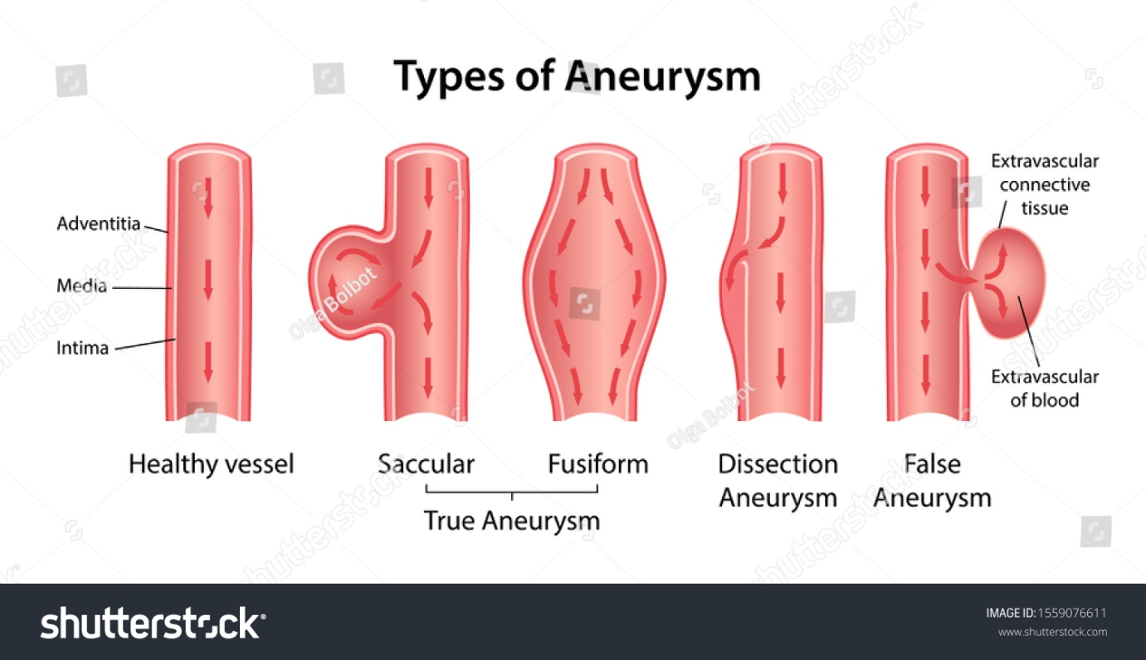

Method continued:
Assess ilacs vessel involvement
Assess for aortic leakage
Assess kidney size

Follow up action required as per protocol:
Less than 5cm – rescan in 1 year
More than 5cm – advise prompt vascular surgical referral

Images required as per protocol:
LS of aorta from diaphragm to bifurcation
TS of aorta (proximal, middle and distal segments) and any area of dilatation
Additional views of an aneurysm, renal arteries and kidneys (if they are involved)

Z code to use or not to use? Discuss

Room 3 protocol (May 2021) based on SVT recommended protocol says
- duplex scanning is first line investigation prior to CTA planning and surgery
- B mode for identifying dilatation and content
- Spectral Doppler (PW) for direction of flow, stenotic flow or absence of flow
- Colour Doppler (CDI) for to aid placement of spectral Doppler in stenosis and confirming presence / absence of flow
- Outer – outer measured
Images:
Prox / mid / distal aorta
Image CIAs, EIAs and if possible IIAs
Document thrombus / residual lumen
Presence of dissection or dissection flap
Pseudoaneurysm / arterial wall defects
Presence of focal stenosis or occlusion

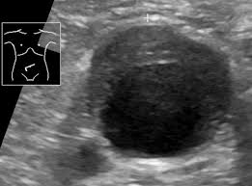

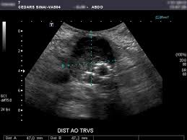

Treatment of AAA –
Emergency surgery for rupture
Planned surgery for patients not suitable for EVAR
EVAR (+/- kissing stents)

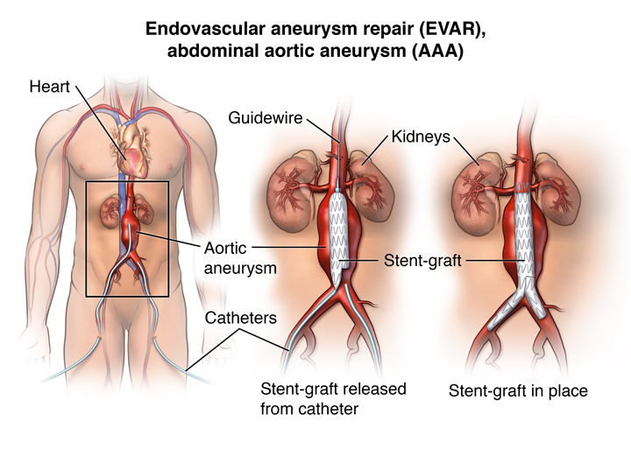

References –
https://www.nhs.uk/conditions/abdominal-aortic-aneurysm-screening/
Protocols September 2015
Room 3 Protocols May 2021 (based on SVT recommended protocol)

