THE DEVELOPMENT OF A VASCULAR ULTRASOUND QUALITY ASSURANCE PROGRAMME

The vascular ultrasound department at the Queen Alexandra hospital in Portsmouth has achieved IQIPS accreditation this year; we are the first NHS Vascular unit to have accomplished this. One of the many requirements that were met in order to achieve this was the implementation of a quality assurance programme.
IQIPS is now a CQC approved scheme, Professor Sir Mike Richards CBE; the chief inspector of hospitals released a policy statement which expressed his support for accreditation and the importance it plays in improving the quality of healthcare.
At present there is not a vast amount of information detailing this process or providing guidance. Many vascular scientists that we consulted on the subject had an ad-hoc programme where the main focus was on auditing of scanning and scan results rather than a comprehensive QA assessment of ultrasound machines and transducers. We thought it may be helpful to other vascular departments, if we shared our experiences.
The first step was to assign two quality assurance leads to implement and develop the programme. Our staff rota and and clinical work load were rearranged and time was given to the QA leads to start developing the necessary checklists and time to use the ultrasound machines
We developed our programme based on BMUS guidelines published in the journal ULTRASOUND in 2013. http://ult.sagepub.com/content/early/2013/11/29/1742271X13511805
The aim of the BMUS guidelines was to collate the information available and to make it available for sonographers in the one place. In addition to this paper, one of the QA leads attended several quality assurance courses. One of the courses was organised by BMUS and was very informative, this course provided very useful information regarding what is required to run a robust QA programme and the specific tests which should be performed. Another useful course is run by the college of radiographers called ‘Delivering a quality ultrasound service’; details of these courses are available on their website. We also purchased a book produced by the Institute of Physics and engineering in medicine (IPEM) called ‘Quality Assurance Of Ultrasound Machines’ this book provides information on a variety of issues including, image quality, acceptance tests, references and standards.
In our department, our Vascular Assistant is tasked with checking a number of details before setting up our scanning rooms and turning on the machines. It was decided that we, as Vascular Scientists, using the machines and signing reports based on the images produced should also have a basic check-list after using the machine for their first scan in the morning. This check list covers, B-Mode, colour, spectral Doppler, transducers and the machine controls and is signed to confirm that the machine is operating to expected limits.
Following on from this and with guidance from the BMUS paper, two additional QA checklists were created. Our level 2 QA checklist was more robust and assessed the transducers for reverberation and shadows and/or streaks and confirmed that the Grey-scale images were satisfactory. The transducers and cables were also checked for wear and tear and any faults or damage. We decided that this would be performed weekly, but on reflection determined that a monthly check was actually sufficient.

A further more in-depth assessment is also carried out on a monthly basis. The system is checked for air reverberation, element drop-out and electronic noise assessment. In addition the clinical engineering department service the machines every six months. The service comprises of back-up of software, a filter clean, brake check, hoovering dust from inside the machine and a B-mode axial resolution check using a phantom.
Coinciding with these check-lists, comprehensive guidelines have also been created so that any member of the scanning team can perform the QA assessments.
During our daily checklist, our linear transducer was found to have what appeared to be superficial wear on the lens with accompanying element drop-out, this was noted and after consultation with the clinical engineering department it was decided that the transducer was no longer fit for purpose and had to be condemned, our curvilinear transducer was also faulty and was replaced, this early intervention and flagging up of issues helps to prevent any delay in clinical throughput and interruption to our busy workload. Our checklist incorporates a visual inspection of the transducer and the cables so that any ingress of gel, damage to the transducer face etc. can be identified early on and monitored.
The programme has already proved invaluable and the department can only continue to benefit from early intervention where problems are pinpointed and dealt with promptly thus avoiding any interruptions to the provision of our service.

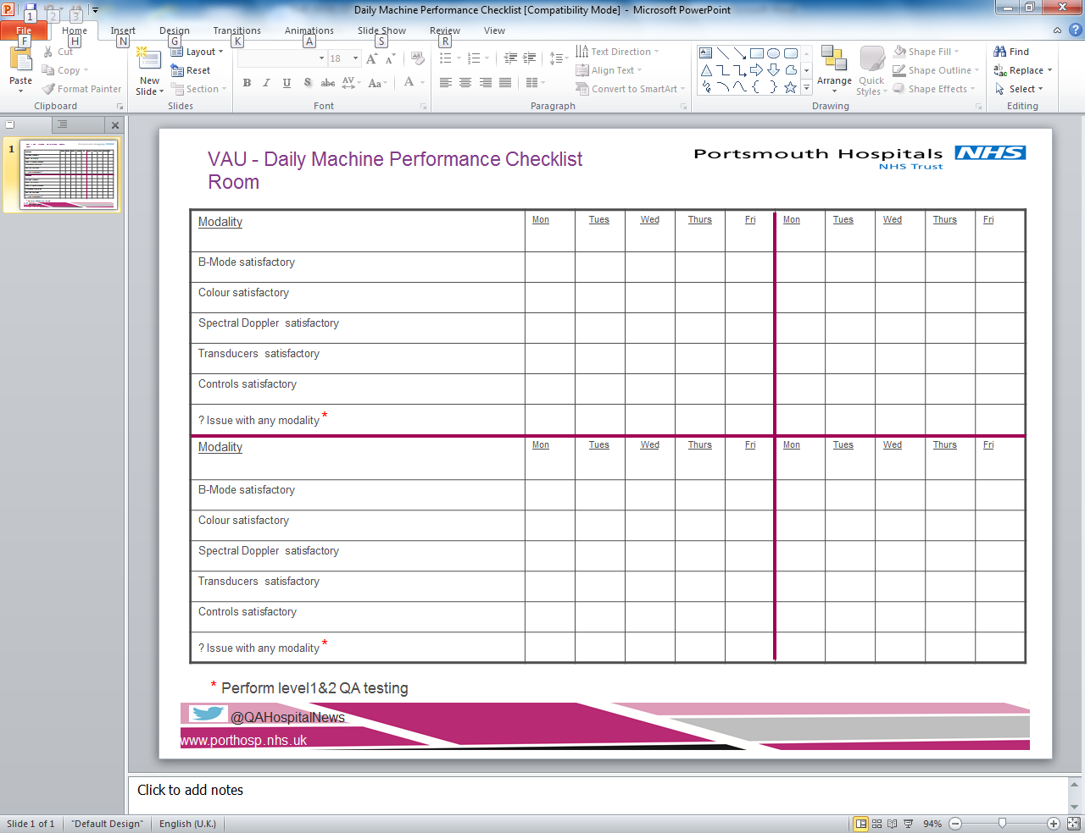

Example of one of our checklists.

Penny Gill and Catherine Rogan Senior Vascular Scientists, Queen Alexandra Hospital
Portsmouth Hospital Trust.

