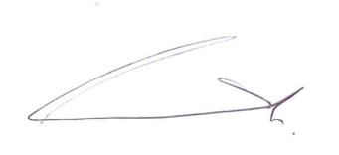

Independent Vascular Services Ltd.

19
^{th}

Annual Update Meeting

6
^{th}

October 2018

Certificate of Attendance

For

………………Stacey Davidson……………

Attendance confirmed by R.Pole, Operations Director, IVS Ltd
:

Signed…
……Date…
6/10/2018
……….

You will be awarded 2 CPD
points for your attendance at this meeting. Please keep this
certificate for your portfolio.

