Secretary - Sara Causley

Wye Valley NHS Trust
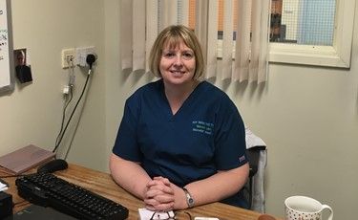
I am a Clinical Vascular Scientist running a single handed service in the Wye Valley as part of the Hereford and Worcester Vascular network.
I started back in 1995 and in those days I was allowed to use my nursing diploma as entry into AVS training and after much hard work and with no one to teach me physics I became fully qualified in 1999.
Being single handed from the beginning meant it could be hard to make contacts and keep fully involved it what was new in the world of vascular science. So in around 2008 I bravely (for me) decided to stick my head above the parapet and become a non-portfolio member of the SVT Executive Committee.
It’s no exaggeration to say this was the best decision I have made professionally and has benefited me as well as hopefully the members over the years. I have met many wonderful people who have helped me so much and I would like to thank them all for their support.
My first job was as membership secretary, a role which I held for many years eventually relinquishing this when I became President in 2017. I have now taken on the role of secretary to support the committee and hopefully add some useful knowledge of events that have happened since I joined.
I also sit on the National AAA Screening Advisory Board as well as being the Clinical Skills Trainer and QA Lead for my local programme.
Living at home in Worcester we have many popular sports to watch. My husband and are season ticket holders at Worcester Warriors Rugby Club, (can be painful to watch). And also Worcester Wolves basketball which is always a good evening out.
Next year I plan to retire and return to work part time. I think it’s time to take things a bit easier.
Taken from SVT website 17th December 2020

