South West Vascular Surgeons
Annual Meeting

This is to certify that
Susan Richards

attended the meeting on
Friday 15th March 2019 at
Royal Bournemouth Hospital

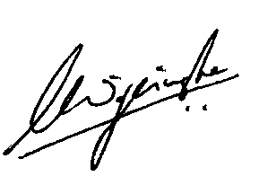

Mr Lasantha Wijesinghe FRCS FEBVS
SWVS Hon. Treasurer

