SVT Past President - Sara Causley

Wye Valley NHS Trust
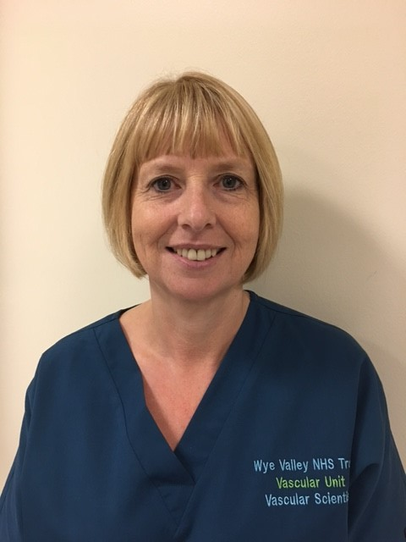
I currently work for Wye Valley NHS Trust in the heart of the Herefordshire countryside, qualifying as a Clinical Vascular Scientist in 1999. I work as a single handed practitioner supported by a Health Care Assistant. I am also Clinical Skills Trainer and QA lead for the National Abdominal Aortic Aneurysm Screening Programme in Hereford.

Taken from SVT website Oct 2019

