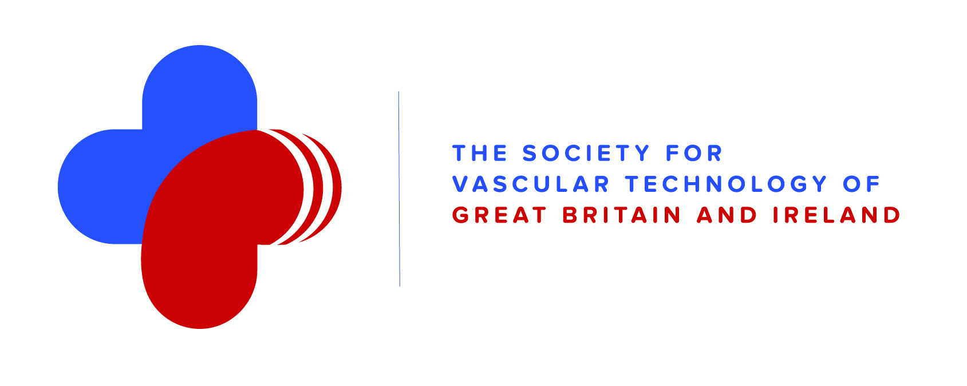

SVT Research Committee
11th June 2018
St George’s Hospital, London

AGENDA

11:00 | Update | Richard Simpson
 | SVT Exec Committee update | Richard Simpson
 | SVT grants | Richard Simpson
 | Research pages of website | Richard Simpson
 | VERN | Fabrizio D’Abate
 | National Research Priorities | Richard Simpson
 | AVS Research module | Steve Rogers
 | Lunch
 | SVT Research workshop | Richard Simpson
 | SVT Research group | All
15:30 | AOB

Agenda with reports / notes

1 | Apologies
 | Welcome back to the committee to Laura.
2 | SVT Exec Committee update
 | RS to discuss
3 | SVT grants
4 grants submitted
- Nazrina Islam – IVS
“The development of a PAES diagnostic criteria using ultrasound”
- Ezra Schwalger-Jackson – Imperial College, London
“Therapeutic impact of Aboriginal Yidaki (Didgeridoo) frequencies on the blood flow of patients with peripheral arterial occlusive disease”
- Nazia Saeed – Northwick Park, London
? GCA project that was rejected last year, after a number of revisions and discussions
- Ben Warner-Michel – Oxford
“A comparison between 2D, tracked-3D and mechanical-3D ultrasound for abdominal aortic aneurysm surveillance and volumetric aneurysm measurement”
4 | AVS Research
8 | SVT Research workshop
5 | VERN
6 | National Research Priorities
8 | SVT Research website
9 | SVT Research group
10 | AOB

