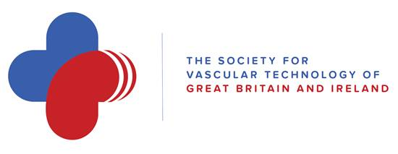

This is to certify that

Michael Davis

Tutored at the Fundamentals Study Day, Cambridge

On

January 27th 2017

And has thus earned 3 CPD points

Signed:
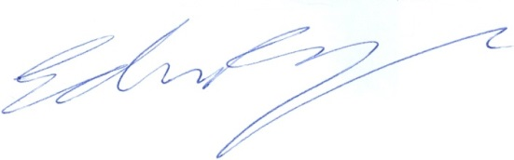
Ed Ramage
As an officer of the Education Committee
Date: 30/01/2017

