 | SVT Executive Committee  Date: 15th September 2023  Time: 10.00am – 4.00pm  Venue: The Marylebone meeting room  Address: The Wesley Conference Hotel  81-103 Euston Street, London, NW12EZ

AGENDA

10:00 |  | Welcome and Coffee.  Apologies: Helena Edlin
1 | 10.10 | Review of Minutes and Action Log | Janine Fletcher / Committee
2 | 10.40 | Conference | Klaus Bond/Steve Rogers
3 | 11:15 | Treasurer | Ben Freedman
4 | 11:30 | Membership | Lynn Mc Rae / Heather Anderson
5 | 11:40 | Education Committee | Hannah Williamson
6 | 12:15 | Professional Standards | Jo Walker
 | 13.00 | LUNCH
7 | 13.30 | Newsletter | Daniella Bond Collins
8 | 13:45 | Study days and Webinars | KM/HW/EW
9 | 14:00 | Website | Robert James
10 | 14:15 | BMUS | Tanyah Ewen
11 | 14:20 | Research Committee | Steven Rogers
12 | 14:40 | Workflows for the Executive committee | Emma Waldegrave
13 | 14:55 | Vascular Society + Circulation Foundation | Emma Waldegrave
14 | 15:00 | CASE MO | Emma Waldegrave
15 | 15:15 | Vascular Stocktake | Emma Waldegrave
16 | 15.20 | Professional Bodes Council (EDI survey) | Emma Waldegrave
17 | 15:40 | NAAASP | Klaus Bond
18 | 15:50 | AOB, NSHCS STP Induction Day - Friday 8th September 2023.  Vascular Practice books  2 x non-portfolio Exec committee applications and a Research committee application. | ALL

1 |  | Minutes & actions from previous meeting |  | JF
***Contact for Belfast/Dublin ALL – e.g. one member attended GCA study day. Orla Warren from Sligo (HW suggested)

Expense card for each committee chair. To make easier. Ongoing****
*** To arrange pre-meeting ahead of the Academy meeting on 7th/8th November. Topic point final assessment for STP. /combine with other action to produce joint statement to state IACC is not working. Andrew Beech no longer in post but no replacement.

Job planning tool for service managers not set up yet

Reduce mailchimp, has been effective previously but no longer needed. EW asked ET to amend newsletter to one PDF document.

See actions :



2 |  | Conference |  | KB/SR
Klaus going on site visit 22nd June.

Conference information to be presented on the day by KB

_________________________________________________________________________

KB presented final programme.

Wednesday AM: Finetuned morning workshop with Cleona. Disagreement over what is ‘advanced’. Compromise reached. Theory sorted. Practical session; some issues. Hands-on during coffee break. Suitable room not yet secured; option for a foyer that can be sectioned off with lighting adjusted (partition/blind). Not ideal. Generally one conference room with side room but side room not available for wed AM. Ongoing, Cleona to visit to confirm suitability for practical session. (4 stations, potential for 6) EW queried whether numbers should be limited. Should it be something to register for to control volume? Discussion; probably be less numbers in general. Long enough session for turnaround of demos. Need for structuring somehow. HW suggested colour coding, similar thing done at GCA day but would be more difficult at conference. Difficult as we won’t know exact numbers. Previous feedback had suggested more hands on. Keep same format as last year but perhaps next year make it more like a bespoke study day with limited numbers. Aiming to get some sponsorship from manufacturers (Cleona leading) in return for having exhibits all day wed/thurs. BF asked about demonstrators. Cleona securing staff/students. SR clarified free registration wouldn’t be available for any Dublin helpers as we have our own members if needed.

Wednesday PM: Carotid imaging. KB discussed potentially contentious data from OL carotid grading audit. KB just wants us to be mindful of possible pushback, e.g. whoever’s chairing.

Drinks reception. KB emphasized expense. Venue proposed (Harbourmaster – pub), reasonably well priced. 10 euros a head for food. No minimum number. Cleona obtained quotes for 100 people. Need somewhere that people have option to order their own food. ***KB to confirm food situation. Can put info out to membership suggesting pre-booking for food.
KB asks are we prepared to fund finger food PLUS welcome drink. VOTE: All in favour to use (max) £2000 with the reasoning that some should be replenished with sponsorship. Group praise for KB in finding.
****KB to obtain invoice for BF.

Thursday: Abstract sessions. Difficulty with getting abstracts reviewed. Notification emails not working ideally. ET to amend deadline to allow potential presenters plenty of time for preparation. Ample abstracts received, 15 (though not as many completed projects).

Great debate topic sparked group discussion on what roles people are actually doing currently. Voting via Slido.

Clarification on how Exec comm should register. No codes. Register as normal and there will be an expense claim form to claim from VS. £100 travel £85 accommodation plus registration fee. Unrealistic, should we top up allowance from own SVT pot?
JW suggested we update ‘cap’ for expenditure for conferences, i.e. top up to realistic figure so working members are not out of pocket. ***KB to produce list of people who will be working on the Wednesday for VS. Need agreement on what is allowed.
Invited speakers allowance, what is reasonable? VS normally pay. KB proposes up to £150. (£85 will be from VS, SVT to top up but KB to agree with VS to have one invoice so BF not bombarded with separate invoices).

JW proposes new defined policy generally for member activities expenses. ***(Action 7) Update current expenses policy BF.

[JW gave apologies as cannot attend conference, will submit report for booklet]

3 |  | Treasury |  | BF
Funds looking good due to memberships. ***EW wants to ensure tick box is available for giftaid. Steve W to help implement.
LMcR discussed issues from people trying to renew membership from abroad. 6/7 people having problems with renewal. Steve W couldn’t find any issues, asked for screenshots for declined incidents. Must be a World pay issue?? KM clarified likely due to change in company owner. BF having difficulty with World pay in annual revalidation. LMcR has reassured members in question that they won’t lapse. She had set month deadline but people still being charged £60. EW suggested LMcR speak to ET as she is knowledgeable about this. ****Take 7 cases to worldpay/Steve and cc accountants. International members will have to send bank transfer direct to SVT then LMcR will manually update membership.
SR brought up Steve W’s lack of assistance. With upcoming website review should we be looking at alternative suppliers. ET advised staying with Steve W as website needs are quite refined.
BF case of lapsed CPD member has to send £200 to circulation via SVT. Otherwise member will lose AVS status.

4 |  | Membership |  |  | LMR/HA
Clarification over whether individuals from the Phillipines with a degree there are eligible to work towards SVT accreditation. Yes but employer should vet degree qualifications, SR shared gov equivalence tool that you can check degree credibility.

One case where CPD points aren’t registering on the overall summary. ****LMcR to speak to Steve W.

5 |  | Education Committee |  |  | HW
- Theory Exams - grading boundary issue and new theory exam system when Inteleos finishes
- Current updates from the Ed Comm committee and agenda of new ed comm chair
Our next Ed Comm meeting is 29th September and so there may be some things that I can't conclude on until after this date but will do my best tomorrow.
I think the main thing to be discussed are the theory exams and Inteleos.

___________________________________________________________________________

- Pass % not clear. HW spoke to exam team. Inteleos states not that simple due to weighted questions, raw scores, adjustment year to year dependent on previous pass rates. Threshold doesn’t seem to make sense, suggests some years are easier to pass than others. Slightly irrelevant now as moving on to new platform (Moodle?) so need to keep all these points in mind. SR discussed what they use for EVS as a recommendation for HW.
HW has ed comm meetings coming up to establish next step with regards to theory exam. BF enquired about costing.

HW ed comm update. HE stepping down from ed pathways role. Michael Davis taking over. ****HW to communicate with him about writing endpoint assessment (with our help) and scope of practice document for Gloucester university students undertaking the new undergraduate vasc practitioner course.
Study day lead needed.
HW queried about ‘paid for’ administrator but EW confirmed not a possibility.

Targets:-
Prioritise practical exam standardisation.
Advanced practice definition. Is there another level of accreditation we could offer in the future? Or is HSST adequate for us as a profession to aim for. SR made the point that AVS already gives advanced status.

Clarification on how committee roles should be filled. Agreed vacancies should all be advertised internally and externally to membership. Committee would then vote.
HW to release vacancies, to include educational pathways.

6 |  | Professional Standards Committee |  |  | JW
PSC Report – Meeting 14th July 2023

IQIPS: A Quality Manual template has been produced by JW and the PSC are to review before the Oct meeting, with a view to finalising and publishing after this date. AC has written a newsletter article about Accreditation Clinical Advisory Group (ACAG) who look after the IQIPS standards.
Job Profiles: The Band 6 & 7 profiles were agreed and now published on the website. The Vascular Practitioner agreed and ready for publication.
Job Descriptions: A first draft of a band 7 JD was produced by JW and edited as a group within the meeting in line with the Band 7 job profile, and this is to be ratified at the next meeting ahead of publication. Band 6 and Band 8a to be discussed at next meeting. The PSC would appreciate any anonymous JDs for higher banding 8a and above.
PSC Webpages: The front page has been redesigned by Rob – Thank you. We have added new sections and reshuffled. Added articles for SVT Ambidextrous scanning recommendations and Clinical Vascular Scientist job planning. Now have areas for:
- SVT Guidelines (PPGs)
- Service Management
- Professional Practice
- Quality & Safety (TBC)

PSC Quality & Safety: 2 docs produced: Vascular Service Quality Management (ready to put into a template and upload) and SVT Image & Report Auditing Guidelines documents for review at next PSC meeting.
Waveform description Document: Nik has finished, agreed by PSC team, and ready to publish onto a standard template

__________________________________________________________________________

JW gave report.
Producing template quality manual that will go on website as PDF. Aim to provide tools to aid members’ service.
***Practitioner profiles still to finalise as well as actual job descriptions for VS rather than profiles. ***JW asked for 8a,b,c job descriptions

Discussion about job planning document. ***Amend non-clinical activities list to not include report writing as all agreed it is part of the overall clinical scanning activity. Discussed importance for managers to refer to.

***Reshuffling of PSC documents. Combine scan time document with job planning

***RJ to move IQUIPS docs

QA tool to apply to images and reports in order to audit against SVT guidelines. Will give score of diagnostic ability. Doc going up soon.

***RJ to edit job profile title to include banding

*** to publish waveforms document on website

Aim to have a whole arsenal of documents geared toward aiding service. Upcoming profiles for Band 8 generic as well as band 8 research

7 |  | Newsletter |  |  | DBC
DB gave report. Half of membership ‘clicked’ on newsletter. Bitesize section proved to be most popular.

Timing: submit by 29th September publish 9th October
29th Dec 9th Jan
Spring newsletter brought forward to beat Easter holidays.
Michael Davis winner of best article.

***EW proposes we have a Conflict of Interest form.

For Autumn edition:-
Confirmation from SR that bitesize research will be quarterly.
Conference- reiterate registration dates
BMUS save the date
GCA feedback, delegate article. On demand access for GCA study day.
Professional indemnity insurance article? EW/LMcR to go through information. Aim for winter newsletter.
Highlight ambidextrous scanning doc.

JW proposed all accredited members having a registration number by way of professional recognition. Cards? KM reminded we wouldn’t be recognised by PSA.
***SR to action.

Rebranding for Winter newsletter.

DB reminded she is stepping down from newsletter editor. ET interim. Then non-portfolio member to be selected.



8 |  | Study Day Program |  |  | HW/KM/EW
- GCA workshop 7th September London RCPCH – Success!
- Ideas for the next study day please –
23rd Feb 2024 or 1st March 2024
________________________________________________________________________

Need for a study day lead.
General vacancy page for SVT committee roles. ***RB to make.

KM proposing carotid day for next September. ?renal artery March, EVAR.
Discussion about relevance of renal artery scanning. Argument against scanning as there will be no intervention. Could potentially include this debate in study day. And fill out with visceral content.

Reviewed previous membership survey on what study day topics people wanted.

Decision made for March: EVAR. Some logistics already in place so shouldn’t be too difficult. Louis from ed comm strong potential to take on study day lead role so he can be guided (e.g. KM will help).

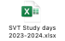

9 | Website |  | RJ
Meeting with SW on Thursday 14th September at Darby

Website Report
SVTGBI Website review / development
Website working group to be established and first meeting is scheduled for WC 12/06/23
- I will be contacting the chair of each committee about their respective website pages design and content over the coming weeks. I am looking to get this stage done reasonably quickly if possible.
- The general feeling is that it is potentially difficult to navigate around and find what you are after, and that the pages are very text heavy. So we will be looking to make it more concise (where possible/suitable) but also much more user friendly e.g.:
Proposed Examples (not finalised!) vs Current
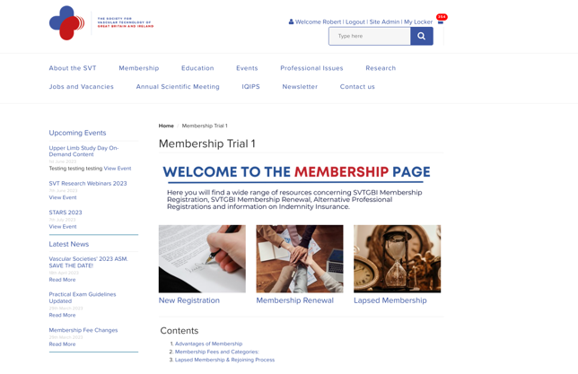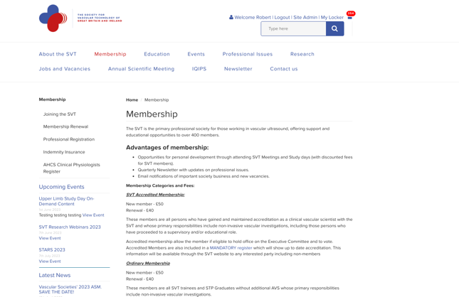
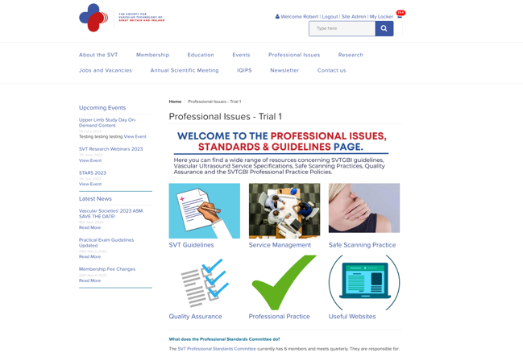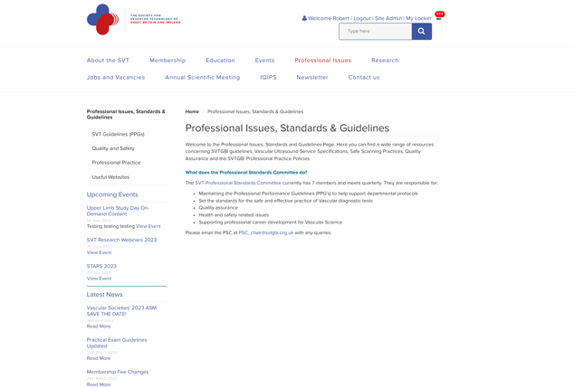

_________________________________________________________________________________

RJ gave report. Previous email issues supposedly resolved according to Steve W. Change of provider so will see how it goes. ***RJ to monitor.
JW raised previous issue with job adverts on website of not getting formal receipt for reimbursing. ***BF to look into.
RJ requested info for next webinar. SR directed to RC member Isaac.
Discussed upcoming website review/development. BF raised issue of costing; decision of who to go with should be made with due diligence as it’s significant expense.
Discussion about new domain. BF questioned whether we need to buy all available domains similar to what we will need for branding i.e. .com, .org, .co.uk

10 | BMUS |  |  |  | Tanyah Ewen
BMUS Report

Next BMUS meeting is next week (September 21st). Nothing to report.
Annual Scientific Meeting (Vascular Stream)

- The Vascular stream speakers have been finalised, see below. One speaker has pulled out, but a replacement has hopefully been found, they are just trying to decide on a topic.
- The workshop has had a good response for demonstrators, so hopefully there will be enough.
- Antonio Sessano is going to do a live demonstration of carotid scanning and upper limb scanning prior to each workshop.

Workshop

Carotid

Speaker - Antonio Sessano
Demonstrators - 1. Jodie Baker
2. Michael Lucas
3. Anna Rengel
4. Felicity Woodgate
5. Sepideh Poushpas
6. Antonio Sessano
7. Simon Ward
Floating Tracey Gall / ? Rob James

Upper Limb

Speaker - Antonio Sessano
Demonstrators - 1. Jodie Baker
2. Michael Lucas
3. Anna Rengel
4. Felicity Woodgate
5. Sepideh Poushpas
6. Antonio Sessano
7. Simon Ward
Floating Lucy Denton / ? Rob James

Vascular Session:

Session 1

- Deep Learning - Philips Rep ? Waiting for confirmation
- Bridging the Gap: Implementation of duplex ultrasound techniques in general medical ultrasound - Ben Warner-Michel (confirmed)
- Vflow – Promising Vascular Study Tool - Hongjin Wang (confirmed)
- Aortic coarctation - Helen Dixon (confirmed)

Session 2

- When an occluded vein isn't thrombus - a case study on Leiomyosarcoma - Jodie Baker (Confirmed)
- TBC - Tracey Gall
- Pelvic Vein Duplex - Katja Norse (Confirmed)
- Pelvic Vein Embolisation, the Vascular Radiologist Perspective
- Dare Seriki (Confirmed

_________________________________________________________________________________

Praise for TE’s agenda

11 |  | Research Committee |  |  | SR
Meeting held this week – report to follow
Next bitesize topic deep venous stenting.

Webinar series going well, all planned til Feb next year. All being recorded. Synced webinars with newsletter. RC in talks about how webinars will continue going forward. SR suggested putting question out to members asking what they want to hear?
BF queried if research ‘clinic’ is appropriate. SR outlined reasoning as to why they don’t want to get involved on an individual basis. Webinars supposed to be used for signposting to help those with projects.
***RJ to readvertise grants.
***KB to let SR know what res comm can do to help at conference.

Working group on equivalence research modules. All STP graduates so they have linked work to their own experiences with MSc so not quite appropriate.
Final syllabus has been fully matched. Different routes available as well as different access points.
SR to set questions (will jointly attend item writing with ed comm).
Hard launch at AGM.
Research workshop to run in spring, problem based learning.
Completed.

Res Comm challenges. Need a new chair. Difficulties with needing AVS as chair. One member of res comm is interested but is reluctant to pursue AVS. Sparked significant debate. JW stated that someone without AVS does not have the certification to prove a certain level of standard for clinical vascular science as would be required from a chair. SR proposes changing terms of reference that specifies 60% of committee need to be AVS however the chair should still be AVS. HW expressed concerns about losing ‘60% rule’. Decision to maintain both aspects.
SR will remain Res comm chair for the next 12 months.
***Decision to advertise externally and revisit at a later date. SR meanwhile can take outcome back to individuals concerned as a society-wide stance.

Separate discussion on SR idea for embedding SVT examinations into STP MSc course.

13 |  | Workflows for the Exec |  |  | EW
Equivalence with Elaine Jenkins
Dear Emma

Good to see you this morning. As we discussed I am happy to recommend to our Education, Training and Standards Committee (ETSC) that the Accredited Vascular Scientist (AVS) Registration process (eligibility criteria, theory and practical exams, quality assurance) should go through our RPL process to be recognised as agreed piece of evidence for the STP Equivalence process. If approved in principle by ETSC we can then work of producing an RPL report which sets out and evidences why RPL can be granted. If that report is approved by ETSC subsequently, it will mean that applicants only have to present their certificate of registration to evidence the agreed standards. Applicants will then focus on providing evidence for the other standards and we can work with SVT to identify the types of evidence that would be suitable. Applicants will follow the STP Equivalence process as set out including writing a summary report and short reflective piece.

Next steps:
- I will take a paper to the next meeting of ETSC on 5 September 2023 proposing that we take the SVT Registration Process through our Recognition process – I will share the draft paper with you for comment before I take it to the Committee
- I will share the mapping template used previously to take a Registration portfolio through the RPL process (to follow) – there will a slight amendment to the template to specifically refer to comparability with the STP curriculum. This as done in a separate document previously
- I will ask the professional body if I can share the RPL outcome report that went to ETSC with you for information
- Working with you I will draft the RPL report, including the mapping of the AVS Registration Process against the Standards in Good Scientific Practice and the mapping against the Vascular Science STP Curriculum. The report will then be considered by an AHCS panel and they will recommend whether AVS Registration can be recognised as an agreed evidence in the STP Equivalence process
- Indicative timeline – aim to take the RPL outcomes report to the meeting of ETSC on 28 November for approval

I have copied Lynne Smith into my email as the Lead for the STP Equivalence process.

I will be in touch over the next couple of weeks with a draft ETSC paper for comment.

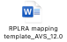

EDI Survey with PBC – Membership team to complete – Action
Our website update should include inclusive language.



Create a Scope of Practice document for the Level 7 Apprentice – Work with Tracey Thurgood Longden

__________________________________________________________________________

SR flagged issue of data being ‘critically sensitive’ as involves protected characteristics therefore we would be limited in what we could do with the data. Reminder for us as a society to convey inclusivity.

14 |  | Vascular Society and Circulation Foundation |  |  | EW
Verbal Update – Emma W and Kamran attended
______________________________________________________________________________

15 |  | CASE |  |  | TE/E
Next meeting Feb

16 |  | PBC AHCS |  |  | EW
Meeting was unfortunately on a Thursday and I couldn’t get time off work.
Vox healthcare journal are looking for Leadership pieces from all societies.
If anyone would like to write about their journey / experience of being a leader this would be great – Steve any HSST trainees?

18 |  | NAAASP |  |  | KB
19 |  | AOB |  |  | ALL
Currently have Jenny Anton as Non-Portfolio – should move to a role in November (Newsletter, Membership, ??)

3 x New Non-Portfolio Role applications on the Exec

Katy Allen, SVT Member: 925, AVS
University Hospitals of Morecambe Bay NHS Trust -
Veronica Sagayarajah – Good for non-portfolio exec member
Nazia Saeed – Good for Research Committee

