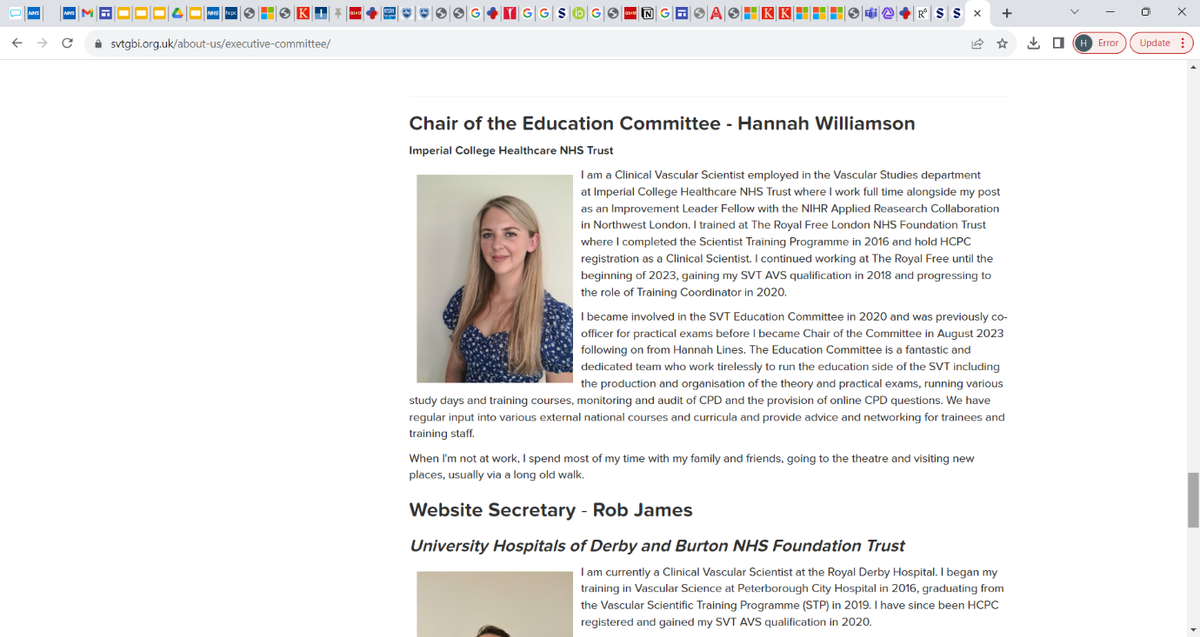
Post on SVT Education Committee as Practical Exam Co-officer (March 2020 to September 2023) and Chair of Education Committee beginning August 2023 – present.

https://www.svtgbi.org.uk/about-us/executive-committee/

