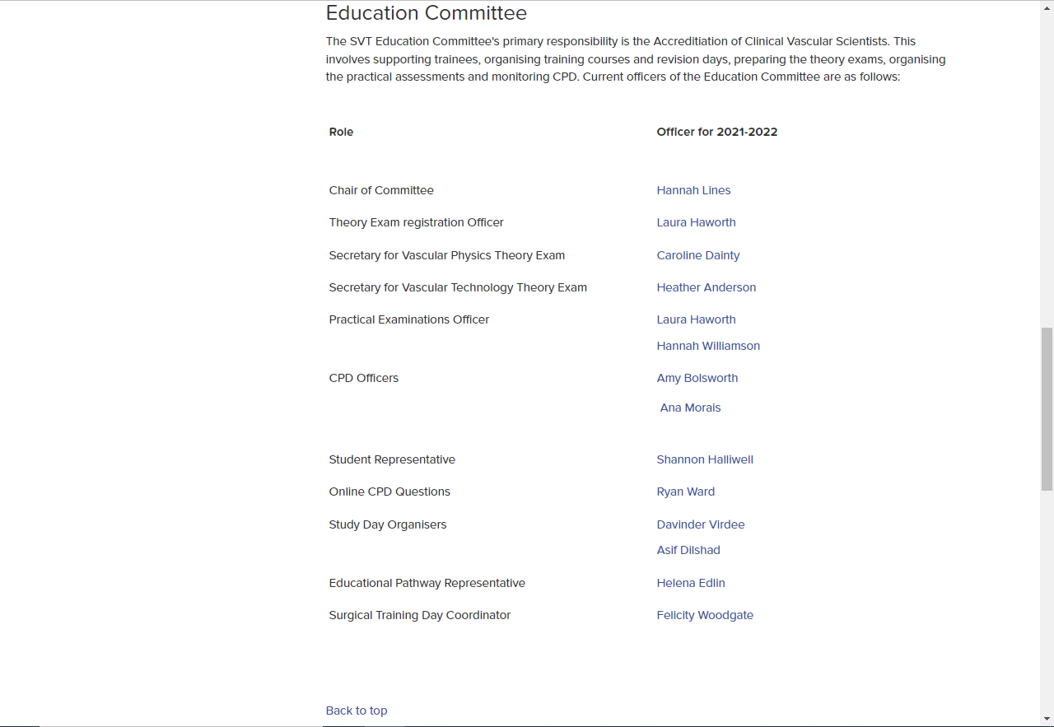

Print screen taken from the www.svtgbi.org.uk website evidencing that I (Caroline Dainty) am on the SVT Education Committee.

