SMA Syndrome
- Rare, potentially life-threatening gastro-vascular disorder
- Duodenum gets compressed between the SMA and the aorta.
- Caused by decrease in retroperitoneal fat between the SMA and aorta.
  - Typically seen with AA / SMA angle of 6 – 25 degrees (normal 38-56 degrees)
  - Typically seen with Aorto-mesenteric distance 2-8mm (normal 10-20mm)

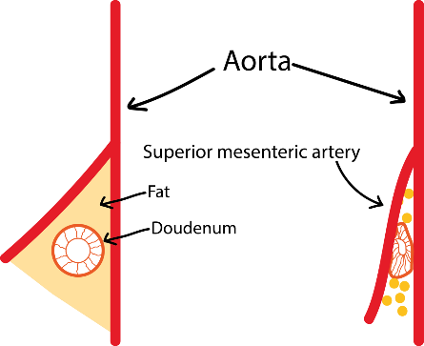

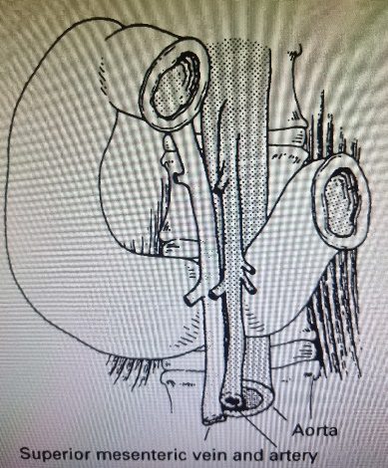

Nutcracker syndrome may occur in association with SMA syndrome (see below).

Symptoms:
- Early satiety, nausea, vomiting, severe post-prandial abdominal pain, abdominal distension, reflux, heartburn
- May be relieved by knee-to-chest position, or prone position, as this widens the angle between AA and SMA
Causes
Any condition that decreases the amount of retroperitoneal fat
- Acute – sudden weight loss, eating disorders, psycho-social, spinal surgery, trauma.
- Chronic, congenital – very thin build, high insertion of duodenum, or low origin of SMA, scoliosis
- Usually occurs after an episode of weight loss.
Post prandial pain causes a reluctance/avoidance of eating, further decreasing the retroperitoneal fat and exacerbating the problem in a self-perpetuating cycle.

Diagnosis
Difficult, and usually one of exclusion
- Females between the ages of 10 and 30 are most frequently affected, hence physicians may mistakenly think that emaciation is a patient choice rather than a consequence of SMA syndrome.
- Patient usually significantly underweight at the time of diagnosis.
- CT usually best imaging modality, however:
- Ultrasound and angiography can be useful to assess SMA angle.
- Ultrasound likely to show a mass, which is the dilated stomach and duodenum.
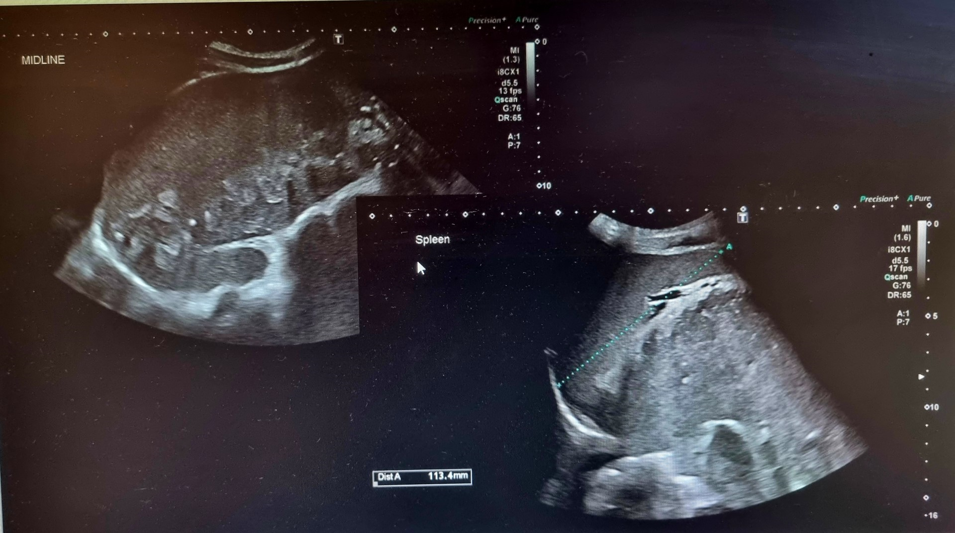
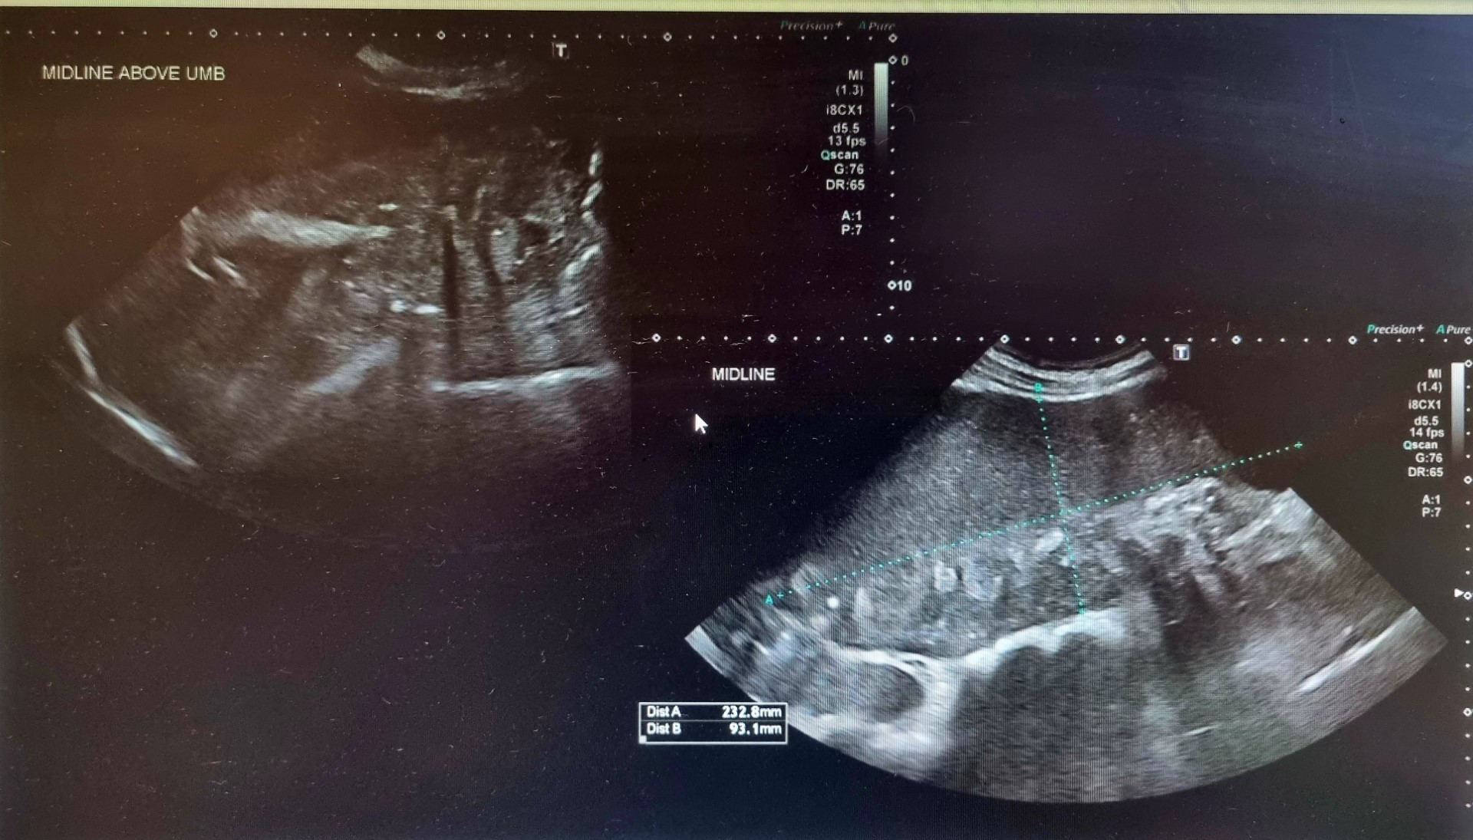
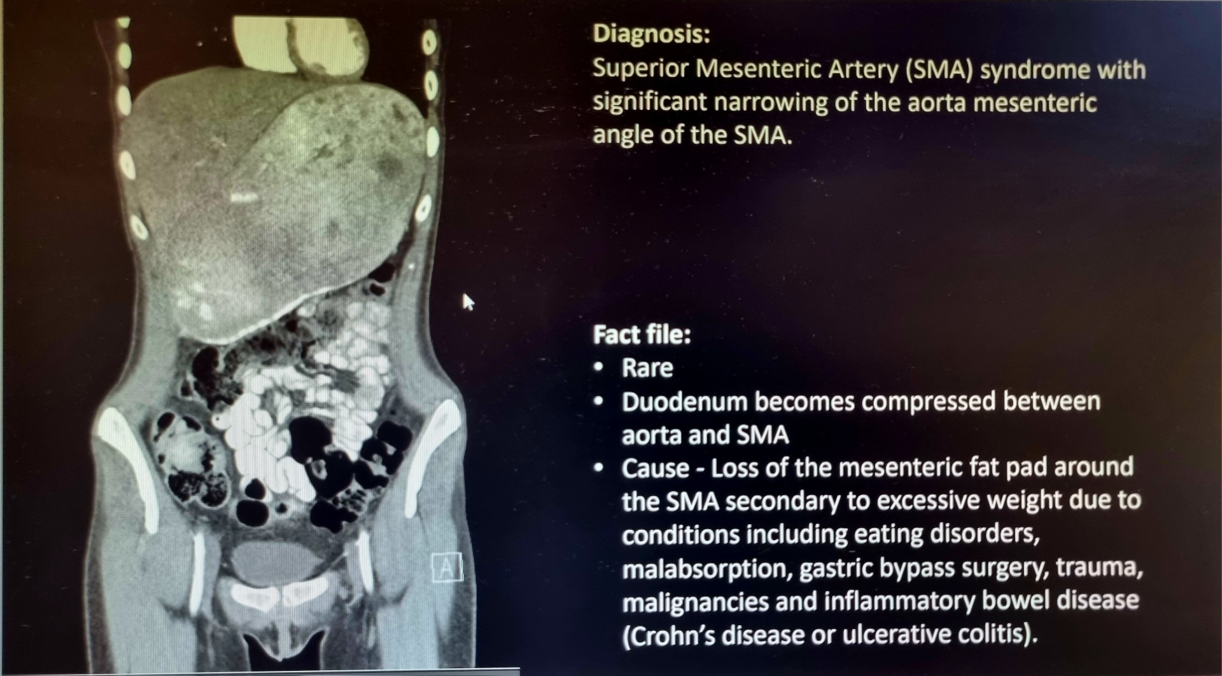

Treatment
- 70% medical, based around increasing nutrition.
- 30% surgical, duodenojejunostomy or transposition of SMA
- Needs to be allied with psychological assessment.

Prognosis
- Delay in diagnosis can be fatal – advanced malnutrition, dehydration, electrolyte abnormalities, hypokalaemia, intestinal perforation, upper GI bleeding.
- Outcome from treatment is considered excellent.

References
Superior Mesenteric Artery Syndrome: Diagnosis and Treatment Strategies N. D. Merrett & R. B. Wilson & P. Cosman & A. V. Biankin J Gastrointest Surg (2009) 13:287–292 DOI 10.1007/s11605-008-0695-4
Superior Mesenteric Artery Syndrome; Radiopaedia https://radiopaedia.org/articles/superior-mesenteric-artery-syndrome
Ahmed A R, Taylor, I, Superior Mesenteric Artery Syndrome, 1997, Postgrad Med J; 73: 776-778

Nutcracker Syndrome
- Entrapment of left renal vein between SMA and AA
- Leads to renal venous hypertension, resulting in.
  - Rupture of thin-walled veins in the left renal collecting system
    - Haematuria
Symptoms
- left flank pain, pelvic pain, haematuria and gonadal varices.

Radiographic features:
- Reduced aortic SMA angle.
- Left renal vein stenosis.
Complications
- Renal vein thrombosis.

