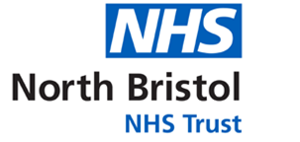
Renal Failure and Haemodialysis Access Study Day:

A multidisciplinary team perspective

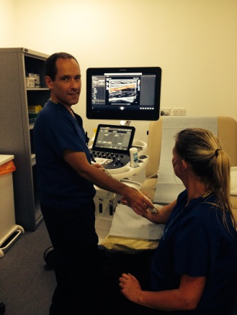

This collaborative study day will be jointed delivered by the University of West of England and North Bristol NHS Trust, who are one of the largest centers in the South West of England involved in renal failure and haemodialysis (HD).

The course is aimed at a wide range of health professionals in primary or secondary care who are either new to renal disease or currently working in the area and would like a more in depth knowledge of the fundamentals of renal disease, haemodialysis, access/formation, ultrasound assessment and radiological intervention.

A morning of theory will cover a broad range of topics from the prospective of the many health professionals involved in the management of renal disease at North Bristol Trust. The afternoon will be dedicated to multi station, interactive hands on practical demonstrations.

Speakers include a renal physician, consultant surgeon, consultant radiologist, renal specialist nurse and vascular scientists.

Delegates will additionally:
- Hear a patient’s perspective of living with renal disease
- Observe ultrasound assessments of HD access on patients
- Learn practical skills for scanning and assessing haemodialysis access (no experience required).

Delegate packs are included and a CPD certificate will be issued at the end of the day.

Lunch and refreshments will be provided
Date
Friday 20th April 2018
9:00 – 16.30
Registration 08:45 – 09:00

Location
Learning and Research Building
North Bristol Trust
Southmead Hospital
Bristol
BS10 5NB

Cost
£125

Contact
Tel: +44 (0)117 32 81158
Email: has.studydays@uwe.ac.uk
Twitter: @UWEhasCPD

