
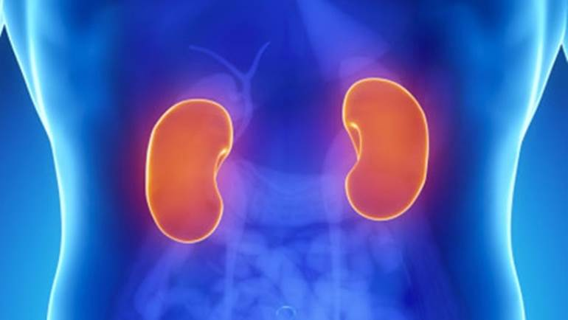

Paediatric Renal Ultrasound Presentation
By Patricia Wilkie, Sheffield Children’s Hospital.
Wednesday 22nd January 2020

This is to certify that …Matthew Beardshall…………… attended this CPD meeting
Signed……………………Nicholas Sowden, Deputy Lead Sonographer

