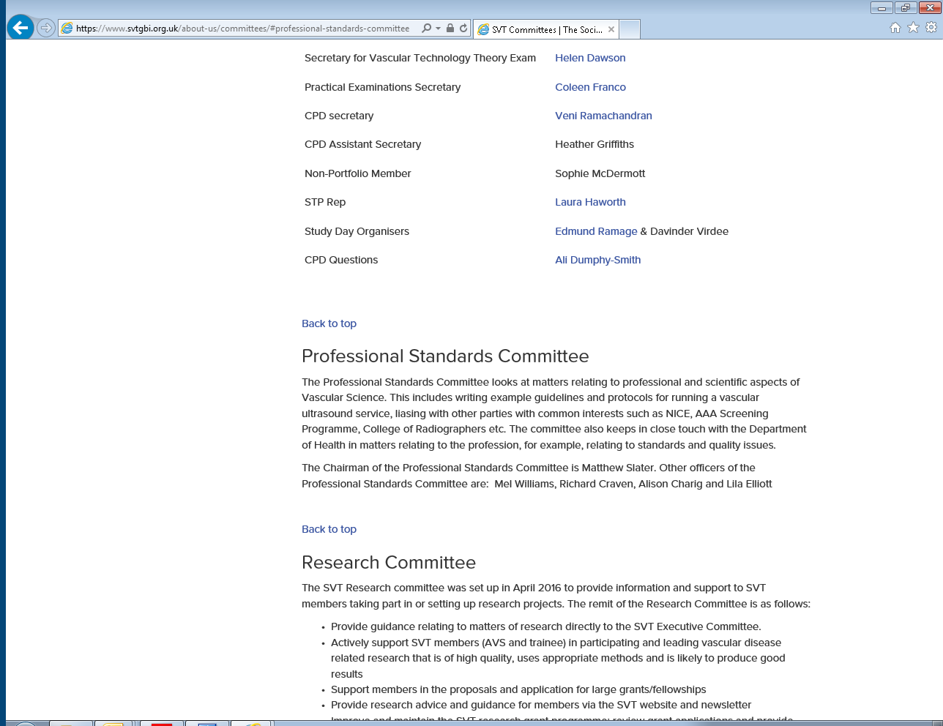
Screenshot taken from SVT website on 17/3/17

