From: Akhtar, Anam (RTH) OUH <Anam.Akhtar@ouh.nhs.uk>
Sent: Wednesday, August 30, 2023 2:40 PM
To: Lee, Regent (RTH) OUH <Regent.Lee@ouh.nhs.uk>
Subject: RE: OxAAA study open day invitation

Dear Regent,

I hope this email finds you well.

Apologies for the late reply, I now have confirmation from the team with regards to who can attend the oxAAA study open day on the 7th October. Myself and Rachael will attend the event and we are happy to represent and demonstrate ultrasound scanning. Thank you so much for inviting us to celebrate the 10th anniversary for the study.

Kindest Regards,
Akhtar, Anam (RTH) OUH
The program for the day is as below: (EVAR surveillance is also relevant)
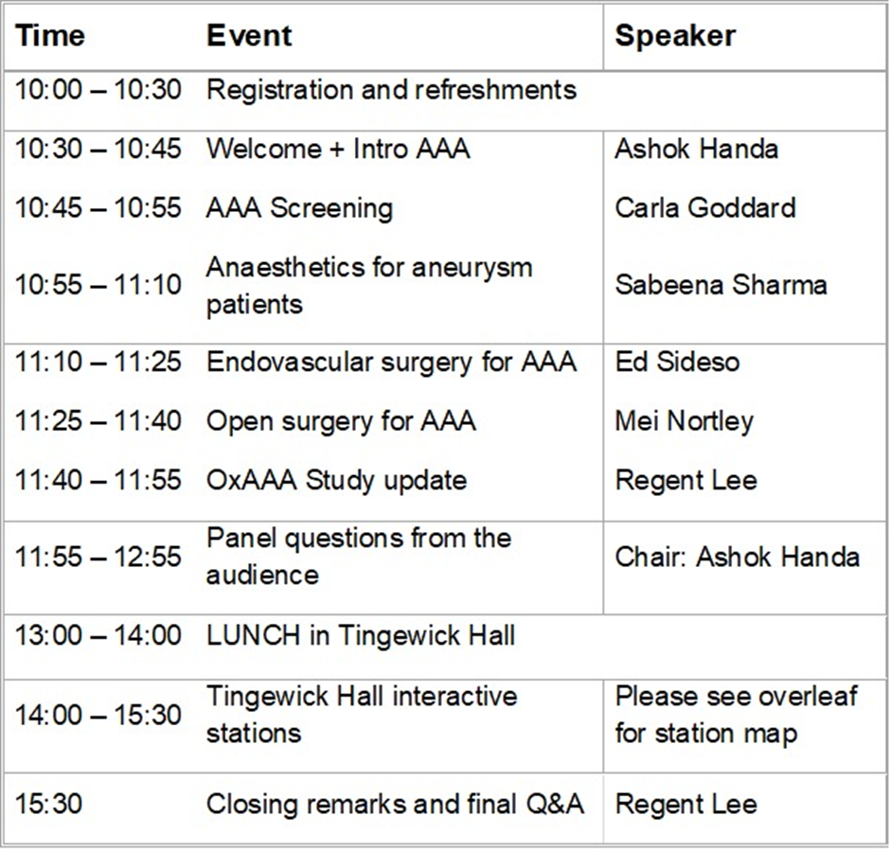Subject: OxAAA study open day invitation
Dear Klaus, Anam,
We wonder if you (JWVSU team) would be interested to join us on the OxAAA study open day on 7th October, (Saturday) 2023.
Venue: Lecture Theatre 2 and Tingewick Hall
We plan to invite the OxAAA study participants and other patients on the OUH AAA surveillance program (with families) to attend. The event marks the 10th year anniversary for the study and will feature talks in the morning, lunch, then interactive stations in the afternoon.
We are hoping to have JWVSU representation and provide demonstration of ultrasound scanning, ABPI etc. We last held a similar event in 2016 and it was well received.
Both Nick Killough and Felicity Woodgate will join us on the day as alumni.
We look forward to hearing your thoughts.
KR Regent
Regent Lee
MBBS, MS(Vasc Surg), DPhil (Oxon), FRCS (Vasc Surg)
Associate Professor of Vascular Surgery, University of Oxford Honorary Consultant Vascular Surgeon, Oxford University Hospital NHS FT

