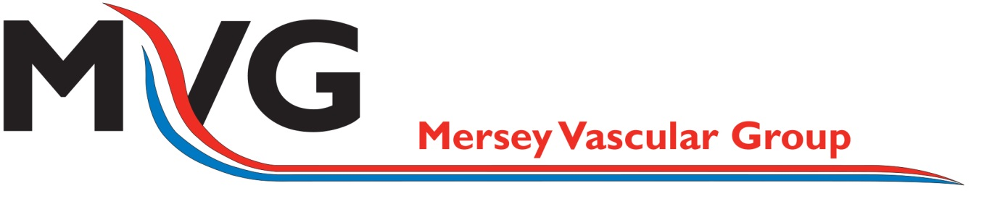

The Mersey Vascular Group Meeting

Sponsored by
Tuesday 17th March 2015
Sponsored by

The Crowne Plaza, Chester
Trinity Street, CH1 2BD

Programme

18:00 Registration
Be sure to visit our rep stands in the foyer. Welcome drinks provided.

19:00 Welcome
Mr Sameh Dimitri, Secretary of the Mersey Vascular Group

19:10 ‘Intervention for Asymptomatic Carotid Stenosis and Cardiac Surgery – before, during, never – my view’
Mr John Chambers, Consultant Cardiac Surgeon, Liverpool Heart & Chest Hospital

19:50 ‘Ischemic Retinopathy and the Carotids’
Mr Balasubramanian Ramasamy, Consultant Ophthalmologist, Wirral University Teaching Hospitals Trust

19:30 ‘Asymptomatic Carotid Stenosis and Intervention – my view’
Dr Peter Enevoldson, Consultant Neurologist, Walton Neurosciences Centre

