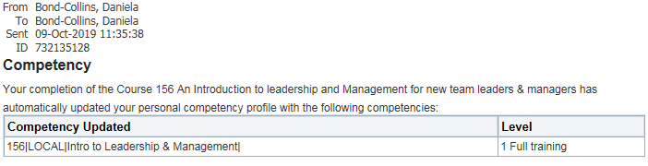
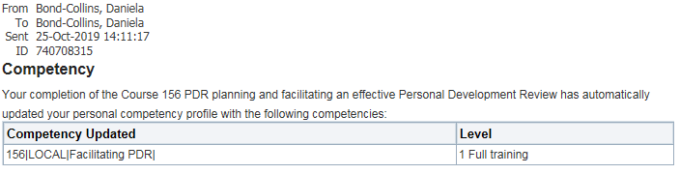
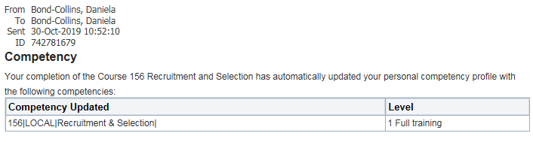
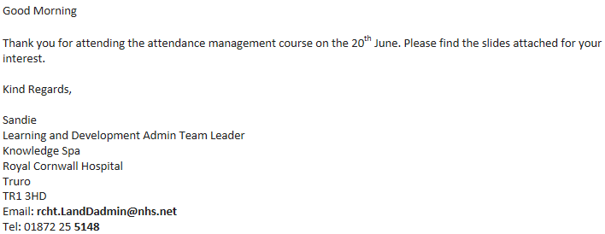

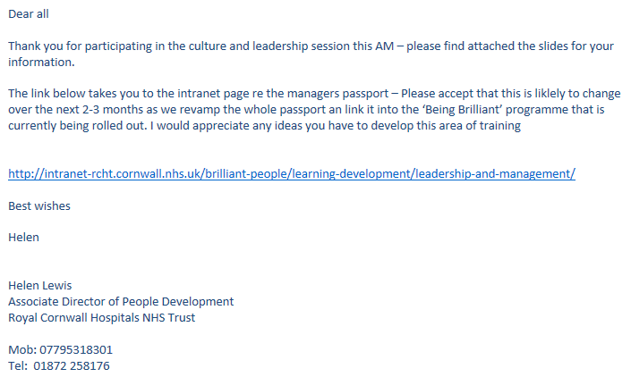

Managers Passport modules completed (18.5 hours):
- Introduction to Leadership & Management
- Managing Performance & Employee Conduct
- Attendance Management
- Planning & Facilitating Effective PDR
- Recruitment & Selection
- Culture & Leadership
- Finance Skills & Development for non-financial staff

