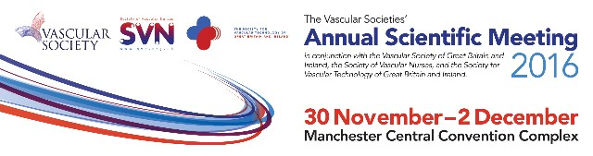

Certificate of Attendance
Certifies to all that
Mairead Brosnan
attended
The Vascular Societies' Annual Scientific Meeting
Wednesday 30 November - Friday 2 December 2016
Delegates
VS Trainee Joining Scheme - Full Conference (includes one year membership)
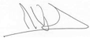 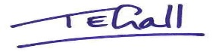
Mike Wyatt, President, The Vascular Society
Nikki Fenwick, President, Society for Vascular Nursing
Tracey Gall, President, Society for Vascular Technology

