Certificate of attendance
This is to certify that

Suzanne Hargreaves

Attended
The Annual North West Vascular meeting
Held on the 16 October 2019 at the Village hotel club, Whiston
This meeting has been accredited 6 CPD by the
Royal College of Surgeons of England

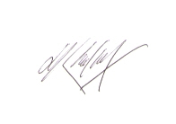
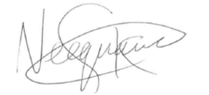
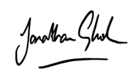
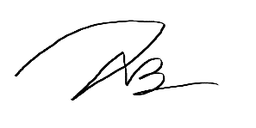

S Neequaye N B Teo H Al-Khaffaf J Ghosh

Organising Committee

