Matthew Slater
Vascular Scientist
Addenbrookes Hospital
Hills Road
Cambridge
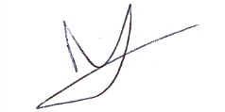
CB2 0QQ
Matthew.Slater@addenbrookes.nhs.uk
07855799747

11th of September 2018

Dear SVT CPD officer.
As PSC chair from November 2013 to November 2017 I can confirm that Lila Elliott was an active member of the committee throughout that time. Where possible she attended meetings and replied to queries and generally helped the committee.
The following is a list of the PSC meetings during the requested years (2015, 2016 and 2017). Meetings in bold are the ones that Lila attended.
2015 | 2016 | 2017
13/01/15 | - | 12/01/17
07/04/15 | 21/04/16 | 04/04/17
09/06/15 | 14/06/16 | 12/09/17
15/09/15 | 06/09/16

Lila went on maternity leave on the 24th of august.
If you would like further clarification on any of the above please do not hesitate to contact me.

Yours Sincerely,

Matthew Slater

