 | SVT Executive Committee  Date: 19th January 2024  Time: 10.00am – 4.00pm  Venue: The Marylebone meeting room  Address: The Wesley Conference Hotel  81-103 Euston Street, London, NW12EZ

MINUTES

10:00 |  | Welcome and Coffee.  Apologies:
1 | 10.10 | Review of Minutes and Action Log | Janine Fletcher / Committee
2 | 10.40 | Conference feedback | Klaus Bond
3 | 11:15 | Treasurer | Ben Freedman
4 | 11:30 | Membership | Lynn McRae / Steve Rogers
5 | 11:40 | Education Committee | Hannah Williamson
6 | 12:15 | Professional Standards | Jo Walker
 | 13.00 | LUNCH
7 | 13.30 | Newsletter | Jeny Anton
8 | 13:45 | Study days | KB/SR/KM
9 | 14:00 | Website | Robert James / SR
10 | 14:15 | BMUS | Tanyah Ewen
11 | 14:20 | Research Committee | Steven Rogers
12 | 14:40 | Vascular Stocktake | EW/KM
13 | 14:55 | NAAASP | Klaus Bond
14 | 15:00 | Vascular Practice books | All
15 | 15:15 | National School meeting | SR/HW/KM
16 | 15.20 | Vascular CRG meeting | EW
17 | 15:40 | Equivalence | EW
18 |  | AOB | All

1. | Minutes and Action Log  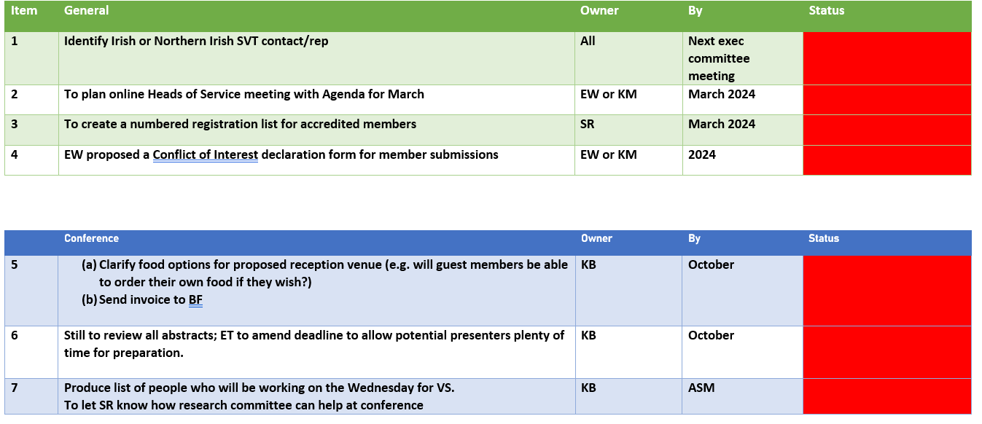  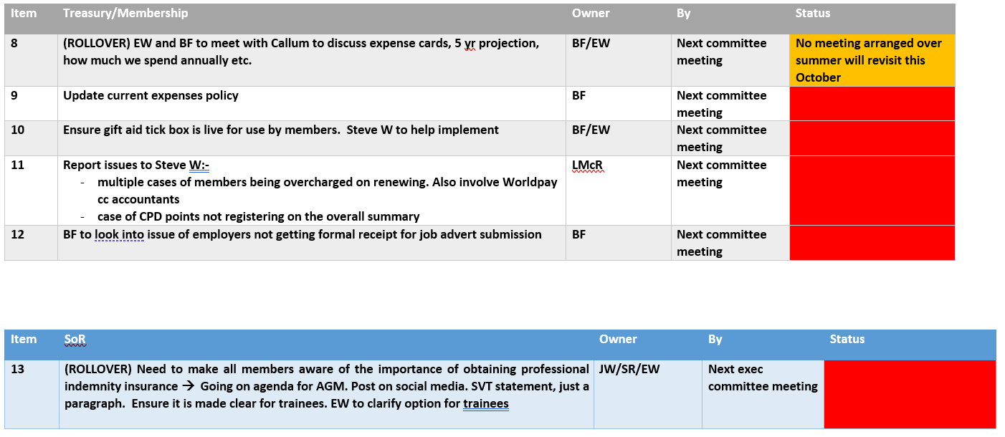  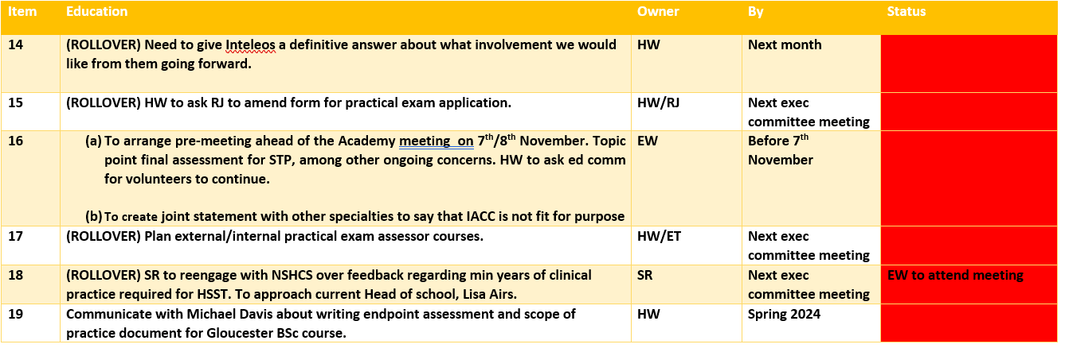  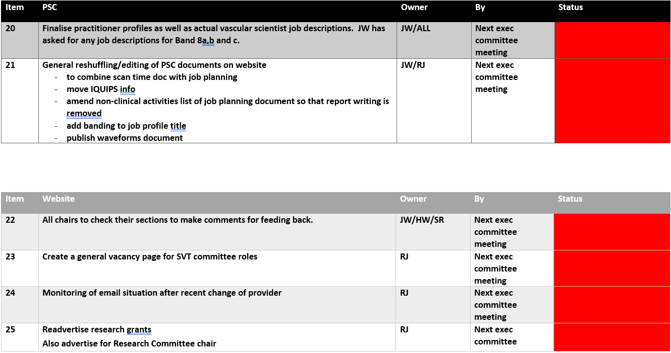  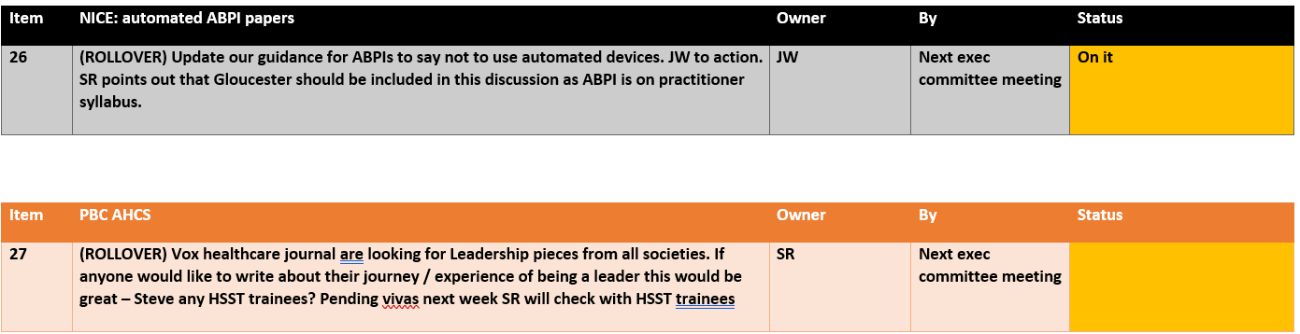 | JF  1.Complete  2.HoS meeting – are they worth it?  One rep per hospital to meet up to discuss general issues across vascular services. Vascular lead network? SR suggests we could be duplicating current NHS England work.  ACTION: Find out who regional leads are in order to publicise. KM to reach out to gauge info  No further HoS meetings?  HW concerns over some regions getting excluded.  LMcR suggests newsletter page dedicated to heads of service.
2. | Conference  KB delivered summary of conference feedback:-  Overall score excellent.  KB commented that EBS survey was poor. So he has asked them to improve for next time.  Challenges: room allegation was tricky. Took a lot of effort to get what we wanted. Costing issues over this specifically.  Couple of speakers dropped out.  Trophies: transport to Dublin proved difficult. Got stuck in customs.  Finances/expenses – made a loss. Need to make changes for next year. SR/KM to meet with Marcus to discuss general allocation/ticket price/model to make everything clear.  Difficulty uploading presentations.  Slido didn’t work perfectly.  Feedback highlights:-  Negatives “too casual”, “lacked focus”. Worth considering but emphasis on majority positives.  Workshop –  Feedback; could we demonstrate pathology? Not practical/achievable  More practical stations – will try to obtain more space for next time.  Feedback on desired topics for workshop:-  Fistulas, abdominal, “knobology”  Thursday desired topics:-  Prof issues, renal, rfa of vvs, evid.based practice, changes, development of role of vascular scientist  Finances. Overview  Questions for 2024:-  Surgeons training day? If they want it then yes happy to provide (for a fee). ACTION: Find out if there is interest KB  Wednesday format? Change? Generally the same.  Equipment:- ask for payment for manufacturers to attend (KM says Phillips have indicated they would be happy to do that)  Negotiate with EBS/VS over presence in exhibition hall as well as workshops. 2/3 days? ACTION: KB to confirm terms  Invited speakers: Number, 19 at Dublin. BF highlighted costing implications. Losing money. SR outlined if ASM fee goes up to £250 then we would break even and be able to have 20 speakers. Discussion of increasing price; hasn’t gone up for a long time. ACTION: KB/SR to discuss with VS in Feb before making ultimate decision on pricing. JW suggests survey sent to previous attendees asking how their place was funded and if they were granted leave etc. BF suggests offering no. of funded places. SR concerned about financial loss as 2024 looks to be a costly year with re-branding etc. ACTION: RJ/KB to put out survey to previous attendees to ascertain details of funding and leave allowance, as well as opinion on conference books only being available online as opposed to paper copy (see next highlighted point below).  Back to speaker numbers: good comments about having more prestigious speakers (1 or 2).  Who can claim expenses? Discuss current claims process:-  Abstract speaker – yes  Invited speakers – conference day, travel/accomm  Exec members – one day  Workshop – individual who sources content/patients same as exec members.  Changes? Accommodation allowance – for the days that are worked by exec members. Should also apply to sub-committee members who are called upon? HW plans to have trainee rep leading on trainee breakouts and therefore would like trainee rep to be reimbursed also. Concerns over justification of expense. Dependent on doing dome general work at the conference. As with any other such individuals.  Local lead – full reimbursement. Lead team members?  EBS processed registration claims. SVT processed travel and accommodation, which worked out cheaper as no transaction fee as with EBS. BF happy that it is a simpler way to do it. To keep the same essentially. Obtain in writing from VS an agreement on expenses process going forward (meeting with Marcus).  Drinks reception-how much? Generally around £2000. Last time in Brighton £2500. Would be a big help to gain sponsorship to help cover that cost as BF mindful that it is a stretch. To justify event proposed EW/SR propose to change title from ‘drinks reception’ to something like ‘evening symposium’ ‘networking evening’. KB proposes planning for 200 this year in Brighton. E.g. £25 a head.  KM asks if a charitable donation could be made towards the venue. Could be tricky but possible.  Conference books – worth going online? Add to RJ’s survey. BF suggests shopping around. | KB
3. | Treasurer  Treasurer report –Jan 2024  Account balances as at 18.01.2024  Current account – …………………………..£11040.78  Reserve account - …………………………..£133129.85  Income and expenditure  Main costs -  Expenses for meetings, etc including quite a bit of the conference costs.  Elsevier renewal £2.8k  Showmotion media (video of a meeting) £0.9k  Case membership renewal £1.9k  BMUS contract £2000  Exec risk insurance £0.5k  Conference expenses approx:  Invited speaker claims so far £2.5k  Exec claims so far £2.5k  Prizes £1.25k  Other news:  HMRC have accepted our application to claim gift aid so we now are registered as a corporation.  Need to make a website change and members need to confirm this each year to be able to claim. We may be able to claim  Now registered with HMRC to be able to claim gift aid. Needs to be included on website, tickbox for “yes I am a taxpayer”. Perhaps for every transaction. To claim gift aid all fees need to be described as ‘donations’. KM suggests capability cloud should be able to give advice as they already do this for BMUS. ACTION: BF to get in touch with CC to help implement. Worth doing as can claim back 20%.  Should we put out something now to encourage members to ‘tick this box’ or wait until August when renewing. | BF
   | OCT | NOV | DEC | Total
  Income £ | £4213.13 | £3371.30 | £1650 | £9234.43
  Expenditure £ | £4902.64 | £7782.46 | £6455.90 | £19141.00
4. | Membership  - fCVS nomenclature  - mCVS nomenclature  There are currently 523 members of the SVT /CSVS, comprising of the following:  Accredited (AVS): 289  Ordinary: 199  Honorary: 16  Associate: 19  It appears that there are some AVS members who are not showing on the search of the register, therefore, I have gone through the database to see how many aren’t showing and there appears to be at least 22 who aren’t. Hopefully I will have the answers as to why not by the meeting on the 19th. Also myself and Rob are going to have a meeting to see if there is anything that can be improved with regards to the membership side of the website, so hopefully this will be soon too.  LMcR requests more communication betweek ed comm wrt members who don’t have enough CPD points as LMcR cannot access that information. EW says we need clarification over accredited members: membership, register and CPD. If lapsed this should be evident. Gaps identified in placing newly passed AVS on the register. How is this actually done? Need to identify who is missing off register. HW will need to look into this but SR/LMcR figured out how to reflect this on the register.  LMcR raised issue of member request for refunds. Advised to go back to member explaining this is a charitable donation.  ___________________________________________________________________________________________________________________  SR presented spreadsheet for work on new proposed membership numbering system  Formatting will be outlined as a member joins (prefix m) or becomes accredited (prefix F). Assignment of numbers will be an automated process.  KB suggests for honorary members we could use the term “Honorary fellow”.  VOTE taken over whether to adopt this new method of assigning membership numbers. All voted YES. Agreed that SR will take responsibility for writing this new policy ACTION | LMcR
5. | Education  Education Chair Agenda for Jan 19th Exec Meeting  1. New Theory Exam provider:  Mettl  Costings for Mettl–  1. Set Up costs = £1000 (content upload of up to 800 MCQs provided in Word/Excel)  2. Running costs = £80 per proctored session (using a live Mettl Proctor for up to 10 candidates) + £9 per candidate. (E.G. If there were 5 candidates in one session, the cost would be: £80 + 5 x £9 = £125 total for the session)  Costings for exam consumables (rough guide) –  1. A4 size whiteboards with the SVT logo = approx. £114 for a pack of 35  2. Whiteboard pens and drywipes = approx. £115 for 250 personalised SVT whiteboard pens + £39.00 for approx. 112 whiteboard erasers (not personalised)  3. Sealable clear bags and SVT logo stickers + large envelopes for posting = approx.. £75 for logo tape/stickers + £5.50 for 100 A5 size plastic bags + £10.00 for large envelopes (Approx 100)  4. Postage costs = approx. £4.40 per equipment package  Total per 100 exams taken = approx. £3584  Total including Mettl set up costs = approx £4584  2. Conflict of Interests policy  3. Change in ’Returners to practice’ policy  4. Ed Comm positions and vacancies  5. Training Breakout and passing of AVS ‘ceremony’ at next ASM  6. Education/AVS future  - Exam consumables:-Whiteboard pens and drywipes – JW suggests pad and paper may be better  - Revisited idea of returning to face to face exams but HW says committee felt it was more beneficial to maintain flexibility.  - Discussed new platform Mettl. (Moodle was too expensive)  - KM raised issue of our previous Inteleos theory exam questions; are they in our possession? They will need to be uploaded to onedrive, password-protected and backed up. SR offered to keep a copy as has an extra secure storage option.  - KM highlighted that Inteleos service expires on 29th March so need to be prepared. KM checked with HW that work demand is acceptable.  - With regards to keeping costs low it would be advisable to limit theory exam dates, e.g. per quarter  - HW raised question of refunds. Agreed that candidate information needs to be explicit enough that any potential claims for refunds could be dismissed as being in the pre-info.  - Briefly discussed theory exam price of £125 and no objections to maintaining this.  - After hearing all of HW’s research into a new theory exam platform, a VOTE was taken and all agreed to proceed with Mettl. ACTION: This will be announced in the next newsletter and comms sent via website. JA/RJ HW to confer with BF  - EW suggests having a test run of Mettl before official launch. This could delay things so will probably need to extend Inteleo past March, possibly until June. ACTION: HW to extend Inteleos deadline. If any issues then can always revert to ‘old school’ method of examining temporarily.  - Returning to practice discussion. Lapse after 5 years you have to resit practical and theory exams. Needs amending? HW suggests points system, e.g years of experience. HW discussed HCPC protocol which does not ask for any re-taking of exams. Safety issue in reinstating AVS for people have been out of practice for a significant amount of time. General discussion on how much to accommodate return to work individuals… suggested to retain current policy however there will be a reduced rate of theory/practical exams. ACTION: HW to amend this in policy. SR also raised issue of supervised status.  - Every member should agree to declare any conflicts of interest. ACTION: KM to write to ET for C of I letter to be sent to all committee members. Clarification needed for what happens once conflicts are declared-to exclude bias any discussions around potential conflicts of interest the person in question should be asked to leave the room. ACTION: Create policy JW. Will place onus on individual to declare and act accordingly. Checklist for every meeting? SR to send example to JW.  - HW wanted to clarify role of study days lead as someone who will work with exec. HW declared concern about a role for the revision days. SR suggested revision days could potentially be pushed back in line with inteleos/mettl transition.  - Return to presenting certificates for new AVS; fellowship ceremony at the ASM.  - Next goal for ed comm will be to standardise practical exams. | HW
6. | Professional standards  PSC Update: Meeting 12th Jan  New Members  2 New Members: Janine Fletcher and Veronica Sagayaraja  1 New ‘Assistant’ Sivs (as she is not experienced enough for a committee role in PSC, but welcome her enthusiasm and help.)  Job Profiles & Job Descriptions  No further work with profiles  Job descriptions: 6 & 7 now ready for website, >8 in final review  Website  JW has emailed Rob with the PSC page changes (re-shuffling areas)  Ask exec which areas/data to be member only versus public (what are we paying for as a member versus what should be public domain eg PPGs for medicolegal etc)  PPGs & Document updates  The documents tracker has been reviewed and updated. There are docs without a review date, so we added this for Sept 2024. These were the Code of conduct, social media policy, and complaints procedure.  There are 8 PPGs to update and these have been shared out and planned over the next quarter.  IQIPS  Alison stepped down as an assessor, but still on ACAG. However would also like to step down from this. We are looking at a new PSC rep to send and JW will do this in the meantime.  Webinars  JW keen to have some PSC webinars, but pleased to hear from UKAS that they are doing some good ones which we can hopefully share on our pages. Then when we get time we will do vascular specific ones.  Indemnity Insurance  Emma sent JW update. ?For membership sec to publish guidance on that page not PSC As it is on that web-section  BSc Scope of practice  Keen to see a definition as still concerns about carotid, and use of colour & Doppler competency versus ‘knowledge’. Maria is hosting a direct entry student on the course (no workplace job) so she would be very happy to help if a group is required.  SVT Name change  Let us know about process for rebranding. Templates etc. Also is there a strategy for cascading this to other organisations that link with us (SOR, UKAS, CASE etc)  Discussed work on job descriptions. Poor clarity between higher level bandings, i.e. 8b,c,d. And discrepancy over requirement through ESR for HCPC registration which not all scientists have. JW raises as concern. Ratification by SVT should add weight to our job profiling work. KM/SR emphasise importance of having this documentation onto the website. ACTION: JW to action, even if docs are in “consultation” phase.  SR says journal of vascular surgery are interested in publishing scanning guidelines. Credit would be given.  Webinars – KM suggested one focusing on PPGs. Or could be a pre-recorded resource. HW suggested using “bitesize” term across all sub-committees.  ACTION: EW to liaise with LMcR about posting indemnity insurance/SoR info on membership page.  JW presented PSC concerns about BSc curriculum and difference in in-house and direct entry students. Collaborative approach between ed comm, exec and PSC? (Maria). Need for a link person between SVT and NSHCS. HW says potentially the candidate for education pathways lead. | JW
 | LUNCH
7. | Newsletter  JA still in transition to role | JA
8. | Study days/Webinars  - new dates/topics;  - fistula study day later in the year? (September?) BF to put to Louis and come up with a date to run by ET. ACTION: KM will send out email to BF, RJ, ET, LA. To consider venue, Kings a possibility? Need somewhere with both patients and facilities. ET handles logistics.  - CX update; SVT invited to put on a study session. 1 day, lectures AM/ practical PM. 2 topics, carotids/EVAR. Audience of medics; need to explain about how to image, limitations etc…innovation. 24th April Day 2 (wed). Contributors will get free registration to the event and SVT membership will get reduced rate (ACTION: to go on comms RJ). Opportunity to make a profit. Cost up expenses for our support then ask for donation to the SVT. ACTION: KB to email out to exec to confirm help. KM can help with finding patient subjects for EVAR. Potentially HW for carotid disease patients. | KB/SR/KM
9. | Website  Website Report – January 2024  SVTGBI Website review/development  Overview  Completed / Nearly Completed  - A first draft of the SVT website planning document has largely been completed (pending Steve W’s feedback) and most of the committee members with unique interactions with the website have been canvassed for ideas and improvements.  - Awaiting some replies from Edcom which will come after their next meet on 2nd Feb  - This will all need to be reviewed by the website review committee before submission to Steve W / Capability cloud for review/quotation/development.  Upcoming tasks/decisions  - Decide on:  - A maximum budget for whole redesign  - Website Theme/branding  - Logo  - Branding  - ? Use of external graphic designer  Website committee meeting to review in mid Feb  (Date TBC)  Other Discussion Points:  - Pricings for job adverts:  - Single £500  - Repeat with no further email or SM (within 3 months) £0  - Repeat with another email and SM (within 3 months) £200  - Repeat (after 3 months) £250  - Multiple adverts? ?  Wording of pricing Document:  “ Job Adverts - £500  This includes an advertisement on the website (up to 3 months), a single email to membership and a single post on each of our social media channels.  Re advertising jobs  The closing date of a job advert can be extended once within the initial 3 month window at no additional cost. However, it costs an extra £200 to resend an email to the membership and re-post on social media.  After 3 months (or if requesting a second change in closing date), readvertisement costs are 50% of the original cost (£250 for new website post, email and social media posts). “  - IPEM Manuals - A member is asking if they are able to still buy these?  Discussion on how distribute IPEM manuals. More appropriate to offer out to heads of service. ACTION: To check with ET how we would set up delivery cost process KM?.  RJ to link with Ed com meeting  Need to try to establish timeline for new website launch. SR advises that RJ makes it very clear from the start exactly what work needs to be done so as to avoid ‘add-on’ fees for any subsequent work. | RJ
  Phase | Task | Timeline
  1 | Meeting with SW/CC for process discussion | Sep ‘23
  1 | SVT website Planning document | Jan ‘24
  1 | EDCOM process improvement documents | Jan ‘24 (1st week feb)
  1 | Treasurer/Membership process improvement documents | Jan ‘24
  1 | Catch up with Steve W/CC for progress update | WC 15th Jan
  1 | Website Review Committee (WRC) Review | Mid-End Feb
  2 | Website Development (CC) | ? Spring
  3 | Website Testing (WRC) | ? Late Spring / Early Summer
  4 | Content Creation/Transfer | ? Summer
  5 | Launch | Late Summer / Autumn
10. | BMUS  BMUS  Not much to report from BMUS, everything has been focused on the annual conference. BMUS has not yet had any meetings in 2024.  BMUS conference York  Day 1  The vascular session was well attended, the room was full, which was a huge relief. There were some really interesting presentations and lots of discussion and questions were asked. Everyone seemed to enjoy the topics covered.  Day 2  Although the delegate list for the workshops was reasonably full, both workshops were poorly attended. After discussion with Emma Tucker, we have decided not to run a vascular workshop at next years conference. It hasn’t been decided whether SVT have more time allocated to presentations instead. That will be discussed at the next meeting.  Lower limb – 10 people attended (15 booked)  Upper limb – 15 people attended (25 booked)  All I need now are topic ideas for this year !!! | TE
  Speaker | Title
  Joao Carreir | 'Calf and Pedal 3D and Contrast Ultrasound Imaging
  Ben Warner-Michel | Bridging the Gap: Implementation of duplex ultrasound techniques in general medical ultrasound
  Lynne McRae | Bilateral Persistent Sciatic Artery
  Borsha Sarka | A multidisciplinary team-led approach to improving care for patients with suspected giant cell arteritis
  Jodie Baker | When an occluded vein isn't thrombus - a case study on Leiomyosarcoma
  Tracey Gall | Carotid Scanning Criteria
  Katja Norse | Disparity in Pelvic Vein Incompetence: Time To Recognise and Treat in Women
  Dr Dare Seriki | Pelvic Vein Embolisation, the Vascular Radiologist Perspective
11. | Research  No formal report as committee meeting has not yet been held  Update lost one member but SR feels they have enough anyway  To continue bitesize work. ACTION: Need to set up next webinar, SR.  SR informed of various trials, including Thrive.  SR has identified a new potential chair so has a sound succession plan. Isaac from Coventry. No objections from exec.  EW raised issue that research questions still need to be created for research module. ACTION for SR | SR
12. | Vascular Stocktake  Update | EW/KM
13. | NAAASP | KB
14. | Vascular practice books  Cost/distribution options | All
15. | National School meeting  Report from meeting with Lisa Ayers and Owen Driscoll  Plan to increase trainees by 30% by 2030.  IACCS to change. Info to be published in newsletter  Suggested that SVT get involved in HSST interview process to vet so that candidates can be assessed for ‘readiness’ | SR/HW/KM
16. | National CRG meeting  Report from 08.12.2023 meeting | EW
17. | Equivalence  Documents for Equivalence RPL status created and submitted to Dr Elaine Jenkins on 09/01/2024 and we should hear back in a few weeks. | EW
18. | AOB  Executive committee meeting dates  SOR Insurance statement | All

12. NHS England data collection. Some issues with people gaining access to the portal. KM informed that some feedback will be due in March.

16. money will be filtered down to ICBs starting apr 2024, region by region

