The Society of Vascular Technology of GB & Eire

Annual Scientific and General Meeting Programme 2021

Part of

Vascular Societies' Annual Scientific Meeting 2021

Manchester Central Convention Centre

Tuesday 30th November – Friday 3rd December 2021

Conference Theme: The Future of Vascular Science

At a Glance: (Coffee and lunch breaks at same time as VS)
 | Monday | Tuesday | Wednesday | Thursday | Friday
Morning |  | Travel  SVT Introduction to Vascular Ultrasound for Surgeons in training | Research Workshop | Completed studies and Scientific/case study oral presentations | VS Sessions  Hot sandwiches
Afternoon |  |  | NIHR careers talk  Research proposals  Joint VASBI session  Heads of service meeting | Debate  Invited speaker talks | Travel
 |  |  |  | Jackie Walton Lecture  AGM/Trainee breakout | Travel
Afternoon |  |  | 1600-1620: Emma representing SVT in circulation foundation session of VS programme | Prize giving and honorary achievements | Travel
Evening | Chair & Moderator briefing 18:00 via zoom | Travel | VS & SVT Drinks Receptions | Conference Gala Dinner | Travel

Duties Rota: Plan A
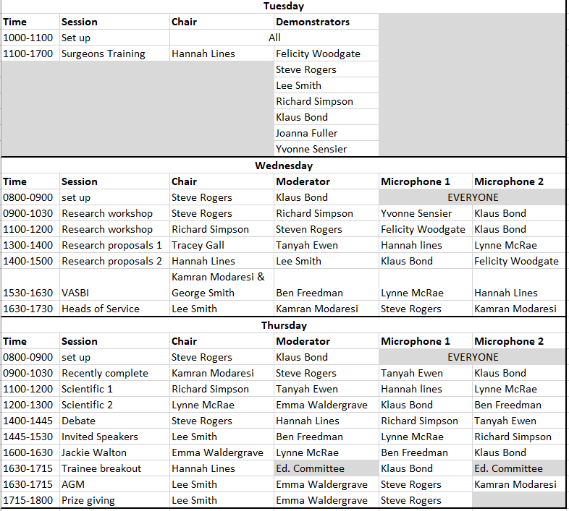

Duties Rota: Plan B

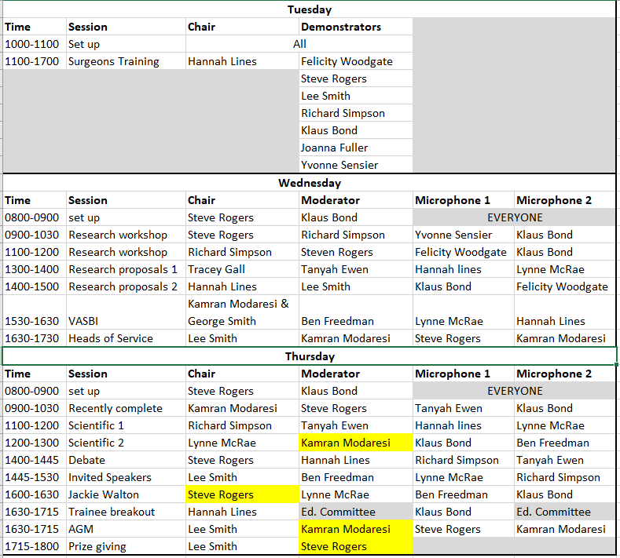
TUESDAY 30TH NOVEMBER 2021 PM – 11:00 – 17:00
Set up: All demonstrators
Chair: HANNAH LINES
Moderator: FELICITY WOODGATE
Microphones: Not required

Assisting: Steve Rogers, Lee Smith, Richard Simpson, Joanna Fuller, Yvonne Sensier, Klaus Bond (floating).

Session: | Introduction to Vascular Ultrasound
Pre-course learning:
This will be sent out in the weeks preceding the event. Delegates will need to register and use the e-learning for health module available on e-LfH which is free.

https://portal.e-lfh.org.uk/Component/Details/545939

- Focused Acute Medicine e-learning
11:00-11:30 | Welcome Introduction by session chairs  Allocation into groups for afternoon sessions (as per pre-planned Excel sheet)  Overview of each practical station
11:30-13:00 | 2 x Practical sessions  10 minutes initial demonstration  4 x 5-minute hands on per participant  5 minutes session change over
13:00-14:00 | Lunch in the exhibition hall
14:00-16:30 | 4 x Practical sessions  10 minutes initial demonstration  4 x 5-minute hands on per participant  5 minutes session change over
16:30–17:00 | Working with your vascular scientists  Session Close by Chairs
Practical sessions:  (30 minutes per station with demonstrators)  Station 1 - TBPI and Doppler Waveforms:  - Acquiring Doppler signals and listening to waveforms  - Correct positioning and equipment  - Accurate toe pressure measurements  Station 2 – Pre-Fistula Mapping  - Calibre measurement in of the upper limb veins  - Upper limb artery assessments  Station 3 - CFA scanning:  - Visualisation of the CFA and landmarks inc. high bifurcations  - Assessing patency and flow  - Calcification and access issues  Station 4 - Aorta screening measurement:  - Visualisation of the aorta and landmarks  - Taking AP measurements  - Pitfalls and limitations  Station 5 – Carotids:  - Visualisation and landmarks  - Identifying bifurcation level  - Checking pre-operative patency  Station 6 – Venous:  - Visualisation of the LSV  - Measurement and mapping  - Access and planning for RFA/EVLT |  | Equipment:  - 6 x Ultrasound machines (to contact manufacturers Mindray, GE)  - 6 x Couches  - 1 x TBPI kit including visual Doppler (Huntleigh)  - 100 x Individual ultrasound gel sachets  - 6 x Clinell wipes  - 6 x Couch Rolls/tissues  - Small, medium and large gloves  - Roll of Aprons  - Box of disposable Masks (if still required due to COVID)  - Alcohol hand gel  Volunteers/Patients  - 2x Patients with known abdominal aortic aneurysms (also willing to allow scan of common femoral)  - 1x Patient with “moderate” carotid disease  - 3x “normal” volunteers  N.B These can be all swapped for normal healthy volunteers from the SVT if pandemic restrictions make external volunteers too high risk  Staffing:  - 2 x session leads (Hannah and Felicity)  - 5 x Demonstrators (SVT to source)
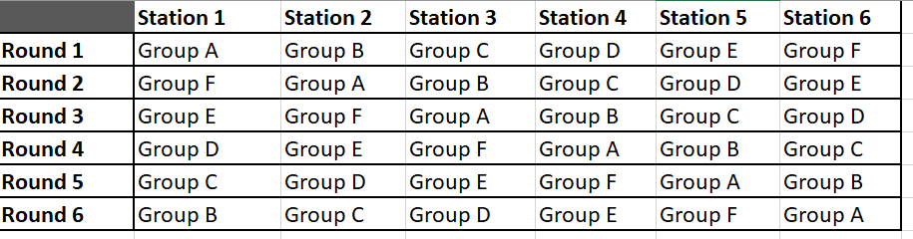

 | Modality | Demonstrator
Station 1 | Waveforms/TBPI | Lee Smith
Station 2 | Pre-fistula mapping | Jo Fuller
Station 3 | CFA scanning | Felicity Woodgate
Station 4 | Aorta screening | Yvonne Sensier
Station 5 | Carotids | Steve Rogers
Station 6 | Vein mapping | Richard Simpson
Floating |  | Klaus Bond
Floating |  | Hannah Lines

 | Group A | Group B | Group C | Group D | Group E | Group F
Delegate 1 | Ahmed Abdelal |  | Toni Calver | Sarah Mcanelly | George Ninkovic-Hall | Aleksandra Staniszewska
Delegate 2 | Hala Ahmed | Nourelhuda Darwish | Lucy Green | Ed Charles | Stacie Hodge | Muhammad Hussien
Delegate 3 | Samantha Muse | Aminder Singh | Shailendra Singh | Dimitrios Vlastos | Ahmed Soliman | Manoj Nair
Delegate 4 | Zaim Zahid | Adam Talbot | Emad Shawish | Lukasz Zielinski | Daniel Thompson

19:30 SVT Conference Dinner
Dimitris Tapas Bar Taverna, 1 Campfield Arcade, 322-326 Deansgate, Manchester, M3 4FH
https://www.dimitris.co.uk/

WEDNESDAY 1ST DECEMBER 2021 AM - 0900-1200

Set up: Steven Rogers & Klaus Bond plus anyone else
Chair: Steven Rogers
Moderator: Richard Simpson
Microphones: Yvonne Sensier & Klaus Bond

Session: | Research Skills and methods workshop 1
Pre-course | Good Clinical Practice – https://sites.google.com/a/nihr.ac.uk/crn-learn-help/accessing-nihr-learn
09:00 | Welcome introduction by session chairs
09:02  (15min +5)  (15min +5)  (45min) | Dr Richard Simpson | SVTGBI & Principle Vascular Scientist, Nottingham NHS FT | A roadmap to Research
09:02  (15min +5)  (15min +5)  (45min) | Prof. Cliona Kirwan | Consultant Oncoplastic Breast Surgeon – Manchester University NHS FT  Professor of Surgical Trials - Royal College of Surgeons of England & University of Manchester | Levels of evidence, pitfalls of research and Patient and Public Involvement in Research
09:02  (15min +5)  (15min +5)  (45min) | Dr Richard Simpson &  Dr Steve Rogers | SVTGBI | ‘Live data exercise (ABPI + TBPI vs Duplex)’
10:30-1100 | Coffee break in exhibition hall

Chair: Richard Simpson
Moderator: Steven Rogers
Microphones: Felicity Woodgate & Klaus Bond

Session: | Research Skills and methods workshop 2
1100-11:59  (15min +5) | Prof. Matt Bown | Professor of Vascular Surgery, University of Leicester | Funding and grants(wo)manship’
(15min +5) | Dr Steven Rogers | SVTGBI & NIHR Clinical Lecturer, The University of Manchester | ‘When is research, research and what paperwork do I need?’
(15min +5) | Miss Emma Barrett RECORDED | Manchester University NHS FT & The University of Manchester | ‘Basic Statistics for Vascular Science’
(5min) | Ms Yvonne Sensier | SVTGBI & Senior AVS, Leicester Hospitals NHS FT | ‘Reporting and dissemination’
12:00 | Session Close by Chairs
12:00-13:00 | Lunch provided in the exhibition hall
WEDNESDAY 1ST DECEMBER 2021 PM - 1300-1500
Chair: Tracey Gall THEN Tanyah Ewen
Moderator: Hannah Lines THEN Lee Smith
Microphones: Hannah Lines & Lynne McRae THEN Klaus Bond & Felicity Woodgate

Session: | Research proposal oral presentations
13:00 | Welcome introduction by session chairs
1300-1320  (15+5 min) | Keynote speaker | Organisation and job title | Title
1300-1320  (15+5 min) | Dr Beth Harris | NIHR Senior Programme Director | “NIHR Funding to Develop your Research Career”
13:25-15:00  (8 + 2 mins each) | Abstract Speaker | Organisation and job title | Title
13:25 | Mr Louis Alexander | Clinical Scientist, King's College Hospital NHS Foundation Trust | The clinical efficacy of vascular ultrasound screening prior to kidney transplantation.
13:35 | Miss Chloe Bishop | Trainee Vascular Scientist, Newcastle upon Tyne Hospitals NHS FT. | Understanding the impact and associations of Health Literacy with outcomes for Chronic Limb-threatening Ischaemia (CLTI); The HeaLTHI study
13:45 | Miss Sophie Bowen | Trainee Vascular Scientist, University Hospitals Bristol. | A prospective evaluation of the current diagnostic pathway for patients with suspected giant cell arteritis
13:55 | Miss Hannah Davey | Trainee Vascular Scientist, University Hospital Southampton NHS FT. | Transthoracic ultrasound evaluation of Thoracic aortic aneurysms.
CHANGE CHAIR, MODERATORS AND MICROPHONES
14:05 | Miss Shannon Halliwell | Trainee Vascular Scientist, University Hospitals Bristol. | A retrospective service evaluation investigating the role of carotid artery screening prior to elective cardiac surgery in reducing perioperative stroke rate.
14:15 | Mr David Machin | Trainee Vascular Scientist, Gloucestershire Hospitals NHS Foundation Trust | A single centre service evaluation examining the effectiveness of contrast enhanced ultrasound compared to computed tomography angiography and duplex ultrasound in the detection of endoleaks post endovascular aneurysm repair
14:25 | Mrs Rebecca Nygaard | Trainee Vascular Scientist, Nottingham University Hospitals NHS Trust | An evaluation of using Ankle-Brachial Pressure Index (ABPI) and Toe-Brachial Index (TBI) as a screening tool post-angioplasty.
14:35 | Miss Abigail Traynor | Trainee Vascular Scientist, Imperial College Healthcare NHS Trust | A retrospective study on ultrasound velocity criteria for suspected Popliteal Artery Entrapment Syndrome (PAES)
15:00-15:30 | Coffee break in exhibition hall

WEDNESDAY 1ST DECEMBER 2021 PM - 1530-1630
Chair: Kamran Modaresi & George Smith
Moderator: Ben Freedman
Microphones: Lynne McRae & Hannah Lines

REMINDER: 1600-1620: Emma Waldergrave representing SVT in circulation foundation session of VS programme.
Session: | Joint session with VASBI – Endovascular AVF and ultrasounds role
1530-16:15  (10 + 5 mins each) | Speaker | Organisation and job title | Title
1530-16:15  (10 + 5 mins each) | Miss Amy Bolsworth | Vascular Scientist, Barts Health NHS Trust | “The role of US pre-operatively in planning AVF construction”
1530-16:15  (10 + 5 mins each) | Dr Ounali Jaffer | Consultant Interventional Radiologist and Deputy Director Research, Barts Health NHS Trust. | “The role of US in endovascular AVF creation”
1530-16:15  (10 + 5 mins each) | Dr Zaib Khawaja  RECORDED | Speciality Doctor in Renal Transplantation and Dialysis Access Surgery, University Hospitals Birmingham NHS FT | “The role of US in endovascular AVF surveillance and how surveillance differs to conventional AVF”
1615 -1625  (7+3 mins) | Mr Jon De Siqueia | Deputy Chair, Vascular Access Special Interest Group, Vascular Society GB&I | “Research priorities in vascular access from the priority setting partnership with the James Lind Alliance”
16:25 | Session Close by Chairs

WEDNESDAY 1ST DECEMBER 2021 PM - 1700-1800
Chair: LEE SMITH
Moderator: Kamran Modaresi
Microphones: Kamran Modaresi & Steven Rogers

Session: | Face-to-face Heads of Service Meeting - Agenda provided by President

18:00 VS Drinks Reception in Main Auditorium
19:30 SVT Drinks Reception
Manahatta (The Argyle Suite), 188-192 Deansgate, Manchester M3 3ND.
https://www.manahatta.co.uk/bars/deansgate/private-hire-manchester
Booked food for 60, room holds 125. Glass of prosecco on arrival.

THURSDAY 2ND DECEMBER 2021 AM - 0900-1030

Set-up: Steven Rogers & Klaus Bond plus anyone else who can come early
Chair: Kamran Modaresi
Moderator: Steve Rogers
Microphone: Tanyah Ewen & Klaus Bond

Session: | Recently Completed Studies oral presentations
0900 | Welcome introduction from the President SVTGBI
(12+3 min each) | Name | Organisation and job title | Talk Title
0905 | Mr Ian Hornby | Junior Vascular Scientist, University Hospitals Bristol | Retrospective analysis of abdominal aortic aneurysm growth rate in patients undergoing local ultrasound surveillance
0920 | Miss Emily Morgan | Clinical Vascular Scientist, University Hospitals Bristol | Prospective evaluation of inpatient treatment for lower limb Deep Venous Thrombosis (DVT)
0935 | Dr Osian Llwyd | Clinical Vascular Scientist, Oxford University Hospitals NHS FT | The feasibility of assessing Cerebrovascular Reactivity with Carotid Duplex ultrasound (Duplex-CVR)
0950 | Miss Hannah Lord | Clinical Vascular Scientist, King's College Hospital NHS Foundation Trust | A service evaluation of abdominal aortic aneurysm ultrasound surveillance in a large London teaching hospital
1005 | Mr Amine Turay | Clinical Vascular Scientist, Imperial College Healthcare NHS Trust | Should the iliac veins and veins below the knee be scanned routinely as part of the protocol in ultrasound scanning for deep vein thrombosis diagnosis?
1020-1030 | Session Close by Chairs
1030-1100 | Coffee break in exhibition hall

THURSDAY 2ND DECEMBER 2021 AM - 1100-1300

Chair: Richard Simpson THEN Lynne McRae
Moderator: Tanyah Ewen THEN Emma Waldergrave
Microphone: Hannah Lines & Lynne McRae THEN Klaus Bond & Ben Freedman

Session: | Scientific and Case Study oral presentations
1100 | Welcome introduction from session chairs
(12+3 min each) | Speaker | Organisation and job title | Talk Title
1100 | Miss Emily Hillier | Vascular Scientist, King's College Hospital NHS Foundation Trust | Case study – Superior Mesenteric Artery (SMA) syndrome
1115 | Miss Alison Phair | PhD Student, University of Manchester | Semi-automatic measurement of carotid plaque volume using 3D ultrasound: a potential new clinical tool
1130 | Mrs Nicolette Kelly | Vascular Scientist, Worcestershire Acute NHS Trust | Persistent Sciatic Artery
1145 | Dr David Barrett | Trainee Vascular Scientist, Manchester University NHS FT | Popliteal Artery Entrapment Syndrome – Using Ultrasound to Determine What is Normal vs Pathogenic.
CHANGE CHAIR, MODERATORS AND MICROPHONES
1200 | Ms Helen Dixon | Senior AVS, King's College Hospital NHS Foundation Trust | Case study - Transient Perivascular Inflammation of the Carotid artery (TIPIC) syndrome
1215 | Miss Alison Phair | PhD Student, University of Manchester | Measuring carotid plaque content with grey-scale median by 3D ultrasound
1230 | Dr Nazia Saeed | Senior AVS, London North West University Healthcare NHS Trust | Carotid Web; Missed on Duplex
1245-1300 | Session Close by Chairs
1300-1400 | lunch break in exhibition hall

THURSDAY 2ND DECEMBER 2021 PM - 1400-1445

Chair: Steven Rogers
Moderator: Hannah Lines
Microphone: Richard Simpson & Tanyah Ewen

Session: | Debate – “Should vascular ultrasound only be performed by experienced vascular scientists?”
1400 | Welcome introduction from session chairs
1400-1440  (5 + 3 min) | - (For) Mrs Lynne Macrae, SVT Membership Secretary  - (Against) Dr Kamran Modaresi, SVT Vice-President Elect  - (For) Prof. Alun Davies, Professor of Surgery – Imperial Collage London  - (Against) Miss Sophie Renton, Consultant Surgeon and VS Secretary  - (Against) Mrs Louise Allen, SVN President
1440-1445 | Voting and Session Close by Chairs

THURSDAY 2ND DECEMBER 2021 PM - 1445-1530

Chair: Lee Smith
Moderator: Ben Freedman
Microphone: Lynne McRae & Richard Simpson

1445 | Introduction from session chairs
Session | Key note and Invited Speakers
 | Name | Job Title & Location | Talk Title and Abstract
Key Note
1445- 1505  (15+5 min) | Prof. Justin Mason | Chair BHF project grant committee & Professor of Vascular Rheumatology, Imperial Collage London | Role of MRA and PET, compared with US, in the management of patients with large vessel vasculitis.
Invited Speaker
1505-1525  (15+5 min) | Mr Neil Hopper | Consultant Vascular Surgeon, Royal Cornwall NHS Trust | Personal experience of being a vascular surgeon and a bilateral lower limb amputee. How can my experience help my patients?
1530 | Session Close by Chairs
1530-1600 | Coffee break in exhibition hall

THURSDAY 2ND DECEMBER 2021 PM - 1600-1630

Chair: Emma Waldergrave
Moderator: Lynne McRae
Microphone: Ben Freedman & Klaus Bond

1600 | Introduction from session chairs
Session | Jackie Walton Memorial Lecture
Jackie Walton Lecture:
Jackie Walton was a pioneering Vascular Scientist who was instrumental in helping create the accredited vascular scientist training programme and quite righty was the SVT’s first President. This lecture honours Jackie’s name where each year we invite one speaker to present pivotal results that aim to advance the field of vascular science.
 | Name | Job Title & Organisation | Talk Title and Abstract
1600-1620  (15+5 min) | Mr Gurdeep Jandu | Interventional Vascular Scientist, My Vein Clinic | The role of an interventional vascular scientist in venous procedures and my journey so far
1620-1630  (7+3 min) | Mr Dan Carradice | Chair, Venous Special Interest Group, Vascular Society GB&I | Patient let prioritisation of venous research and national multidisciplinary collaboration

THURSDAY 2ND DECEMBER 2021 PM - 1630-1715

Chair: Lee Smith
Moderator: Emma Waldergrave
Microphone: Steven Rogers & Kamran Modaresi

Session: | SVTBGI Annual General Meeting
1630 – 1715 | Chairs:  LEE SMITH & EMMA WALDEGRAVE | SVTBGI Annual General Meeting  Reports:  - Miss Hannah Lines, Education Chair.  - Dr Kamran Moderesi, Professional Standards Chair.  - Mrs Lynne McRae, Membership Secretary.  - Mr Ben Freedman, Treasurer.  - Mr Richard Simpson, Research Chair.  - Ms Emma Waldergrave, president-elect (BMUS and workforce reports)  - Mr Lee Smith, Presidential Report.  Also present:  - Dr Steven Rogers, Conference Secretary.  - Mr Klaus Bond  Apologies:  - Mr Carlos Pinho, website master  - Mrs Daniela Bond-Collins, newsletter Editor  - Mrs Sara Causley, NAAASP representative.  - Mr Dominic Foy, Past-President

OR

ROOM – Exchange 10

THURSDAY 2ND DECEMBER 2021 PM - 1630-1715

Chair: Hannah Lines
Moderator: Felicity Woodgate, Hannah Williamson, Amy Bolsworth, Sophie McDermott, Laura Haworth, Asif Dilshad, Davinder Virdee
Microphone: Klaus Bond

Session: | Trainee Breakout session
1630–1645 | Review of the SVT training pathway | Review of the process of gaining your AVS and maintaining it beyond accreditation (including introduction of CPD and audit)
1645-1700 | Survey of training experiences | Interactive session including a PowerPoint to assess the provision of training across centres and to encourage discussion on the experience of trainees
1700-1710 | Trainee discussion and questions | Open discussion regarding training and questions to the education team
1710-1715 | Signposting and close | Close of session including contact details for committee and signposts for trainee wellbeing

Trainees to re-join main SVT programme

THURSDAY 2ND DECEMBER 2021 PM – 1715-1800
Chair: Lee Smith
Moderator: Emma Waldergrave
Microphone: N/A

1715-1720 | Ann Donald Scientist of the Year 2021  Ann Donald was a highly respected member of the vascular diagnostic and research community and an important pioneer of the SVT, serving as our President in 2004-2005. Established in 2012 this annual prize of £500 was created in memory of Ann to recognise an outstanding scientist who has performed the best original research or been the most innovative in the promotion of vascular ultrasound during the year.
1720 – 1725 | Best research proposal, Best Completed Study & Best Scientific Paper Winners 2021
1725 – 1730 | Lifetime Honorary SVTGBI membership 2021 – Dr Valda Gazzard (Intro. By Lee Smith)  “Although I was not in SVT at the very beginning, I did join in quite early days in 1994 going straight on to the committee as Conference secretary which I did for 2 years. I was in the first cohort of members to be accredited and contributed to the start of the accreditation process for the whole of the SVT. I had various roles on the Education committee, including Chair, had a later role on the Executive as a member without portfolio, and had many, many years as SVT rep on CASE and a CASE accreditor. I had various roles (sometimes more than one role at a time) for SVT for over 20 years on and off until 2020. It was often challenging - especially due to the distance between Cornwall and the rest of the world - it’s not so bad now we can have Zoom or Teams meetings - but in “my day” a lot of travel was involved. A great many things have changed, even more so recently. Over the years that I have worked with SVT, I have met with some amazing people, I also have worked with a great team in Cornwall. The SVT continues to go from strength to strength. It is a wonderful Society and I wish it every success in the future.”
17:30 | Closing remarks from the President (exchange of medals)
1930-0000 Reminder about Conference Dinner
Manchester Central Convention Centre

