Irish Institute of Clinical Measurement Science
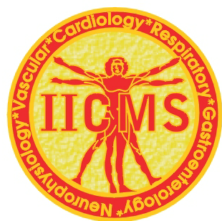

Colette Choiseul

Attended

The IICMS Scientific Meeting on 6th May 2016

Tanya Byrne
______________________________________
Tanya Byrne
Chairperson, IICMS

8th August 2016

