This year the SVT giant cell arteritis (GCA) study day was held on 7th September at the Royal College of Paediatrics and Child Health, London.
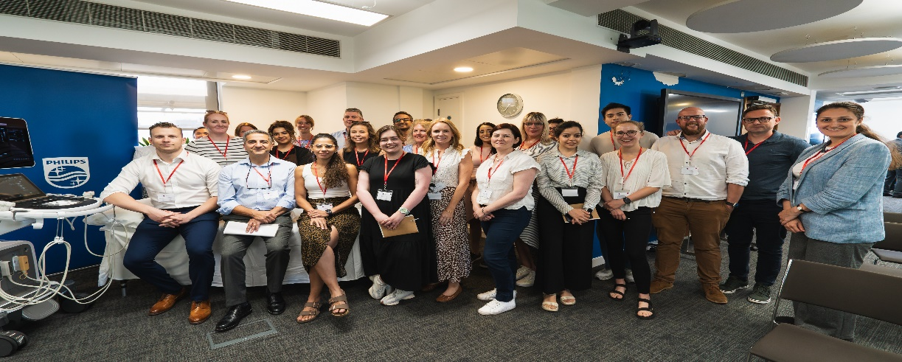

Following a gracious opening from Dr Kamran Modaresi (Vice President of SVT), the study day commenced with an introduction to vasculitis and GCA by Consultant Rheumatologist Dr. Shahir Hamdulay from Northwest University Healthcare NHS Trust. In the discourse about common signs of GCA, I was intrigued and highly engaged in Dr Hamdulay’s session referencing his patient's diary. This diary underscored uncommon symptoms and provided a persuasive illustration of the significance of early recognition of atypical symptoms to prevent delayed diagnosis and vision loss. While he emphasized the utility of ultrasound scans (US) as a valuable non-invasive diagnostic tool for GCA, in instances marked by strong clinical suspicion and elevated blood markers, Dr Hamdulay advocated for the gold standard of GCA diagnosis: a biopsy.

Dr. Nazia Saeed, a Senior Vascular Scientist at London Northwick Park Hospital (LNWH), held the next presentation on setting up a new GCA service. She discussed some of the challenges she faced when creating London’s first GCA clinic at LNWH in 2017, such as lack of labs performing GCA scans and lack of protocols. She cited reaching a consensus on the diagnostic pathway and aligning the criteria with the rheumatology team as crucial goals. Dr. Saeed’s presentation stimulated inquiries from the audience, particularly regarding the anticipated volume and frequency of GCA referrals.
She drew a comparison, pointing out that unlike the substantial number of referrals from the ambulatory care unit for DVTs, that GCA referrals exhibited significant variation, with some weeks seeing a surge in patients, while others had less. I found this lecture to be valuable as it offered insights into best practices and potential pitfalls for those of us involved in either the initial setup or the operation of a recently established GCA service.

In the next part of the study session, an insightful perspective was given from Mr Mojahid Najem, Consultant Vascular Surgeon at Bedford Hospital NHS Trust, on performing GCA biopsies. He spoke about the belief that conducting numerous GCA biopsies in the past was deemed a "waste of time” and felt that time in the operating theatre could have been allocated to more impactful and life-changing surgeries. Dr Najem’s viewpoint was intriguing, particularly when delving into the pros and cons of surgical approaches that entail larger incisions on the head or artery removal. Additionally, in cases of segmental GCA, the selection of the correct portion for biopsy was identified as a challenge. I gathered the impression that Mr. Najem's central message underscored the necessity for a more discerning approach to GCA biopsies and leveraging alternative diagnostic techniques like US before conducting an invasive biopsy.
Following Mr. Najem's presentation, Dr. Saeed led a multidisciplinary meeting featuring the introduction of Dr. Qasim Akram, a Consultant Rheumatologist from Stockport NHS Foundation, who joined the panel via Teams. During the Q&A session with the audience Dr Akram attributed seasonal changes, such as the onset of spring, as potential triggers for GCA. During his talk, I learned that Stockport received a greater number of GCA referrals in comparison to LNWH, primarily attributable to the predominantly Caucasian population in that area. This information was valuable especially when anticipating patient volume for planning in our respective clinics, given our geographic locations. Later in the session, we listened to Dr Akram’s online lecture where he reiterated the use of US as an effective bedside tool for diagnosing GCA. It was wonderful to learn about the achievements of Dr. Akram's GCA Fast Track clinic in Stockport, which has effectively reduced GCA-related vision loss through using this approach. It was interesting to see that he employed a more open-ended approach in his clinic, accepting referrals from general practitioners (GPs) and local nurses, in contrast to LNWH specialist referral pathway.
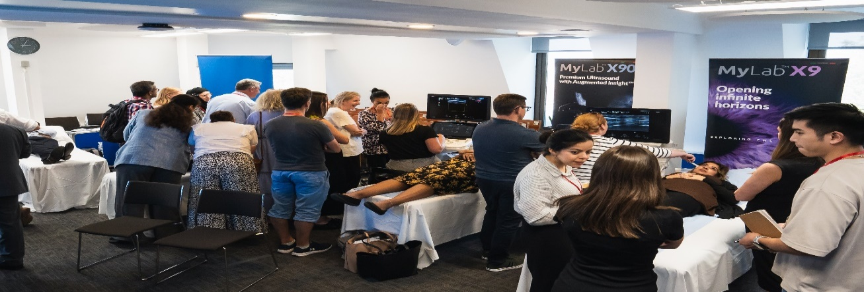

During the afternoon session, after a delightful networking lunch, Dr. Saeed's lecture on the temporal artery scan protocol (with examples of the halo sign, stenosis, and atherosclerosis), was closely followed by one of the much-awaited segments: the hands-on practical session involving the dedicated volunteers. I felt this was an excellent way to put my knowledge into practice and acquire essential skills in conducting these scans. This session not only allowed me to network with others but also encouraged the exchange of expertise and insights. Aside from getting gel in my hair, it was one of the standout moments of the study day for me!
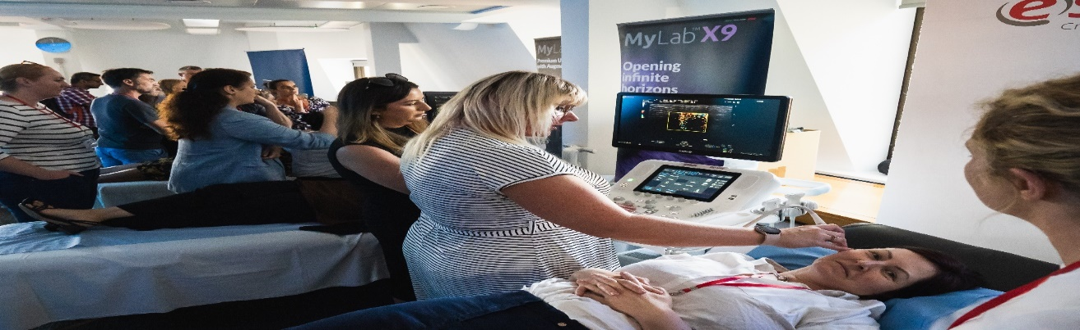

In summary, despite some technical issues, the day ran smoothly and provided an excellent opportunity for attendees to listen to informative lectures by esteemed professionals and to exchange techniques during the workshops. The key insight gained from this is how well-balanced the arguments were when considering the optimal approach for diagnosing and treating GCA, despite the somewhat subjective choice between biopsy and relying on US.
Whilst networking, Emma Waldegrave, President of SVT, actively participated in conversations about SVT scan protocols, local policies, and importance of one’s training journey as a vascular scientist. Additionally, she informed me about the upcoming training sessions set for this year's Annual Scientific Meeting in Dublin, which I am eagerly looking forward to attending.

Husnayya Al-haddad
Clinical Vascular Scientist
Lewisham and Greenwich NHS Trust

