Vascular Testing
Southmead Hospital
Westbury-on-Trym
Bristol BS10 5NB
Telephone: 0117 4145300

CPD Coordinator
Society for Vascular Technology

10 September 2019

RE : Eleanor Walker membership 215

Eleanor Walker is employed by North Bristol NHS Trust as a Vascular Scientist.
I can confirm that Eleanor had a period of long term sick leave from 14 August 2018
to 19 July 2019

Yours faithfully

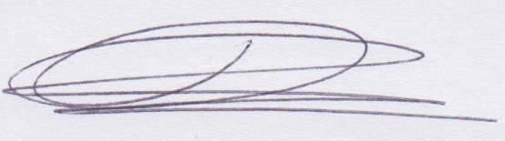

Maria Morgan
Vascular Testing Manager

