Medical Imaging Education – Online Presentation
Doppler Waveforms Interpretation & Analysis

Doppler waveforms provides info about:
- Presence of blood flow
- Direction
- Changes in flow over cardiac cycle
- Velocity
- Quality of flow (laminar/ turbulent)

Waveform parameters:
Quantitative = PSV, EDV, RI, PI, TAMV, Volume, systolic rise time, acceleration
Qualitative = resistance, damped, hyperaemic, tardus parvus, pulsatile, continuous. Therse are descriptions used in reports to provide info about vessels and the end organ being perfused.

Doppler equation = machine using this to generate a doppler shift (positive if towards, negative if away) by assessing the difference between transmitted and received frequency. Depending on the speed and direction of flow the ultrasound is sending in – it will return at a different frequency

Normal waveform – will depend on the vessel being assessed as difference vessels exhibit different waveforms.
Q = P / R
Flow = Pressure gradient / resistance (depending on how much distal tissue bed requires)
High resistance waveforms – vessels feeding organs with low demand. E.g ECA, Upper limb arteries, SFA at rest, SMA (fasting).
Low resistance waveforms – vessels feeding organs with high blood demand. E.g ICA, renal artery, SMA (post-prandial).

Resistance Index (RI) = allows to quantify how high / low resistant a waveform is.
RI = (PSV-EDV) / PSV
RI is generally used to measure the state of distal organ.

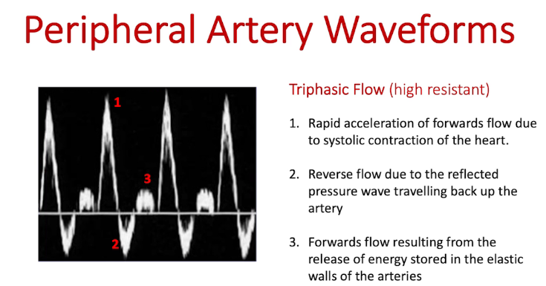
2. reflective pressure wave travelling back up the artery – vascular bed don’t require high demand for blood. Pressure hits capillary bed and reflects/bounces back causing reverse flow.
3. release of energy stored in elastic walls.

Biphasic waveforms = when vessels start to become diseased – artery wall loses their compliance (elasticity) therefore loses the 3rd phase of waveform. Elastic recoil of vessel walls in diastole is lost due to hardening of vessels.

Monophasic waveforms:
Q = P/ R
In flow limiting stenosis – the resistance increases as its harder for blood to flow through – and this accompanied by a drop of pressure across the stenosis.
Increase resistance and decrease in pressure means less flow through (Q is lower).
In order to compensate -arterioles dilate to reduce the resistance of the distal vessel bed and therefore 2nd phase is lost – resulting in monophasic waveforms which gives monophasic waveform where now continuous flow forward throughout cardiac cycle.

Tardus Parvus (slow and weak)
Slow acceleration and low velocities (reduced PSV)
Late, taking longer to reach peak systolic velocity.
Systolic acceleration is delayed after any flow-limiting stenosis.
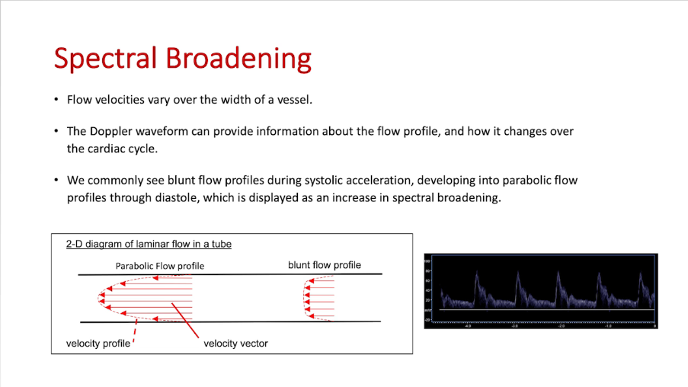
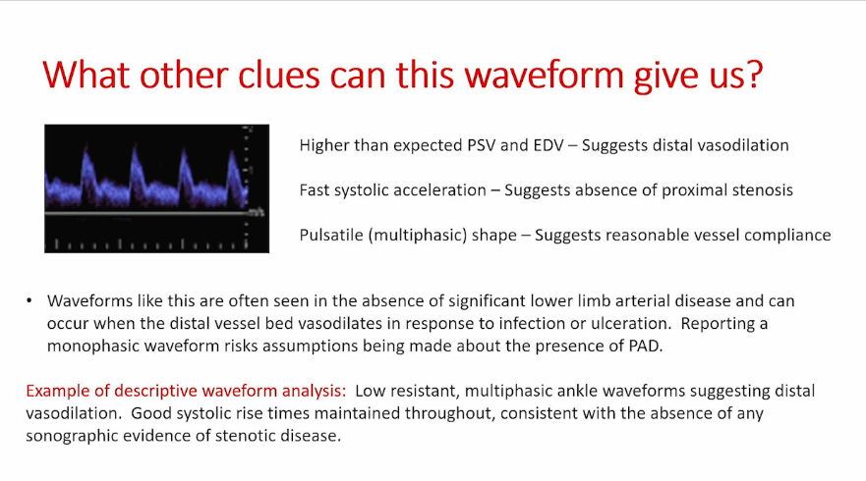

Increase in the range of velocities in the waveform.
Parabolic flow profile just after systole due to friction between blood and vessel walls which slows down flow.
In stenosis – laminar flow becomes turbulent.

Can optimise spectral trace by optimising transmit frequency to give better penetration: useful when poor signal to nosie ratio at depth.
