QA for Vascular Scientists and Yr 3 Trainees
Daily QA

Daily QA checks are performed by the scientist at the start of each day/session. This can be carried out by qualified or trainee scientists. Record results on ticksheet.

- With the scanner power off inspect the scanner, peripherals and all cables for visible mechanical, electrical or infection hazards, e.g. sharp edges, loose components, visible damage. Check the mains and video cables for signs of wear and tear such as loose plugs or torn sheathing. Examine transducer face and casing for cracks. Note any signs of damage to the scanner, monitor etc.
Standard:
There should be no observable concerns with mains, transducer or video cables, transducer cracks, sharp edges, potential infection control issues, etc
Remedial Action:
Withdraw any damaged probes/ultrasound machine from clinical use if there are safety concerns.
Log damage and request urgent engineering intervention to rectify any issues immediately affecting patient or staff safety.
Schedule remedial action for issues not immediately affecting safety.

Examples of defects that can be detected by daily inspection
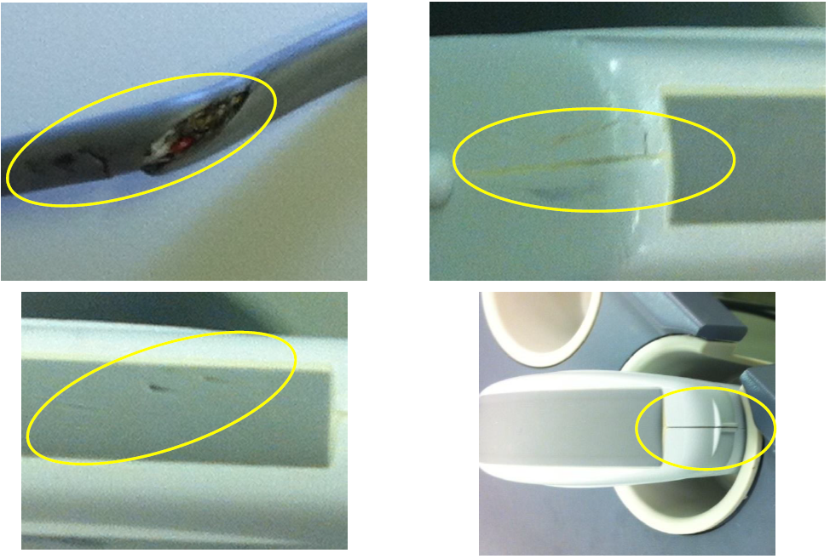

Weekly QA

Weekly QA checks are performed by a scientist before the first session of the week.
These outcomes are recorded on the ticksheet in room. No images are stored unless a defect is suspected.

- With the scanner power off inspect the scanner, peripherals and all cables for visible mechanical, electrical or infection hazards, e.g. sharp edges, loose components, visible damage. Check the mains and video cables for signs of wear and tear such as loose plugs or torn sheathing. Note any signs of damage to the scanner, monitor etc.
- Clean the probe if dirty or contaminated. Use the materials as per the departmental decontamination policy and observe local health and safety and infection control guidelines.
- Check each probe, its cable and connector for signs of damage, eg. cracks in the probe housing and tears in the cable (e.g. where it may have been caught under a wheel).
- The scanning face should be examined by gently running a finger along the surface to detect small regions of non-uniformity; these might indicate a crack or a region where the front layer has become detached.

Standard:
There should be no observable concerns with mains or video cables, filters & vents, sharp edges potential infection control issues etc
There should be no evidence of physical damage to probe, cable or connector.

Remedial Action:
Withdraw any damaged probes/ultrasound machine from clinical use if there are safety concerns and do not switch ultrasound machine on to continue weekly QA.
Log damage and request urgent engineering intervention to rectify any issues immediately affecting patient or staff safety. Schedule remedial action for issues not immediately affecting safety.

- Switch the ultrasound machine on, dim the room lighting to normal scan levels.
- Check the monitor brightness and contrast settings (where possible) and ensure that all display/text is visible throughout screen to corners.
- Check that the greyscale bar is fully visible from white to dark grey.
- Select a transducer and the QA preset (no harmonics, compounding, speckle reduction).
- Leave the transducer in its holder with no gel and increase B mode gain to maximum.

- Look at the reverberation pattern and check for any dark areas or vertical lines.
- Examples of non-uniform reverb patterns
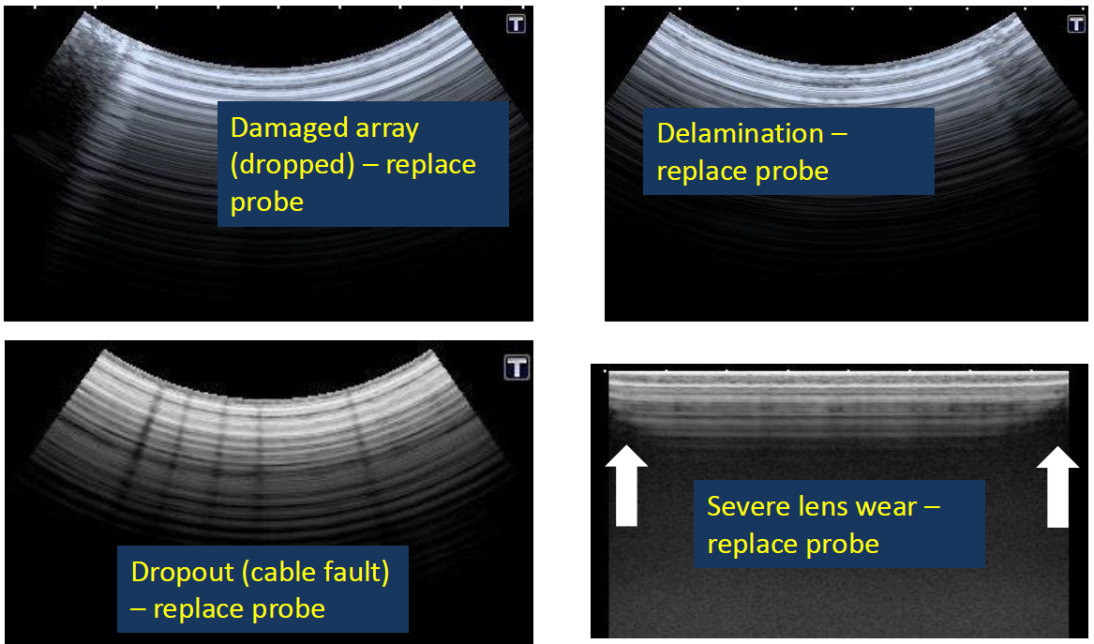

- If any are present put a small amount of gel on the transducer and run the edge of a smooth thin metal object, such as a paperclip, carefully along the face. Note any drop-out of signal as the object passes as this may indicate element damage.

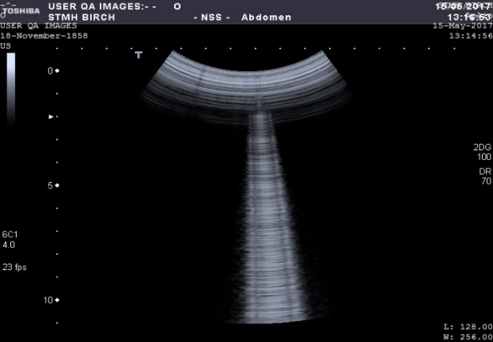. 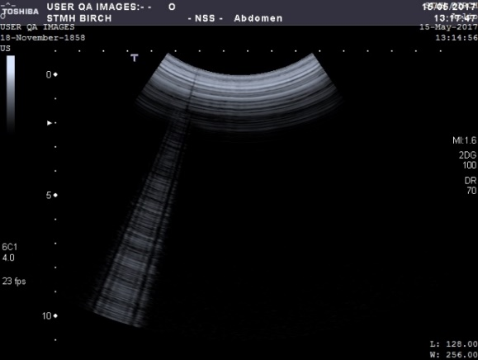
Normal paperclip reverb Paperclip reverb indicating element drop-out

Standard:
Dark grey background, peak white not saturated, all grey scales discernible. Brightness & contrast same as baseline. Uniform reverb pattern and no local signal weakness detected with paperclip reverb if used.
Remedial Action:
Log concerns on “Vascular QA Actions” and request reactive physics test; rectify or replace if necessary.

Scan full ticksheets onto shared drive tatooine, vascular USQA, “QA Daily completed ticksheets scanned in” folder.

