Physics Training forum in preparation for SVT Physics Theory Exam 2021
Danny Rimmer hosted the SVT physics training forum for 2 of our trainees on the 28/4/2021, the session lasted 3 hours and included a powerpoint presentation followed by questions from the trainees relative to their own revision.
The session was performed over teams to limit staff travel and contact relative to the COVID19 pandemic.
Both trainees are booked to sit their SVT exams mid-May and gave excellent feedback about the session and Danny’s Knowledge.
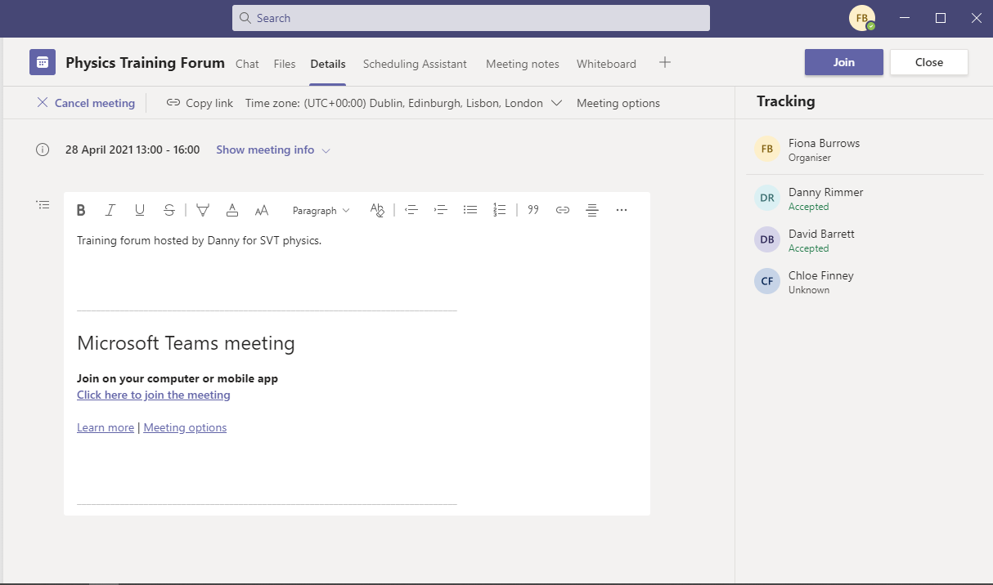
Electronically Signed
F Burrows
Fiona Burrows
Training Manager & Operations Associate
Accredited Clinical Vascular Scientist


